

Long Analyst Report

Presented by Michael Misluk & Abhishek Srivastava

April 26, 2019

UCONN Graduate student managed fund

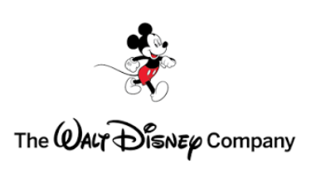

Table of Contents

Executive Summary3

Company Overview3

Investment Thesis3

Catalysts3

Investment Risks3

Business Description4

Operating Segments4

Recent Developments5

Industry Overview6

Communication Services6

Investment Thesis7

Catalysts7

Risks8

Financial Analysis9

Price Performance9

Earnings Per Share (EPS) Analysis9

Ratio Analysis9

Dividend Analysis10

Competitor Comparison10

Valuation11

Conclusion12

Appendixes13

A) Quarterly Financials – Balance Sheet13

B) Quarterly Financials – Income Statement & Cash Flow Statement14

C) Discounted Cash Flow Model15

D) Comparable Companies Model16

E) Sensitivity Analysis16

F) Sources Used16



# Long Analyst Report Executive Summary

**The Walt Disney Company (Ticker: DIS)**

S&P Credit Rating: A+

|  |  |  |
| --- | --- | --- |
|  | **DIS** | **Peers** |
| **ESG** | 65.5 | 60.2 |
| **Environmental** | 65.2 | 59.3 |
| **Social** | 63.5 | 54.4 |
| **Governance** | 67.9 | 66.9 |

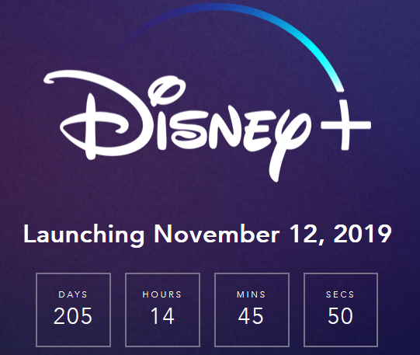

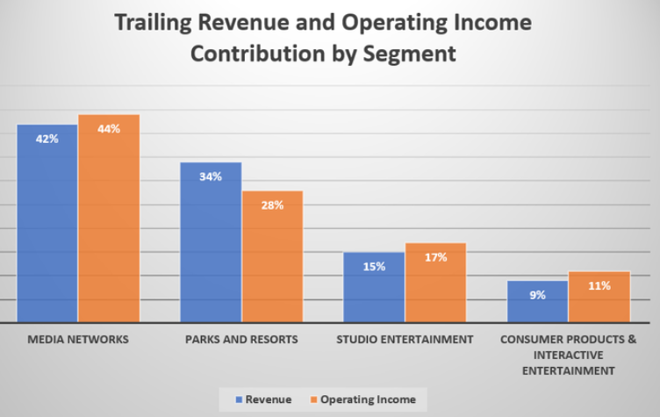

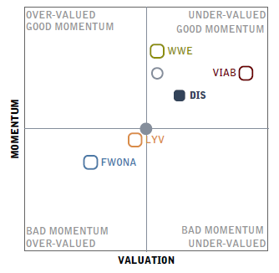

Target Price: $156.08

Current Price: $132.45 Stop loss: $93.97

52 Week High/Low:

$132.87/$97.68

Market Cap ($ Bn): $198.68

Dividend Yield: 1.33%

Enterprise Value to EBITDA: 10.18

Beta: 0.57

% ROE: 21.94/8.08 (Entertainment)

Price/Earnings: 18.12

EPS (TTM): $7.30

Price/Book: 3.95

% ROA (TTM): 9.15 /

5.80 (Entertainment)

**Research Analysts:**

Michael Misluk

Abhishek Srivastava

# Catalysts

The Walt Disney Company (Disney) is a global media & entertainment company with four divisions: Media Networks, Parks and Resorts, Studio Entertainment and Consumer Products & Interactive Media. The company owns and leverages well-known brands, ranging from Mickey Mouse and Frozen to ESPN and ABC. In the last twelve years, Disney has acquired Pixar, Marvel, Lucasfilm and recently most of Twenty-First Century Fox’s assets, to be the largest content provider in the world.

# Investment Thesis

**21st Century Fox Acquisition**: The acquisition of the majority of 21st Century Fox’s assets will significantly expand its content portfolio. They will have telecasting rights of MLB and the NBA in the United States; Premier League, Serie A, Bundesliga and UEFA Champions League in Europe and the Indian Premier League. Fox’s television business is expected to strengthen the TV slate globally and Disney’s international footprint will increase substantially in Europe and India.

**Impressive Slate of Big Budget Movies:** Disney’s Studio Entertainment segment has many big movies slated to be released over the next 18 months, such as: *Captain Marvel, Dumbo, Avengers 4, Aladdin, Toy Story 4, The Lion King, Frozen 2* and *Star Wars: Episode IX*. The success of blockbuster hit movies also tend to bode well for the Consumer Products division as well as the theme parks which have new attractions tied to them such as Star Wars Land and Toy Story Land.

**Direct-to-Consumer Media Streaming Services:** ESPN+ and Disney+ will have exclusive content that is highly desirable and should be able to attract a wide range of subscribers. The recent termination of a distribution agreement with Netflix will enable it to offer rich content exclusively from Disney, Pixar, Marvel, Star Wars, and National Geographic; including all theatrical releases starting with the 2019 slate.

A fully employed consumer with rising wages is a positive indicator for media consumption. Consumers have acquired the high-end digital devices needed for optimal viewing and consuming of digital content. Consumers overall, particularly millennials, are accessing digital content via Over-the-Top (OTT) platforms and content providers should benefit. Disney is excellent in their ability to monetizing their media content and should be well positioned over the next three to five years.

# Investment Risks

**Direct-to-Consumer Streaming Competition**: While ESPN+ and Disney+ could be huge catalysts, the service will face significant competition in the streaming market from Netflix and Amazon Prime. Netflix enjoys a first-mover advantage and has a solid original programming portfolio. Amazon enjoys a huge subscriber base thanks to its Prime membership bundling. With new entrants, Apple and Walmart, they may be late to the party and may have difficulty in signing up new subscribers.

**Cord-Cutting & Higher Programming Costs**: A fresh NBA agreement and increase in contractual rate for NFL programming are driving programming costs higher, which could hurt profitability. Cord-cutting remains a significant concern for Disney’s cable network business, which also hurts advertising revenue growth.

**Tourism & Consumer Confidence:** An economic slowdown in global consumer spending, particularly in China, could provide a headwind for Disney’s Consumer Products & Interactive Media division as well as their Parks & Resorts division.

# Company Overview



**Business Description**

The Walt Disney Company is a global entertainment company based in Burbank, CA. The company owns and leverages well-known brands, ranging from Mickey Mouse and 'Frozen' to ESPN and ABC. Disney acquired the animated movie producer Pixar Animation Studios in 2006, comic book and movie producer Marvel Entertainment in 2010, 'Star Wars' originator, Lucasfilm, in 2012, and a 75% interest in streaming video technology platform BAMTech (now Disney Streaming Services) in 2017, and acquired the majority of 21st Century Fox Assets on March 20, 2019 in a deal worth $71 Billion. Disney derives 24% of its revenue from outside of North America and 12% of its revenue from Europe. Revenues were $59.43 billion in fiscal 2018.

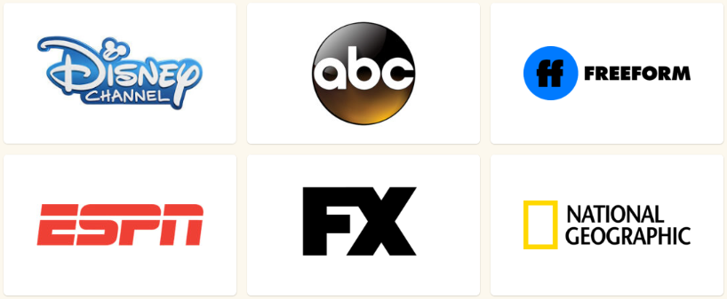**Media Networks (41.2% of Total Revenue)** is the primary unit of The Walt Disney Company that contains the company’s vast array of television networks, cable channels, associated production and distribution companies, and owned and operated television stations across two divisions – Walt Disney Television and ESPN.

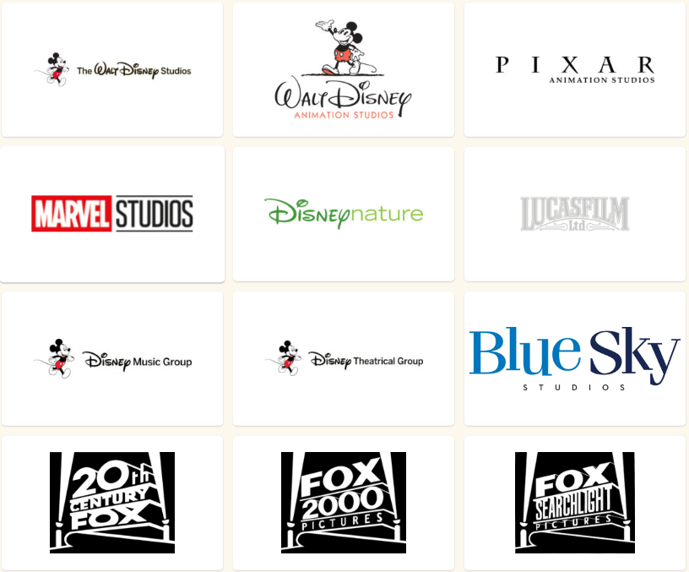

**Studio Entertainment (16.8% of Total Revenue)**

For over 90 years, The Walt Disney Studios has been the foundation on which The Walt Disney Company was built. Today, the Studio brings quality movies, music and stage plays to consumers throughout the world. The Studio Entertainment segment produces animated and live action motion pictures, direct-to-video programming, musical recordings, and live stage plays. The library of films is distributed under 5 banners namely Walt Disney Pictures, Touchstone Pictures, Pixar, Marvel, Lucasfilms and now 20th and 21st Century Fox. Just this quarter alone, between Disney and Fox, they received 37 Golden Globe nominations including ‘Best Picture’ for *Black Panther* and *Mary Poppins Returns*.

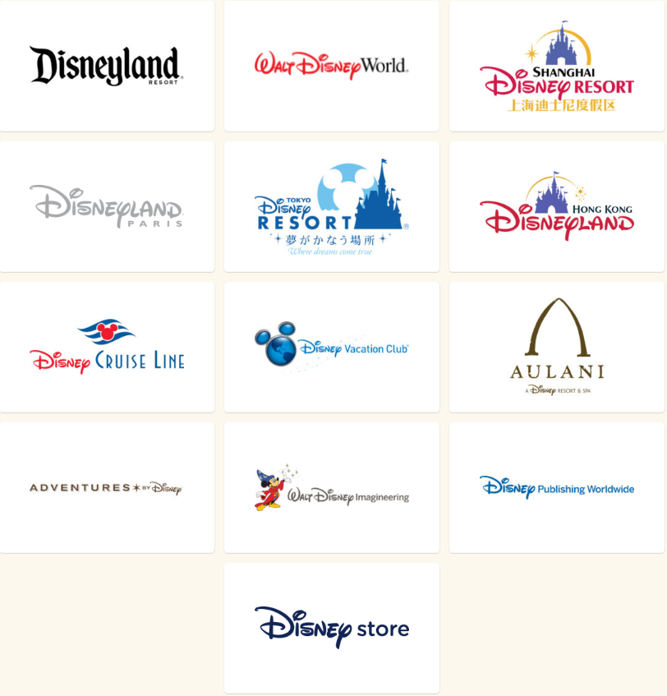**Parks, Experience and Products (34.1% of Total Revenue)** is the global hub that brings Disney’s stories, characters, and franchises to life through theme parks and resorts, cruise and vacation experiences, and consumer products—everything from toys to apparel, and books to video games.

Parks, Experiences & Products segment is a combination of global consumer products business with Parks and Resorts. Parks and Resorts owns and operates the Disney World Resort in Florida, the Disneyland Resort in California, the Disney Vacation Club, the Disney Cruise Line, and Adventures by Disney. The company also has ownership interests in Disneyland Paris, in Hong Kong Disneyland Resort and in Shanghai Disney Resort, and licenses the operations of the Tokyo Disney Resort in Japan. Consumer products business engages with licensees, manufacturers, publishers and retailers to design, develop, publish, promote and sell a wide variety of products based on existing and new Disney characters and other intellectual property via its Merchandise Licensing, Publishing and Retail businesses throughout the world.

**Direct-To-Consumer and International (7.8% of Total Revenue)**

Comprised of the Company’s international business units and various direct-to-consumer streaming services, Direct-to-Consumer and International (DTCI) aligns technology, global content sales and advertising sales into a single business segment to create and deliver personalized entertainment experiences to consumers around the world.

Direct-to-Consumer & International segment comprises Disney’s direct-to-consumer (DTC) streaming services (Disney+, ESPN+, Hulu and Hotstar), international media operations and global advertising sales and ad technology for Disney media properties including Freeform, ESPN, ABC and Disney Channels.

**RECENT DEVELOPMENTS**

Disney held an Investor Day on April 11 that was all about the company's direct-to-consumer (DTC) distribution plans. Management has repeatedly stressed that DTC is the company's highest priority. While competition from a surging Netflix makes DTC a must-have defensive strategy for Disney to remain relevant in the media marketplace, DTC could also become a driver of significant future growth. However, as management laid out at Investor Day, the costs to capturing market share in the growing video streaming business will be high.

Disney expects to launch its Disney+ streaming video service as the 'cornerstone' of the company's DTC strategy in the U.S. on November 12, 2019. Disney+ will join Disney's other two streaming services, the majority owned Hulu, and ESPN+ which launched in April 2018. Management made quite clear that it will be investing heavily in all three streaming services to produce and globally distribute the kind of high-quality video entertainment that could lure subscribers to these services.

The company is targeting between 60 million and 90 million Disney+ subscribers by the end of FY24 (September 2024) with the mix 1/3 domestic U.S. and 2/3 international. The Disney+ international roll out is expected over the coming years. Disney plans to invest about $1 billion in original content for Disney+ in FY20, ramping to about $2.5 billion by FY24. Licensed content expense is expected to be around $1.5 billion in FY20, ramping to $2.5 billion in FY24 though these license expenses will be intra-company. Total operating expenses for Disney+ are expected to be less than $1 billion in FY20, ramping as the service adds subscribers. Management forecasts Disney+ operating expenses to peak from FY20 through FY22 and forecasts profitability by FY24.

Disney+ will have a price point of $5.83 per month for an annual subscription, or $6.99 for a month-to-month subscription. This compares favorably to the Netflix $8.99 'Basic' monthly subscription and even more favorably to $12.99 'Standard' subscription. An Amazon Prime membership costs $8.25 per month and video streaming is essentially an add-on to that company's Prime free shipping service or $8.99 per month as an Amazon Prime Video stand-alone service. Disney+ will have the advantage of both new and library exclusive premium content from its Disney, Star Wars, Marvel, Pixar, and National Geographic studios.

They are also planning a discounted bundle price for all three of its streaming services which could make for an even more compelling offer as Disney's ESPN+ service provides exclusive sports viewing, something that neither Netflix nor Prime Video do. ESPN+ with 2 million subscribers already, can expect operating losses of $650 million in FY19 and FY20 and to break into profitability in FY23. Management projects that Hulu with 25 million paid subscribers will grow its subscriber base to 40 million to 60 million in FY24. Peak operating losses of $1.5 billion are expected from Hulu in the current FY19 with profitability in FY23 or FY24.

On April 15, AT&T announced that it had sold its 9.5% interest in Hulu (originally purchased by Time Warner) back to Hulu for $1.43 billion. This sale values all of Hulu at $15 billion. The remaining owners of Hulu, Disney at 60% and Comcast at 30% are to negotiate how to divide AT&T's interest though we think this is only preparatory to a sale of Comcast's interest to Disney also since Comcast already has no management interest in Hulu. Disney CEO Bob Iger, who confirmed his tenure will end in December 2021, has expressed an interest in acquiring all of Hulu. It appears that DTCI Chairman Keven Mayer is the heir apparent. However, much will depend upon the success of Disney's DTCI initiative and the traction that Disney+, Hulu, and ESPN+ are able to generate in the media marketplace.

**Industry Overview: Communication Services**

The Communication Services sector, developed by MSCI and S&P Dow Jones, launched on 9/24/18. The new sector delineation applies to all indices maintained by MSCI and S&P Dow Jones, including the S&P 500, as well as various domestic and global indices maintained by MSCI. The Communication Services sector accounts for 10.2% of the S&P 500, compared to 2.8% for Telecom in its final reading before the changeover.

The new sector includes two major subsectors: Media & Entertainment (80% of sector weight) and Telecommunications Services (20% of sector weight). Media & Entertainment includes Media (advertising, broadcasting, cable & satellite, and publishing); Entertainment (movies & entertainment, and interactive home entertainment); and Interactive Media & Services, which includes search & social media platforms. Telecom Services includes Diversified Telecom (alternative and integrated) and Wireless Telecom Services.

Given the lack of historical performance data for the new sector, S&P Dow Jones Indices performed pro forma back-testing over a 10-year period to determine the general characteristics of the new sector. The style mix is approximately one-third "value" and two-thirds "growth," while the Telecom sector was 100% value. The adjusted pro forma beta is approximately 1.1, compared to 0.7 for Telecom. The 10-year annualized total return for the sector on a hypothetical back-tested basis is 15.8%, compared to Telecom’s actual of 3.5%.

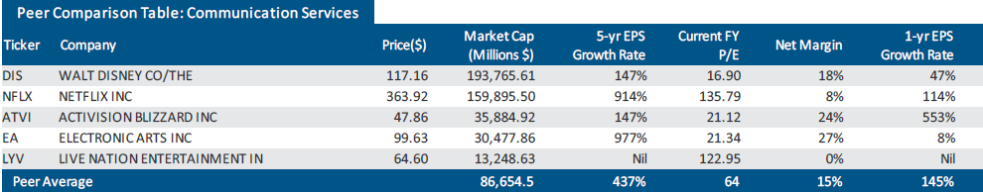

The chart below shows one year performance of Disney versus S&P 500 Index (SPX) and the Communication Services ETF (XLC). Disney has outperformed both indices over the past year by a significant margin.

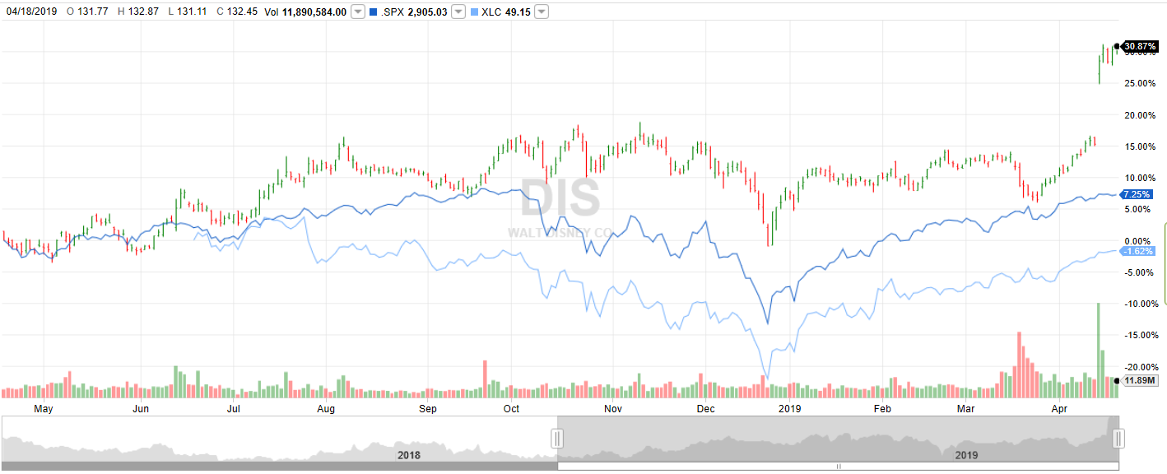

**Investment Thesis**

**CATALYSTS**

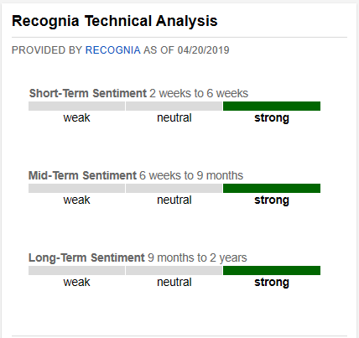The basis of our investment thesis is based on our belief that the below catalysts will drive future growth in the company and will generate returns above the cost of capital. There is also strong sentiment in the short, mid and long-term horizons as evidenced by Recognia based on its algorithm that tracks investor optimism and activity in the stock.

* **21st Century Fox Acquisition**
  + 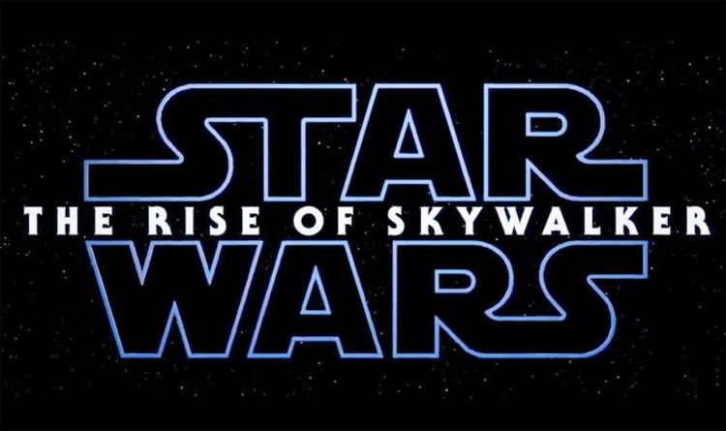Disney completed the acquisition of Twenty-First Century Fox on March 20, 2019. The majority of Fox’s assets acquired contribute greatly to Disney’s overall content portfolio. Fox’s television business is expected to help the company strengthen its TV slate globally, which has been facing some issues in terms of distribution or subscribers. Disney’s international footprint will increase substantially post acquisition. Notably, Fox Networks International operates above 350 channels in 170 countries, while Star India has 69 channels with 720 million viewers per month.
* **Impressive Slate of Big Budget Movies**
  + Disney’s Studio Entertainment segment has an impressive line-up of big budget movies slated to be released over the next 18 months. Movies expected to release in second-quarter fiscal 2019 include *Captain Marvel* and *Dumbo*. Additionally, future releases include *Avengers 4, Aladdin, Toy Story 4*, *The Lion King*, *Frozen 2*, and *Star Wars: Episode IX: The Rise of Skywalker*.
* **Direct-to-Consumer Media Streaming Services**
  + On November 12, 2019, Disney+ is launching in the United States and is expected to be launched in European markets soon afterwards. The termination of distribution agreement with Netflix will enable it to offer rich content exclusively from Disney, Pixar, Marvel, Star Wars, National Geographic and Lucasfilm. Additionally, users will have access to the company’s film and television library content, including all the theatrical releases starting with the 2019 slate. Apart from original content investments in Disney+, Disney is buying content from other providers such as CBS TV Studios to ramp up its content portfolio. Moreover, the company will continue to buy content from third-party providers to cater to consumer demand.
  + Disney already launched ESPN+ that is offering tournaments like Major League Baseball, National Hockey League, Major League Soccer, Grand Slam tennis, Italy's Serie A soccer and thousands of college sports for $4.99 per month. ESPN+ currently has 2 million paid subscribers. Notably, Disney’s deal to air UFC fights on the ESPN platform, both linear and over-the-top (OTT) helped it gain 600K users.
* **Robust Visitor Growth Rates at the Parks**
  + Parks & Resorts are primarily benefiting from the company’s strategy of better-load balancing of attendance throughout the year, which is driving up attendance rate. Moreover, the company’s continuing investment is reaping benefits. The segment continues to show robust performances domestically owing to rise in customer spending, higher ticket prices and average daily hotel room rates. With Star Wars Lands in Disneyland expected to be open in the summer of 2019, we believe this new addition will continue to boost the attendance rate.

**RISKS**

With any investment, there are risks associated with the business which need to be evaluated and addressed. Below we identified what could hinder our outlook for the prospects of the company.

* **Direct-to-Consumer Streaming Competition**
  + 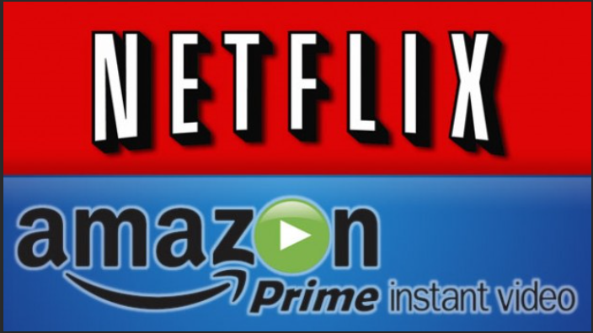Heavy investment in streaming services will hurt profitability for the next two to three years. Management noted that second-quarter 2019 operating income will have a negative impact of $200 million due to investments in ESPN+ and Disney+. Disney expects significant competition in the streaming market from Netflix and Amazon Prime Video as well as potential new entrants like Apple and Walmart. Although late to the game, Disney’s extensive programming library and future content should offset any delays of them entering the streaming environment. However, the large investment to their direct to consumer (DTC) strategy poses a serious risk if these new services are unable to gain traction with customers.
* **Cord-Cutting & Higher Programming Costs**
  + 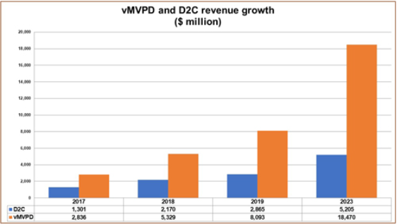Higher programming costs at ESPN were due to increases in contractual rates of a few sports programs, like the National Basketball Association (NBA) and National Football Association (NFL). Cord-cutting remains a significant concern for Disney’s cable network business, which also hurts advertising revenue growth. To counter the cord cutting, ESPN has been included in Dish’s Sling TV, AT&T DirecTV Now, Hulu, Sony’s PlayStation Vue, and YouTube TV, all of which are referred to as virtual multichannel video program distributors (vMVPDs). Currently, the vMVPD market is immaterial to Disney however, inclusion in them represents a hedge against their future growth and the shrinkage of the cable subscriber universe if the cord-cutter phenomenon accelerates, which according to the chart to the right, by 2023 revenue growth is expected to accelerate more than double for the vMVPD market. Yet, there is still risk in these services offering a ‘skinny bundle’ that excludes sports.

* **Tourism & Consumer Confidence**
  + Softness experienced in tourism in China negatively impacted Shanghai Disney Resort results and attendance. Increased cost at both Shanghai and Disneyland Paris affected the results for last quarter. If the slowdowns in China and Europe spread to the rest of the global economy, it will have an impact on overall spending for their Parks and Resorts segment as well as the other segments. Disney also increased its economic sensitivity through the reacquisition of Disney retail stores in North America and Japan.

* 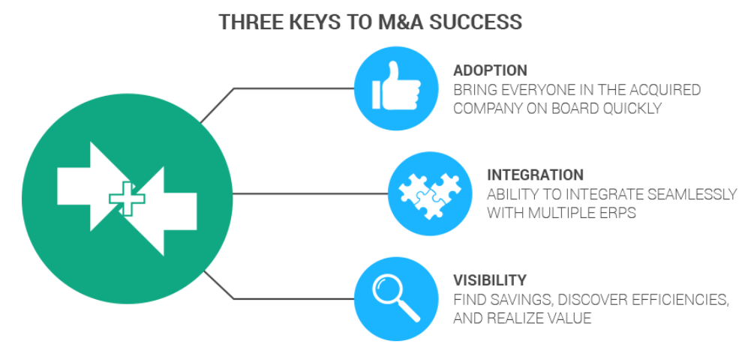**Acquisition Synergies Not Capitalized as Expected**
  + The 21st Century Fox acquisition could lead to integration challenges and major layoffs that don’t produce the expected $2 Billion in expected cost savings. A change of this type could give rise to a talent migration and reduction in staff productivity. Although Disney has shown robust management policies and programs, just by its sure size, diversified footprint and brand visibility, any transition issues could pose serious liability and reputation risks.

**Financial Analysis**

**Price Performance:**

The stock price of Disney has been range bound for the last few years, hovering between $95 and $115. This is primarily due to investors caution about the ESPN subscriber deteriorating numbers and whether or not the company was going to be able to respond to the disruption to the media landscape. We believe that the recent Investors Day helped to show that the company has a plan and subsequently we saw the stock break out of its range as it jumped to $132. As can be seen by the chart below, based on the stock’s highest and lowest expected p/e ratio over the past five years, there is a nice floor for the stock and significant upside.

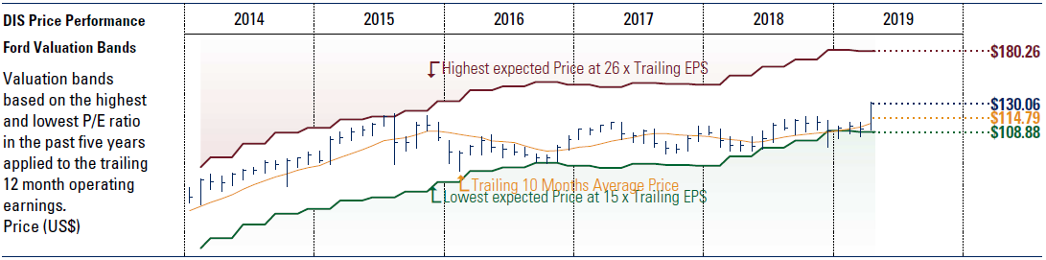

**Earnings Per Share Analysis:**

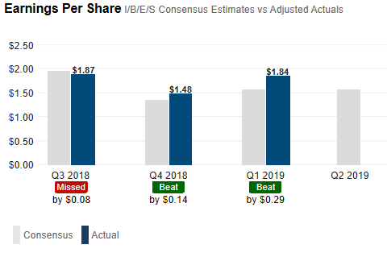Quarterly earnings per share have been a little mixed over the past year with Disney beating the consensus estimate that last two quarters but narrowly missing in Q3 of 2018. However, those numbers were actually higher than the last two quarters so we attribute that miss to slightly over-ambitious analyst expectations. The earnings have been solid for the company for a long time and the company generates over $8 Billion in free cash flow a year. Therefore, we are not too concerned about the occasion earnings miss.

**Ratio Analysis:**

As noted in the table below, Disney has some impressive ratios across the board. A number of them are also trending higher over the past 1, 3 and 5-year timeframe. While not every ratio is higher, a majority of them are and that helps to support our belief that the company has performed well over the past five years and should continue to perform well over the next five years.

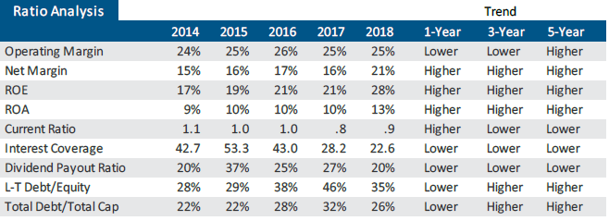 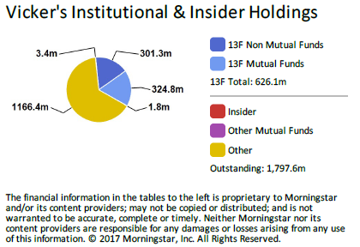

**Dividend Analysis**

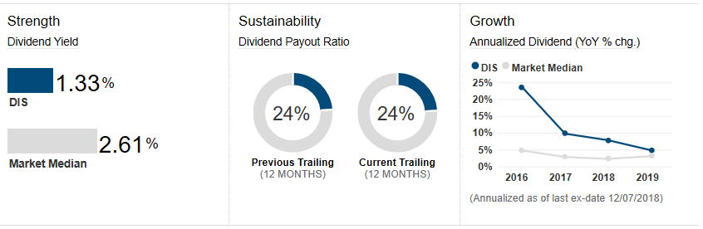Although Disney’s dividend is not all that impressive from a percentage or payout ratio, it is consistent. The company clearly believes that it can deploy its money better back into the business instead of paying it out in dividends. We feel this is a good long-term thinking corporate strategy and are not concerned about the size of the dividend.

**Competitor Comparison**

Although it is hard to come up with a company that parallels Disney in all of its business segments, we have compared them against other companies that have some similar operations. The company does not lead in every aspect but they are competitive pretty much across the board. It shows that the company is strong fundamentally.

|  |  |  |  |  |  |  |  |  |
| --- | --- | --- | --- | --- | --- | --- | --- | --- |
| In Millions of USD | DIS  Walt Disney | CMCSA  Comcast | NFLX  Netflix | DISCA  Discovery | CBS  CBS Corp | VIAB  Viacom | LYV  Live Nation | LGF-A  Lions Gate |
| Market Cap | 158.29B | 157.59B | 118.27B | 19.36B | 17.26B | 10.77B | 9.99B | 3.38B |
| Enterprise Value | 181.64B | 220.68B | 116.94B | 37.78B | 25.92B | 19.26B | 11.48B | 5.87B |
| Trailing P/E | 12.72 | 6.68 | 96.79 | N/A | 13.12 | 6.18 | N/A | 26.64 |
| Forward P/E | 14.14 | 12.37 | 65.19 | N/A | 7.99 | 5.93 | 116.32 | 25.56 |
| PEG Ratio | 2.10 | 0.73 | 1.63 | N/A | N/A | 1.13 | 30.36 | (2.10) |
| Price/Sales (ttm) | 2.66 | 1.79 | 7.94 | 2.01 | 1.20 | 0.83 | 0.90 | 0.84 |
| Price/Book (mrq) | 3.24 | 2.20 | 23.61 | 2.02 | 6.88 | 1.44 | 7.52 | 1.15 |
| Enterprise Value/Revenue | 3.06 | 2.50 | 7.85 | 3.62 | 1.80 | 1.49 | 1.03 | 1.46 |
| Enterprise Value/EBITDA | 10.18 | 7.65 | 68.24 | 10.81 | 8.26 | 6.40 | 16.46 | 12.34 |
| Profit Margin | 21.20% | 27.43% | 8.48% | (8.52%) | 9.42% | 13.28% | 0.15% | 3.30% |
| Operating Margin | 24.96% | 20.72% | 10.98% | 22.25% | 20.21% | 21.59% | 2.86% | 7.84% |
| Return on Equity % | 26.10% | 37.03% | 30.29% | (9.25%) | 52.25% | 24.55% | 2.69% | 3.93% |
| Return on Assets % | 9.54% | 5.92% | 5.07% | 4.77% | 8.10% | 7.36% | 2.44% | 2.22% |
| Dividend Yield | 1.62% | 2.12% | N/A | N/A | 1.58% | 2.99% | N/A | 1.62% |
| FCF | 8.06B | 8.73B | 8.19B | 4.2B | 2.19B | 5.92B | 563.59M | 2.81B |

**Valuation**

We used multiple methodologies in our attempt to value what Disney stock is truly worth. We looked at the past five years of financial data in order to help with our assumptions.

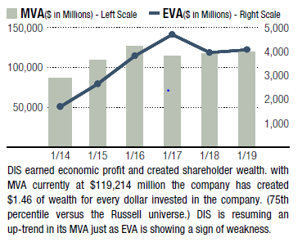

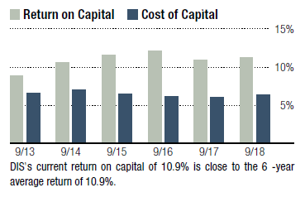

|  |  |  |  |  |  |
| --- | --- | --- | --- | --- | --- |
| In Millions of USD | 2014 | 2015 | 2016 | 2017 | 2018 |
| Revenue, Adj | [48,813.0](javascript:void(0);) | [52,465.0](javascript:void(0);) | [55,632.0](javascript:void(0);) | [55,137.0](javascript:void(0);) | [59,434.0](javascript:void(0);) |
| *Growth %, YoY* | [*8.4%*](javascript:void(0);) | [*7.5%*](javascript:void(0);) | [*6.0%*](javascript:void(0);) | [*(0.9%)*](javascript:void(0);) | [*7.8%*](javascript:void(0);) |
| Gross Profit, Adj | [22,393.0](javascript:void(0);) | [24,101.0](javascript:void(0);) | [25,768.0](javascript:void(0);) | [24,946.0](javascript:void(0);) | [26,708.0](javascript:void(0);) |
| *Margin %* | [*45.9%*](javascript:void(0);) | [*45.9%*](javascript:void(0);) | [*46.3%*](javascript:void(0);) | [*45.2%*](javascript:void(0);) | [*44.9%*](javascript:void(0);) |
| EBITDA, Adj | [13,828.0](javascript:void(0);) | [15,578.0](javascript:void(0);) | [17,014.0](javascript:void(0);) | [16,770.0](javascript:void(0);) | [17,848.0](javascript:void(0);) |
| *Margin %* | [*28.3%*](javascript:void(0);) | [*29.7%*](javascript:void(0);) | [*30.6%*](javascript:void(0);) | [*30.4%*](javascript:void(0);) | [*30.0%*](javascript:void(0);) |
| Net Income, Adj | [7,501.0](javascript:void(0);) | [8,382.0](javascript:void(0);) | [9,391.0](javascript:void(0);) | [8,980.0](javascript:void(0);) | [12,598.0](javascript:void(0);) |
| *Margin %* | [*15.4%*](javascript:void(0);) | [*16.0%*](javascript:void(0);) | [*16.9%*](javascript:void(0);) | [*16.3%*](javascript:void(0);) | [*21.2%*](javascript:void(0);) |
| EPS, Adj | [4.26](javascript:void(0);) | [4.90](javascript:void(0);) | [5.73](javascript:void(0);) | [5.69](javascript:void(0);) | [8.36](javascript:void(0);) |
| *Growth %, YoY* | [*26.0%*](javascript:void(0);) | [*15.0%*](javascript:void(0);) | [*16.9%*](javascript:void(0);) | [*(0.7%)*](javascript:void(0);) | [*46.9%*](javascript:void(0);) |
| Current Ratio | [1.1x](javascript:void(0);) | [1.0x](javascript:void(0);) | [1.0x](javascript:void(0);) | [0.8x](javascript:void(0);) | [0.9x](javascript:void(0);) |
| Return on Equity % | [16.6%](javascript:void(0);) | [18.3%](javascript:void(0);) | [20.4%](javascript:void(0);) | [20.0%](javascript:void(0);) | [26.1%](javascript:void(0);) |
| Return on Assets % | [8.7%](javascript:void(0);) | [9.6%](javascript:void(0);) | [10.0%](javascript:void(0);) | [9.3%](javascript:void(0);) | [9.5%](javascript:void(0);) |
| Dividend Per Share | [$ 1.15](javascript:void(0);) | [$ 1.37](javascript:void(0);) | [$ 1.49](javascript:void(0);) | [$ 1.62](javascript:void(0);) | [$ 1.72](javascript:void(0);) |
| FCF | [6,063.5](javascript:void(0);) | [6,667.0](javascript:void(0);) | [8,718.4](javascript:void(0);) | [9,017.5](javascript:void(0);) | [8,056.1](javascript:void(0);) |

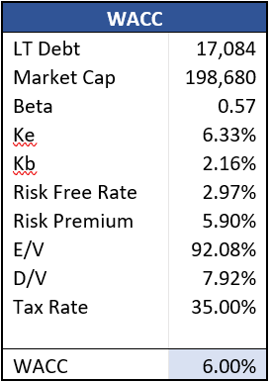

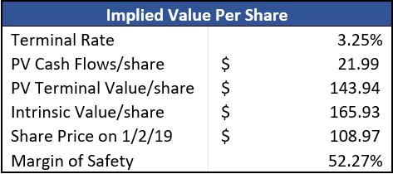Using the Discounted Cash Flow (DCF) model, as shown in Appendix C, we come up with an intrinsic value of $165.93 using a terminal rate of 3.25% and a WACC of 6% as calculated at right. Based on the share price prior to our investment decision, we were comfortable that there was a significant margin of safety in our stock selection so downside risk was greatly reduced. Additionally, we did a sensitivity analysis, see Appendix E, where we changed our assumptions on the WACC and terminal rate, going above and below our initial assumptions. Even using a lower terminal rate and a higher WACC, it still showed an intrinsic value of $124.43 which leaves a 14% margin of safety off of the share price at investment.

Using the Comparable Companies Model, as shown in Appendix D, we see that the median P/E ratio is 13.4x. If we apply this to Disney, it would give us an implied price of $118.55 or 8.8% upside to the stock price of $108.97 at time of investment decision. However, since Disney is really does not have other companies that it is truly comparable to, it made more sense to use it’s own historical P/E ratio to determine its implied stock price. As can be seen in the graph, if we use Disney’s five year historical P/E of 18.67, we get an implied stock price of $156.08 or a 43.23% upside. This is also more in line with our DCF implied price of $165.93.

**Conclusion**

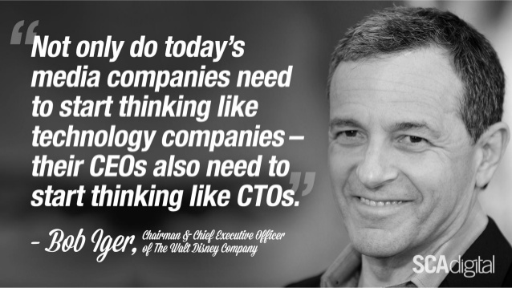In conclusion, we believed, based on our thorough analysis, that the three to five-year outlook for Disney stock was poised for substantial appreciation when we purchased 1,070 shares back on January 25, 2019. We have already seen nearly a 20% increase in stock price since purchasing (up from $111 to $132) and believe there is continued upside potential based on the drivers mentioned previously. Assuming the company continues to heed the words of Bog Iger here, we are confident that our investment will reach or exceed our price target of $156 within the next year.

**Appendix A: Quarterly Financials - Balance Sheet**

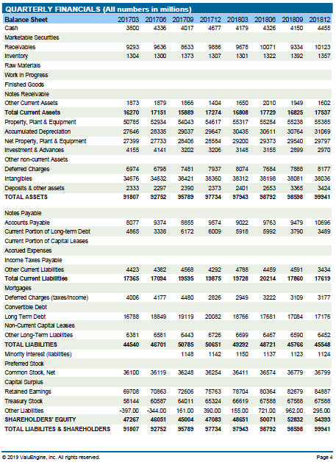

**Appendix B: Quarterly Financials - Income Statement & Cash Flow Statement**

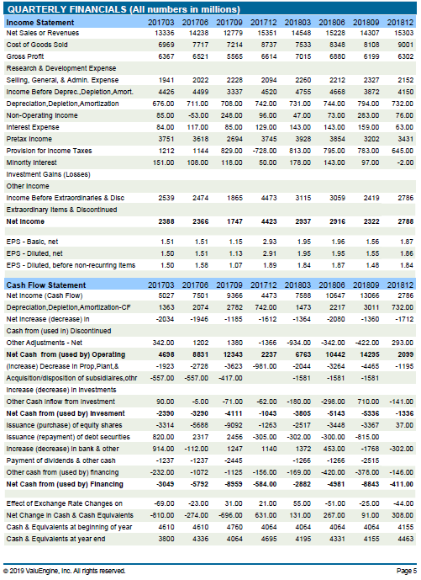

**Appendix C: Discounted Cash Flow Model**

|  |  |  |  |  |  |
| --- | --- | --- | --- | --- | --- |
| **Disney (NYSE:DIS)** |  |  |  |  |  |
| ($MM) | **2014** | **2015** | **2016** | **2017** | **2018** |
| NOPAT | 7,386 | 8,318 | 9,185 | 8,854 | 9,273 |
| Invested capital | 11,104 | 14,206 | 16,712 | 16,789 | 17,243 |
| Return on invested capital | 66.5% | 58.6% | 55.0% | 52.7% | 53.8% |
| Working Capital | 1884.00 | 424.00 | 124.00 | -3706.00 | -1035.00 |
| Change in WC | -521.00 | -1460.00 | -300.00 | -3830.00 | 2671.00 |
| CAPEX | 3315.00 | 4272.00 | 4768.00 | 3630.00 | 4440.00 |
| Dep & Amort | 2288.00 | 2354.00 | 2527.00 | 2782.00 | 3011.00 |
| FCF | 6879.60 | 7859.90 | 7243.76 | 11836.40 | 5173.13 |
| **FCF per Share** | **4.047** | **4.912** | **4.527** | **7.891** | **3.495** |
|  |  |  |  |  |  |
|  |  |  |  |  |  |
| Revenue | 48813 | 52465 | 55632 | 55137 | 59434 |
| OP Margin | 23.60% | 25.20% | 26.00% | 25.40% | 25.00% |
| EBIT | 11540.00 | 13224.00 | 14487.00 | 13988.00 | 14837.00 |
| Tax | 36.00% | 37.10% | 36.60% | 36.70% | 37.50% |
| NOPAT | 7385.6 | 8317.9 | 9184.8 | 8854.4 | 9273.1 |
| Total Shares Outstanding | 1700.00 | 1600.00 | 1600.00 | 1500.00 | 1480.00 |
| Capital Exp per Share | 1.95 | 2.67 | 2.98 | 2.42 | 3 |

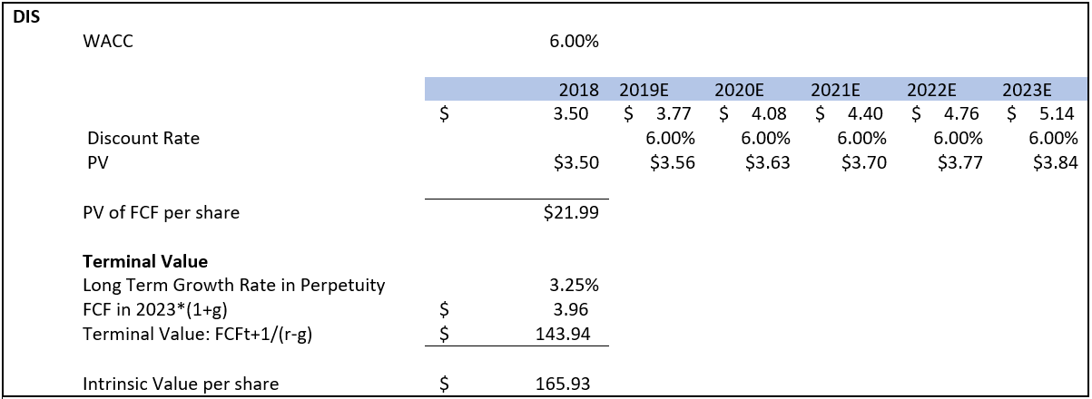



**Appendix D: Comparable Companies Model**

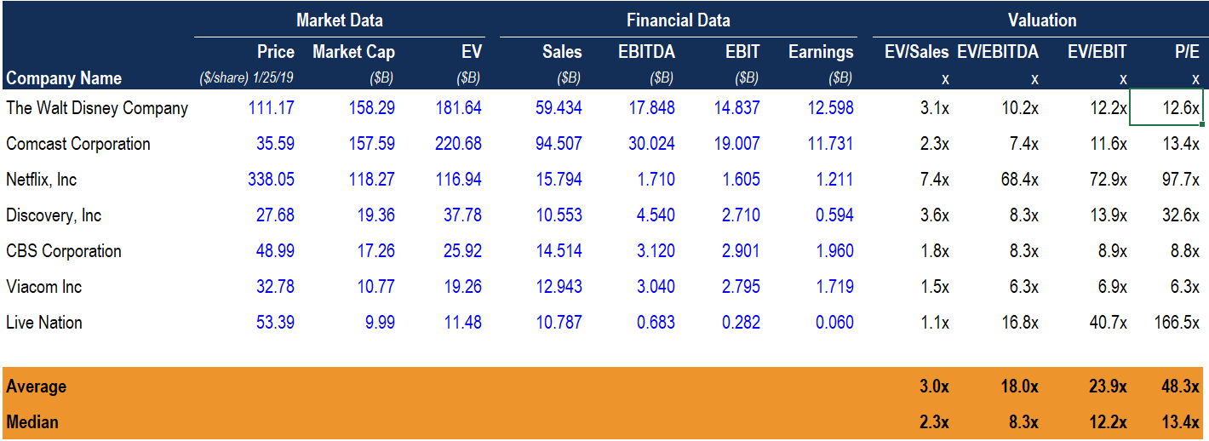

**Appendix E: Sensitivity Analysis**

|  |  |  |  |  |  |  |
| --- | --- | --- | --- | --- | --- | --- |
|  |  | **Weighted Average Cost of Capital** | | | | |
|  |  | 5.50% | 5.75% | 6.00% | 6.25% | 6.50% |
| **Terminal Value Rate** | 2.75% | $ 169.08 | $ 155.13 | $ 143.21 | $ 133.20 | $ 124.43 |
| 3.00% | $ 184.15 | $ 167.57 | $ 153.62 | $ 142.06 | $ 132.04 |
| 3.25% | $ 202.58 | $ 182.50 | $ 165.93 | $ 152.39 | $ 140.81 |
| 3.50% | $ 225.61 | $ 200.75 | $ 180.69 | $ 164.60 | $ 151.05 |
| 3.75% | $ 255.22 | $ 223.57 | $ 198.73 | $ 179.26 | $ 163.15 |

**Appendix F: Sources Used**

*Disney 10-K,* Disney Investor Relations

*Disney 10Q,* Disney Investor Relations

*Disney’s 2018 Fiscal Full Year and Q4 2018 Earnings,* Disney Investor Relations

*Disney’s 2019 Investor Day Presentation,* Disney Investor Relations

*Media and Telecom Disruption Mind Map,* Patrick Terrion PowerPoint Presentation

Argus Research Company

Bloomberg

Columbine Capital Services

Disney Websites

Fidelity Investor Platform

Ford Equity Research

ISS-EVA

Morningstar Inc.

S&P NetAdvantage

ValuEngine, Inc.

ValueLine

Yahoo Finance Website

Zacks Equity Research