|  |
| --- |
| **Investment Thesis** |
| ■ Attractive risk reward with large scale growth through successful development strategies |
| ■ Increased demand for products and services due to extensive market presence |
| ■ Increases in volume growth, and margin expansion over the long term supported by service improvements and efficiency initiatives |
|  |
| **Value Drivers** |
| ■ Strong Market Presence as a dominant force in the railroad industry |
| ■ Increased spending for the development of future efficiencies through Plan 2020 |
| ■ Committed leadership with a focus on development of productivity and efficiency of rail cars and locomotives |
|  |
| **Catalysts** |
| Potential catalysts could include ongoing progress towards the company's productivity targets. Trends in freight demand, fuel, and foreign exchange prices are additional potential catalysts. |
|  |

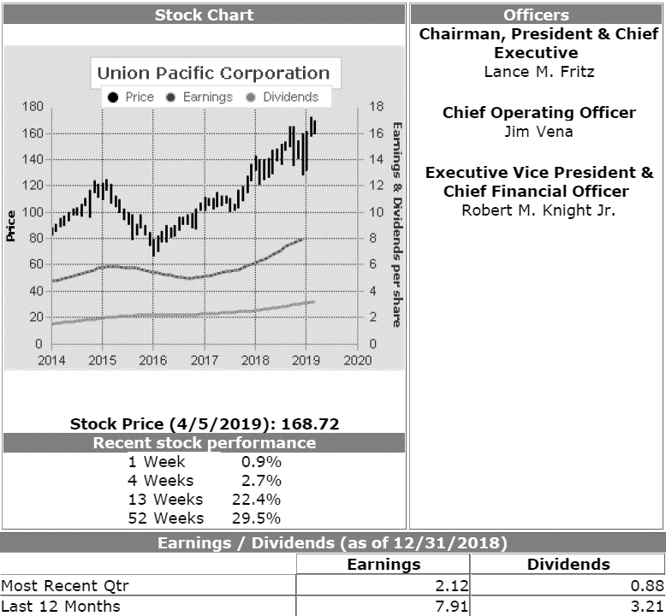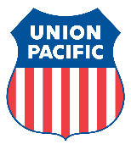

Valuation Date: 26/10 /2019

Valuation Target Price: $169.62

Price at Purchase: $141.34

Purchase Date: 11/2/2018

Percentage Increase: 21.62%

**Union Pacific Corporation (NASDAQ: UNP)**

**Industry: Transportation – Railroad Holding BUY Valuation as of April 24, 2018**

Union Pacific Corporation is a railroad operating company in the United States. The company’s business mix is comprised of Agricultural Products, Chemicals, Coal, Automotive, Intermodal, and Industrial Products. These operations are controlled by its principal operating company, Union Pacific Railroad Company (UPRR). Their freight operations are primarily divided in to three categories: bulk, manifest, and premium

**BUSINESS DESCRIPTION**

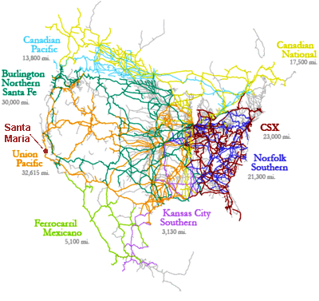Union Pacific Corporation is a railroad operating company in the United States. The company’s business mix is comprised of Agricultural Products, Chemicals, Coal, Automotive, Intermodal, and Industrial Products. These operations are controlled by its principal operating company, Union Pacific Railroad Company (UPRR). Their freight operations are primarily divided in to three categories: bulk, manifest, and premium business. Its bulk freight is comprised of oil shipped in unit trains--trains transporting a single commodity from one origin to one destination. Manifest traffic refers to the company’s operations of freight that is less that a train load and primarily involves commodities such as lumber, paper, chemicals, and foods. Finally, its premium freight consists of the transport of finished products as well as containers and auto-parts. As of December 2016, the company’s rail networks consisted of over 32,070 miles that linked major areas of the Midwest and Eastern United States to ports on the Pacific and Gulf Coast.

**MANAGEMENT**

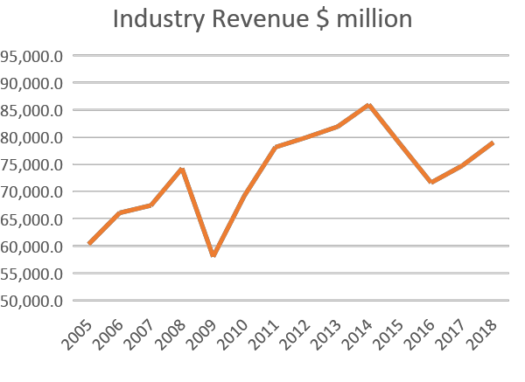The company is helmed by Mr. Lance M. Fritz who is their current Chairman, President and Chief Executive Officer. Fritz who was appointed into his role in 2015, is a veteran of the railroad industry and has worked with the company since 2000. He is well acquainted with the need to develop a profitable organization while continuously returning value to shareholders as well. The company is also led by two other notable figures namely Executive Vice President and Chief Financial Officer Robert M. Knight Jr. and Chief Operating Officer Jim V. Vena. Knight joined the firm in 1980 and was recently named a top CFO by WSJ in the Institutional Investor rankings. Vena was named COO in January 2019. He is leading the Unified Plan 2020 implementation. Prior to joining Union Pacific, he was an Executive VP and COO at Canadian National (CN) and retired in 2016 after a 40-year tenure there. While at CN he was known for achieving the rail industry’s best operating ratio.

**INDUSTRY OVERVIEW**

The railroad industry is defined by strong concentration, high barriers to entry, and stability. The companies are divided into Class I, which handles the majority of U.S. freight activity and Class II, the smaller companies that handle local lines. There are 7 Class I railroads in the United States: BNSF, Kansas City Southern, Union Pacific, Soo Line Railroad, Grand Trunk, CSX and Norfolk Southern. Of these, only Union Pacific and BNSF cover the western two-thirds of the United States past the Mississippi River. Railroads are primarily used for transporting materials used by the mining industry, automobile manufacturing, coal and natural gas, and petrochemical manufacturing. They manage both line-haul and short-line railroads. Rail transportation is privately funded, meaning capital investments are not directly linked to U.S. government budget constraints. Since 1980, $525 billion of private funds ($0.40 per dollar generated through operations) have been reinvested in the rail network.

CAGR = 5.7% U.S. railroads

demand for freight transportation

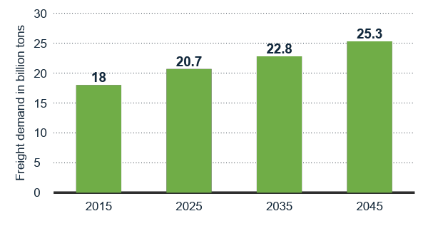**COMPETITIVE ANALYSIS**

BNSF (Burlington Northern Santa Fe) is Union Pacific’s main competitor; the companies have a duopoly on all transcontinental freight rail lines in the Western U.S. BNSF is not publicly traded by itself because it is a wholly owned subsidiary of Berkshire Hathaway. The company tends to do well in economic downturns. UNP competes with trucks who have an advantage in transit times, although railroads have an advantage in fuel efficiency and cost. UNP owns 80% of the refrigerated boxcar fleet in North America, which gives them a comparative advantage transporting perishable agricultural goods.

U.S. railroads' projected demand for transportation from 2015 to 2045 (in billion tons)

Union Pacific moves more products across the border than all other competitors combined. Their unique franchise has the industry’s best access to Mexico as the Company is the only railroad that serves all six major rail gateways between the U.S. and Mexico. Cross-border traffic with Mexico comprised approximately 11 percent of UP’s total 2017 volume.

**SALES ANALYSIS**

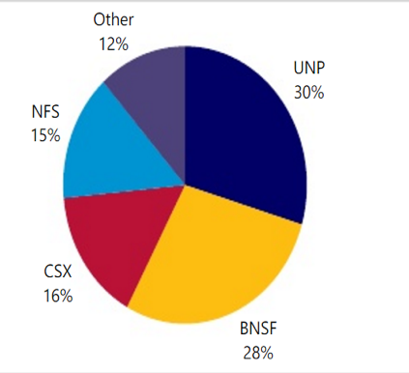As of the fourth quarter of 2018, the company reported total sales of $5.76 billion reflecting a growth of 5.6% compared to the $5.4 billion reported at the same time in the previous year and is a trend that has been reflected over the past 8 quarters of the company’s filings. For the year ended December 2018, the company reported total sales of $22.3 billion an increase of 7.5% (largest increase in its peer group) from its total reported sales of $21.24 billion in 2018. In fact, these figures are fairly close to its record number of $21.96 billion reported in 2013. Given its current employment of 41, 967 employees, and the company reports about $544,047 of sales dollars per employee.

**RECENT STOCK PERFORMANCE**

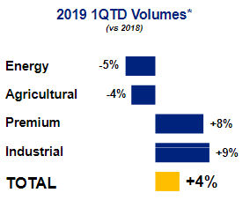The company has continuously appreciated over the last three years (at the end of 2015 it was at $78.20). More recently, the stock was up 29.5% to $168.72 in the 52 weeks ending 4/5/2019. And in the past 13 weeks, it has appreciated by 22.4%. The company currently has a Price/Earnings ratio of 21.33 according to its $7.91 per share earnings as of 12/31/2018. This represents an increase of 30.7% in year over year growth. Interestingly, the 21.3 P/E ratio of the company is the highest of its peer group which currently trade anywhere between 11.3 to 20.2 times earnings. In using a sales multiple, the company currently trades at 5.34 times sales, surpassing the peer group range that extends between 2.68- and 4.97-times sales. Furthermore, in using a price to book ratio, the stock trades at 5.99 times book value that also higher than the peer group range of 2.68 to 4.97 times book value. These stand testament to the market’s value of and confidence in the current and future outlook of the firm compared to its competitors.

U.S. Market Share

**DIVIDEND ANALYSIS**

As of the 12 months ending 12/31/2018, the railroad giant has paid a total of $3.21 in dividends per share resulting in a dividend yield of 1.9% with a stock price of $168.72. This stands testament to the company’s superiority relative to its three national peers who pay dividends between 0.6% and 1.7% of their stock price. The firm has consistently increased its dividend over the past 5 calendar years (dividends in 2013 were $1.48 per share) and more recently declared and paid dividends of $0.88 for the quarter ended 12/31/2018. They have a dividend payout target of 40 to 45% and have had 4 dividend increases in the past 6 quarters.

**PROFITABILITY ANALYSIS**

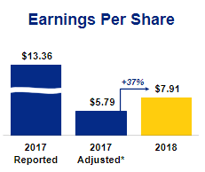Aside from a strong dividend and equity performance, the company also boasts a strong profitability margin that they have cultivated over time. In 2018, they reported a gross profit of 51.4% of sales with cost of goods sold totaling $11.10 billion or 48.6% of the reported $22.83 billion in sales. This gross profit was slightly better than their previous year’s figures where cost of goods sold was 48.7% of sales. In 2018, their EBITDA ratio was the same as the previous year’s as well as their peer group’s ratios at a total of $10.71 billion of 46.9% of sales. Profitability was also emphasized in their return on equity, which grew marginally from 24% in 2017 to 24.3% in 2018.

**INVENTORY ANALYSIS**

The company’s inventory totaled $742.00 million in 2018. Given the $11.10 billion cost of goods sold for the year, the company had approximately 23 days of inventory on hand or turned inventory over approximately 15 times a year. This reflects a slight improvement since 2017, Union Pacific reported inventory of $749.00 million, which was equivalent to 26 days in inventory.

**FINANCIAL POSITION**

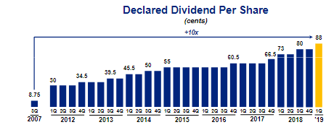This company has increased in value consistently for the past 3 years. The P/E ratio of 21.3, price to book value and price to sales values show that the market is valuing this company at higher multiples than many of its competitors. At the end of 2018, Union Pacific had negative working capital form its liabilities of $4.65 billion and current assets of $4.16 billion. The long-term debt to equity ratio of the company is 1.02. Operating improvements and the changes under the Plan 2020 have made their financial position more attractive.

**BARRIERS TO ENTRY**

**Capital**

Large amounts of Capital are required to establish a railroad network and to purchase locomotives. According to the American Association of Railroads (AAR), railroads typically have a capex-to-revenue ratio of 17% compared to 3% for U.S. Manufacturers.

**Internal Competition**

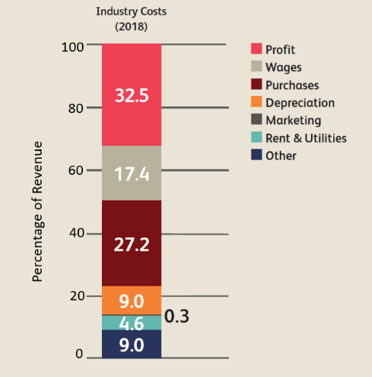Railroads compete on travel time, fuel consumption, safety, regulations, and destinations. It is difficult, if not impossible, to replicate the level of competition that railroads currently operate at. In addition, the company’s dominance of rail networks that span the nation is almost impossible to replicate even by other competitors in the industry.

**COSTS**

**Fuel**

Fuel is the Rail Transportation industry’s primary purchase. Railroads have a significant advantage over truckers because of their ability to implement fuel surcharges that essentially passes the excessive costs on to their customers.

**Wages**

Wages as a percentage of revenue have grown from 17.3% in 2013 to 17.4% in 2018. This is mostly because industry operators have maintained high wages despite falling revenue and decreased employment levels, which has led to a slightly increased average wage. It is notable that during the five-year period, there have been steady capital investments, which have increased employee productivity and has permitted high wages to be maintained.

**Depreciation**

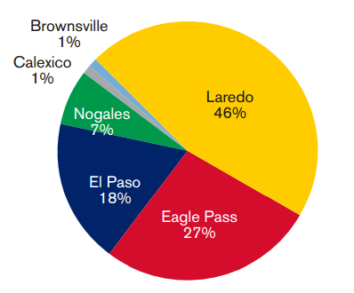 It is estimated that that rental expenses and utilities account for 4.6% of industry revenue in 2018, decreasing over the past five years due to fewer product shipments and lower lease expenses. Depreciation has been a growing expense for industry operators following strong investment in infrastructure by Class 1 railroads.

**GROWTH OPPORTUNITIES IN MEXICO**

**Mexico Direct**

An all-rail, seamless option, offering intermodal service between the U.S. and Canada, and major Mexican markets. With Mexico Direct, shipments do not stop at the border for customs clearance. Instead, they travel in-bound, clearing customs at interior Mexican origins and destinations. Mexico Direct offers a through-rate structure that provides customers the convenience of a single price and a single bill for their ramp-to-ramp shipments to and from Mexico

**Border Direct**

Service to and from the U.S. / Mexico border. Union Pacific’s intermodal network provides expanded access to markets across North America, utilizing four Union Pacific border gateways. Intermodal Marketing Companies (IMCs) monitor the customs clearance process at the border, eliminating the need for customers to do so and making the customs process simple and efficient.

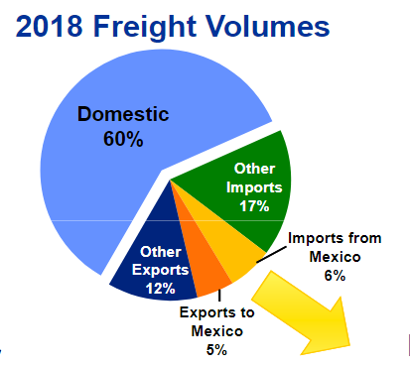

**Loup Passport**

A door-to-door intermodal freight transportation solution for customers throughout Mexico, backed by one of the industry’s largest intermodal container fleet and Loup’s (a Union Pacific subsidiary company) extensive drayage network. Shipments clear customs at the border, are serviced to, and from Union Pacific’s border terminals, including Laredo and El Paso, Texas; and Nogales, Arizona, with drayage in and out of Mexico.

**CATALYSTS**

**Spending to Save**

Capital expenditures made over the past few years and the replacement of older, less fuel-efficient locomotives should boost UNP’s profit margin.

**Traffic Gains**

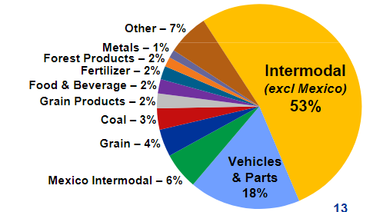BNSF has experienced slower train speeds and serious capacity constraints. Combined with rising fuel prices, UNP will likely see market share gains from BNSF and trucking and have the opportunity to raise prices.

**Rising Fuel Prices**

Crude oil is a major component of diesel fuel and therefore drives fuel expenses. UNP offsets these expenses through fuel surcharges that are passed on to the consumer. When oil prices rise, truckers become less attractive and goods are then shipped by rail. This also has the risk of lowering fuel consumption in the medium term.

**RISKS**

**Concerns over Industry Consolidation**

Although previous mergers have not been successful, UNP’s dominant track network could come under increased competition particularly from competitors who have started to increase spending on track development and maintenance.

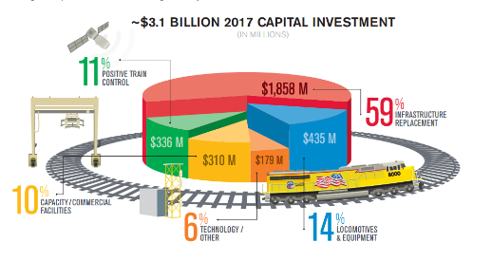**Fewer Opportunities to move Crude-by-Rail**

Substitution of transportation methods from rail to pipeline of one of UNP’s largest transported commodities does not look as favorable when compared to competitors. Its largest market of Bakken oil is expected to remain under pressure in the near term.

**Unfavorable Regulatory Environments**

Given increased government scrutiny of derailments, stricter regulation over train velocities when passing through city centers is expected. Major rail corridors are already crowded – increased regulation could further slow cargo movement, leading to inefficiencies and loss. Incremental adjustments in rail regulation, and the time it takes to respond to those changes could negatively affect the pace of UNP’s pricing gains.

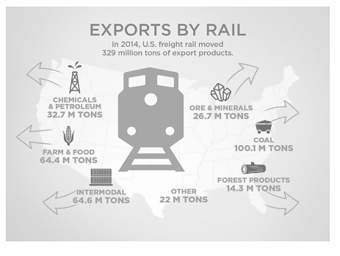**The crash of 2015--What happened and will it happen again?**

UNP dropped 35% due to weakness in key segments such as coal and intermodal. Natural gas traded at $2.40/MMBtu, lower than the $2.50/MMBtu threshold that encouraged utilities to switch to gas from coal, indicating that coal volumes would have decline for UNP Electric utility companies in the U.S. were expected to retire 5,430 MW worth of coal capacity this year, which presented another tailwind for UNP’s coal business.

Transporting goods directly via the road looked more economical as compared to intermodal, which would have created more pressure on UNP’s intermodal business which accounts for 20% of revenue.

Coal prices have since completely rebounded and forecasted increases in exports to China and India have supported coal volumes.

**INTERNATIONAL TRADE**

“Unless international trade collapses, which we suppose is at least a remote possibility, this year (2018) will almost certainly be a record year for U.S. intermodal,” the AAR says.

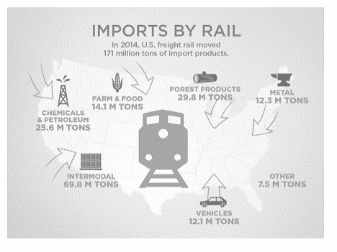Some trends in international trade are the off shoring or near shoring of U.S. manufacturing. Low natural gas prices favor U.S. plastics production. Steel, grain and coal are negatively impacted by a strong U.S. dollar while positive impacts come from international intermodal.

Global crop supply and commodity prices influence demand for trains.

**Plan 2020 Ensuring Continued Development for Railroad Franchise Improvement**

The first three phases of Plan 2020 are complete and despite weather challenges, the network is beginning to regain fluidity. The operating footprint has been streamlined with terminal rationalization improvements. This has included ceasing hump operations at two yards and reducing activity in other yards. This will affect their train schedule and terminal network.

**BROAD NETWORK**

UNP’s unique broad and extensive network not only creates a competitive advantage from a logistical standpoint but also creates a natural hedge against commodity risk, given the wide variety of cargo they ship. They have been expanding their network over the past few years to better serve their customers.

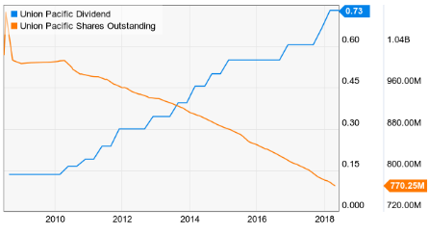

**COST EFFICIENCIES**

With the lowest operating ratio in its class and industry-leading metrics, in net profit margin, ROE, and asset turnover, management has been able to successfully leverage their huge asset base to drive revenues and manage costs well. Their efficiency has been further evidenced through their margin expansion as well as revenue growth in shifting the focus of operations from moving trains to moving cars minimizing car dwell, car classification events, and locomotive power requirements balancing train movements to improve the utilization of crews and rail assets utilizing general-purpose trains by blending existing train services.

**VALUE CREATION**

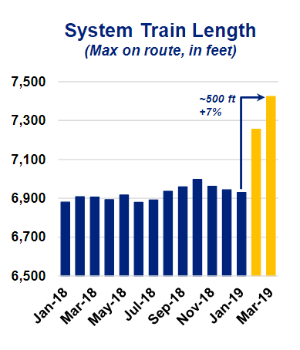

Apart from margin expansion and solid growth, UNP focuses on returning value to shareholders in a multitude of ways including growing dividend rates and implementing an accelerated share repurchase program. Since 2007, they have repurchased 38% of outstanding shares. Starting April 1, 2019, they executed the accelerated share repurchasing program where they plan to acquire 150 million shares. Since 2018, they have acquired $3.8B in shares. Union Pacific has improved its core operating metrics over the past 5 years to become an industry leader, solidifying its place as the best Tier 1 US railway.

Year over year there has been improvement in freight car terminal dwell, freight car velocity, and train speed. As they rebound from weather changes in the remaining quarters of 2019, key performance indicators such as locomotive productivity, workforce productivity, and car trip plan compliance will all be monitored closely and improved upon. There is a focus on asset utilization and minimizing car classifications. For their operating outlook, they want to focus on safety, network efficiency, and service reliability.

According to Union Pacific, their 2019 outlook includes low single digit volume growth, continuing pricing gains in excess of inflation dollars, capital expenditures of around $3.2 Billion, and significant productivity savings of $500M. They also want their operating ratio to be below 60% by 2020.

They are creating new and expanded facilities with access to prime locations and have regional experts connecting customers to the network. Specifically, there will be changes made at three different terminals for network changes. UNP’s quarterly report spells out the modifications and mentions how they will help the lines act more efficiently.

**INVESTMENT RATIONALE**

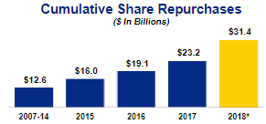

Our price target of $169.62 was derived from favorable sector fundamentals to drive step-function increase in free cash flow (and shareholder returns). Our constructive outlook on the rail sector is based on the industry’s unique characteristics: 1) limited and rational competition; 2) high barriers to entry; and 3) sustainable demand. We expect these attributes to drive real rate increases, volume growth, and margin expansion over the long term supported by service improvements, efficiency initiatives, and the implementation of smart technology. With stable capital expenditure requirements and clean balance sheets, we believe that the industry is positioned to generate increasing free cash flow that will in turn drive up shareholder returns through sustained growth in dividends and share repurchases.

A well-diversified asset base, attractive overall earnings and lower-than-average volatility. UNP’s competitive dynamics--unparalleled access to Mexico and the chemicals sector in the U.S. Gulf Coast, and diversified revenue stream as well as our belief that management is taking the necessary steps towards implementing Precision Scheduled Railroading make UNP shares an attractive investment opportunity.

**PORTER’S FIVE FORCES**

**Threat of New Entrants—Low**

High capital costs to develop the extensive railroad networks.

Economies of scale developed through having a nation-wide network of lines.

Large network for long-distance shipping hard to replicate for new entrants.

**Threat of Substitutes—Moderate**

Land, ocean and air travel are substitutes that have some advantage for certain goods such as personal consumption and perishables.

Advantage to shipping freight in bulk. Railroads can ship commodities such as gains and coal in long cars.

Cost effective and timely to use railroads when shipping many bulk goods.

**Supplier Bargaining Power—High** There are only two main locomotive suppliers, which gives them a higher bargaining power. The railroad maintenance industry is highly regulated which makes the opportunity for new entrants low.

**Buyer Bargaining Power—Moderate**

There is high concentration in the industry among the largest 4 companies: UNP, BNSF, CSX, and NFS.

Demand industries have few choices for how to transport their goods because they are in bulk.

**Buyer Bargaining Power—Moderate**

There is high concentration in the industry among the largest 4 companies: UNP, BNSF, CSX, and NFS.

**Competitive Rivalry—High**

The railroad companies compete on travel time, fuel consumption, efficiency ratios and safety regulations, however the railroads have different territories that they cover so a supplier may only have a few options when looking for a railroad.

**Appendix 1 » Management**



**Lance M. Fritz**

Chairman, President and Chief Executive Officer

Chairman, President and CEO since 2015. He has been working at UNP since

2000. He was paid $17M in 2017, 67% in stock.



**Robert M. Knight, Jr.**

Executive Vice President and Chief Financial Officer

Executive VP and CFO, has worked for UNP since 1980. He was named a top CFO by WSJ and in the Institutional Investor rankings.



**Jim V. Vena**

Chief Operating Officer

Vena was named COO in January 2019. He is leading the Unified Plan 2020 implementation. Prior to joining Union Pacific, he was Executive VP and COO at Canadian National (CN) and retired in 2016 after 40 years there. While at CN he achieved the rail industry’s best operating ratio.

**Appendix 2 » Commodity Group Mapping**

**Agricultural Products**

Grain and grain products, food & beverage, and fertilizer. In 2019 agricultural products are down 4% due to some trends we see in the markets; higher grain inventories, and low food and refrigerated shipment demand.

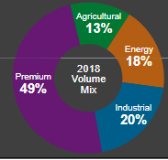

**Energy**

PRB coal, other coal, frac sand, petroleum and LPG and renewables. Through February 2019, their energy products are down 5% due to natural gas prices, inventory management, the weather, greater macroeconomic conditions, frac sand demand, and crude oil prices and spreads.

**Industrial**

Construction, industrial chemicals, plastics, forest products, specialized metals and ores, and soda ash. In 2019 industrial products are up 9% from construction-related materials and higher housing activity, the impact of the US Dollar, a high demand in plastics and a solid demand in base chemicals.

**Premium**

Domestic intermodal, international intermodal, finished vehicles, and auto parts. In 2019, we see a rise of 8% from North American production and sales being high, over-the-road parts conversions, and strong intermodal market fundamentals, although we see transpacific market challenges related to the condition of car manufacturers.

**Appendix 3 » SWOT Analysis**

|  |  |
| --- | --- |
| **Strengths** | **Weaknesses** |
| Operational Network is the best in the industry with far reaching terminals and continuous improvement.  Cost efficiencies from having great operating margins as well as key performance indicators. | Liquidity Position is a weakness for UNP because with the Plan 2020, they have been investing large amounts in their infrastructure.  Their negative working capital could indicate they will have problems in expanding. |
| **Opportunities** | **Threats** |
| Growing Transportation Demand in the U.S. in automobiles and industrial sectors.  Key Investments in growing their influence over the western states and Mexico.  Plan 2020 could lead to better volumes from improved service. | Volatile Fuel Changes influence the price of the goods they ship.  Dependence on Limited Suppliers.  Risk of International Trade weakening which would impact 40% of their business and volatile FX. |

**Appendix 4 » Comparable Analysis**

Using 2018 numbers from the three other largest public railroads operating in the US and weighting them by their market share, we found a weighted average price of $163.10. This is 15% more than the price we bought the stock at back in November, $141.34. However, this is less than the 4/5/2019 stock price of $168.72.



**Appendix 5 » DCF Valuation**

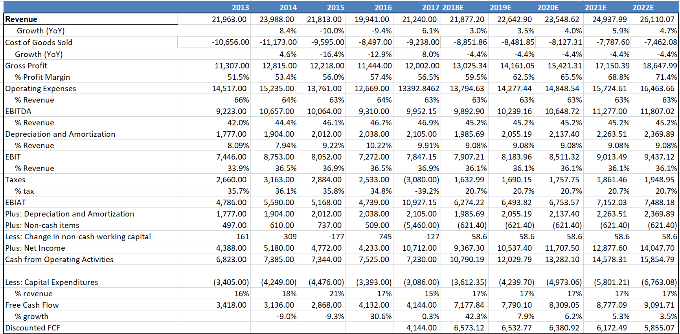

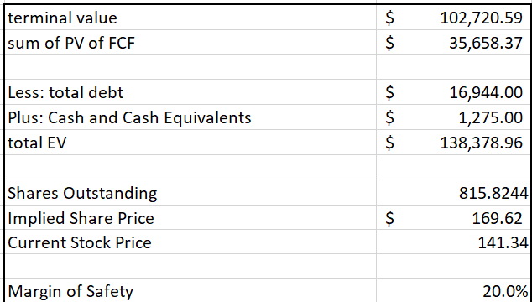

**Appendix 6 » Selected Financial Data**

**INCOME STATEMENT**

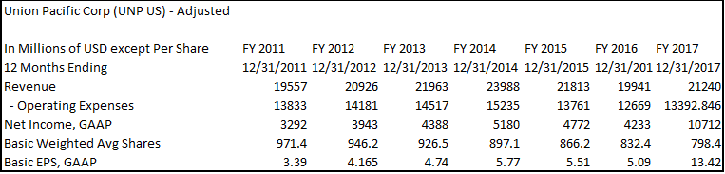

**BALANCE SHEET**

**A screenshot of a cell phone

Description generated with very high confidence**

**CASH FLOW STATEMENT**

