PORTFOLIO REPORT
Graduate Student Managed Fund
Spring 2019

TABLE OF CONTENTS
Portfolio Overview 3
Investment Managers 3
Investment Philosophy 3
Investment Strategy 3
Risk Management 4
Current Market Conditions 5
Process 5
Equity Portfolio and Allocation 5
Performance 6
Economic Outlook 8
The United States & Global Economy 8
Economic Implications of the Trump Administration 9
Federal Reserve and International Central Bank Monetary Policies 9
Sector Analysis 10
Sector Allocation 10
Consumer Staples 12
Industrials 12
Consumer Discretionary 12
Energy 13
Utilities 13
Financials 13
Healthcare 14
Information Technology 14
Communication Services 14
Individual Positions 15
NextEra Energy, Inc 15
Mastercard Incorporated 16
UnitedHealth Group 17
PepsiCo Incorporated 18
Cognizant Technology Solutions 19
The Boeing Company 21
CVS Health Corp 22
The Walt Disney Company 23
AMN Healthcare Services 24
Celgene Corporation 25
Home Depot 26
TJX Companies 27
Bank of America 28
JPMorgan Chase 29
Travelers Companies 30
Spirit AeroSystems Holdings 31
Intuit Inc 32
Biogen 33
Lessons Learned 34

PORTFOLIO OVERVIEW
Investment Managers
Michael Misluk - Team Lead Portfolio Manager Ying (Cheryl) Chen - Co-Portfolio Manager
Alisher Ganiev - Co-Portfolio Manager Reginald Joazil - Co-Portfolio Manager
Abhishek Srivastava - Portfolio Risk Manager Kevin Hebreo - Communications Manager
Lucy Adjei - Digital Media Manager Yizhen (Chelsea) Zhou – Treasurer
Suzan Talo - Fund Manager Tianjiao (Talia) Chai - Fund Manager
Graduate Advisor – Dr. Michel Rakotomavo
Fund Director – Dr. Chinmoy Ghosh

Investment Philosophy
At the core of our investment philosophy is a belief that we are value investors first; we analyze the financials, assess the company's management, and determine the company’s place in its industry. We focused primarily on Mid to Large Cap Value stocks of U.S. based companies. The team seeks undervalued assets, where the intrinsic value of the stock exceeds the market value, with stable, easy to understand business models, strong balance sheets and consistent, predictable future cash flows or dividends. A “Top-Down” investment approach was used to focus our research into desirable sectors based on a late stage market cycle.

Once these desirable sectors were identified, we performed fundamental analysis looking for individual stocks who were leaders in their industry with a high potential for continued strong performance over the next three to five years. The Fund conducts both qualitative and quantitative research in order to find undervalued stocks to add to the portfolio. Qualitative research focuses on understanding the business, looking at actions of competitors, evaluating the company’s management team, and assessing any risks that affect the company’s business model. Quantitative research consists of analyzing a company’s financial ratios and performance. To determine each security's intrinsic value, we applied a combination of absolute as well as relative valuation models including discounted cash flow analysis, dividend growth model and multiples valuation.

Investment Strategy
In order to evaluate the performance of the Student Managed Fund, the graduate team’s portfolio will compare its returns to that of the S&P 500 Index. Our overall strategy is guided based on a three to five-year time horizon for expected company performance.

As such, we performed an economic and market outlook analysis to determine what sectors we wanted to be invested in and at what target percentages. We then researched Exchange Traded Funds (ETFs) for approximately 85% of our expected portfolio allocation that seemed to align with our sector allocation decision. We chose five sector ETFs to make initial purchases while we performed detailed individual company fundamental analysis in order to be aligned with our target sector allocation from the onset.

As individual stocks are approved, we will sell out of the corresponding ETF and purchase into the individual position without drastically altering our allocation percentages as new individual positions are added to the portfolio. We will evaluate and monitor each position for changes that would affect our purchasing decision and adjust the portfolio accordingly.

Risk Management
One of the first steps the 2018-2019 Graduate SMF team undertook was to place risk management at the center of the investment decision making process by voting upon and agreeing to create a position of Portfolio Risk Manager. This initiative not only reflected our endorsement of a best practice but was our joint belief that risk management is as much about return enhancement as it is about risk reduction.

Each manager must properly understand the risks of each security. The Fund considers the following risks:

Business Model Risk – company’s business model is unsustainable or easily duplicated
Balance Sheet Risk – company has leverage well above industry average
Management Risk – company may have unreliable management
Aggregation Risk – a portfolio sharing common risks among its holdings

We maintained a high level of risk management by putting each selected stock through a rigorous screening and analysis process before committing to a purchase. This process includes analysis of the company’s business model, competitive landscape, industry, and corporate social responsibility. Specifically, we take a long-term forward-looking approach to assess whether competitive advantages are sustainable, including the company's financial situation such as debt levels, intelligent allocation of capital, and ability to consistently generate cash for shareholders.

We continue to monitor the portfolio and reevaluate our existing positions as needed. In the event of any single security or the market as whole taking a highly significant downturn, we hold a 15-20% stop-loss from the purchase price to cap potential losses. While considering the immediate and short-term risks, the idea is to identify risks that may suppress the value of the stock on a three to five-year time horizon.

Operational risk is mitigated as no stock pitch was considered without an explicit mention of the risks inherent in the business model, macroeconomic environment and revenue model of the company as well as any market risks. The first time the risks are discussed are at the pre-authorization stage. Many proposed positions were considered and rejected at this stage. This not only saves time for individual managers, but also acted as an additional layer of risk identification and management. The risk management process is holistic and monitors risks at all levels of the decision-making process.

We also looked to diversify our portfolio to reduce our risk. As can be seen in the correlation chart below, aside from our stocks in the Financial sector, we had very low correlation amongst our portfolio. We also had a weighted average beta of 1.17 compared to our simple average beta of 1.24.

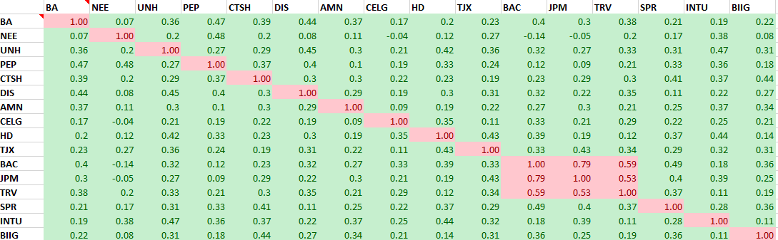

Current Market Conditions
The S&P 500 rounded out Q1 with the best start to a year since 1998 and best quarter since Q3 2009 on the back of trade optimism. The threat of a global slowdown still lingers with the inversion of the yield curve and expectation that Q1 earnings will be lackluster. However, early earnings have come in better than expected, with the exception of a few isolated companies, and the S&P 500 has hit an all-time high of 2,952 with the Dow Jones Industrial Average gaining nearly 5,000 points since the Christmas Eve bottoming of the market. Concerns about slowing global growth, ongoing trade tensions, Brexit negotiations, fear the Fed in increasing rates too fast and an imbalance in the oil complex have seemed to just roll off the backs of investors and as they continue to push markets higher.

Process
Our process stems from meeting twice a week, where we discuss various administrative and investment related decisions. Six members out of the ten fund managers constitute a quorum to begin discussion and a simple majority of the group present will pass an administrative issue. Administrative issues are those that do not involve stock purchase or sell decisions; such as election of positions, election of sectors/sector weights, changes to meeting dates/times, general guidelines for stock screening/selection, research techniques, etc.
Our team added a “Pre-Authorization” phase to gauge the group’s initial thoughts. The pre-authorization is an extra screener where the manager puts together a quick document to outline any recent company news along with the company’s fortes and risks. The purpose of this phase is to see if the stock will generate enough interest to warrant further research to not misuse time that could be spent on other prospects. Pre-authorization requires a minimum of seven votes to be approved. Upon approval, the manager is required to provide an update on their research after three meetings. An acceptable update provides the group with progress on their in-depth research, creates a space to voice concerns or brings forth the full stock pitch.
A stock pitch is a two-page report and presentation with detailed research including valuation method (DCF, multiples, etc.), clearly outlined investment thesis, industry/company specific risks and future projections for profitability. The pitch requires a strong understanding of the company’s business model and strategy. There should be confidence that the strategy is sustainable, can differentiate from peers, and should lead to an increase in intrinsic value. Purchase decisions require a minimum of seven votes to be approved. For those who vote against the purchase, a rationale must be provided to justify their objection.
Once a purchase decision is made, a stop loss order 15% below the current market price is submitted along with the buy order. The stop loss is a risk management tool that can be adjusted depending on the perceived volatility of each specific stock although 15% historically is a good guideline. Once the security has become a part of the portfolio, the group may decide to exit any position before hitting the stop loss parameter with a total of five votes from all members. This has been determined under the logic that if we were to pitch the stock again, the proposal would not reach the required seven votes to buy.

Equity Portfolio and Allocation
The Fund portfolio is currently 96.3% invested in 16 individual stocks with 3.7% remaining in cash. The average position size is approximately 4.7%, with our largest individual positions being Celgene (8.5%/~$179k) and Mastercard (8.3%/~$176k). In total, we have an unrealized gain of $129k but are down $72k from our initial starting value. We did have five positions (Boeing, Mastercard, AMN Healthcare, CVS and UnitedHealth Group) sell on us as they triggered our stop loss limits.

Performance

The charts below depict the portfolio performance from September 28, 2018 to May 1, 2019.
Total Portfolio Performance vs. S&P 500
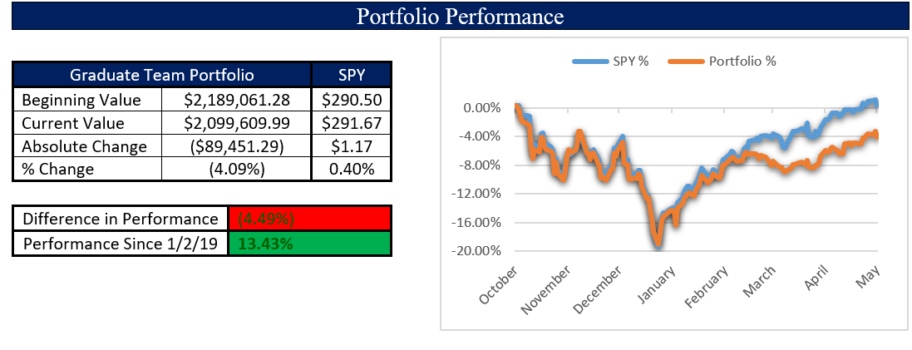
The above shows the overall performance compared to the S&P Index ETF (SPY) over the timeframe we were given our portfolio value. It shows that we underperformed the index by 4.49% but we also wanted to depict how we were able to rebound in the second semester as we entered into more of our individual positions. Below shows how our current portfolio has an unrealized positive position of 5.81% with eleven of our sixteen stocks in positive territory, four of them with double digit gains. It also notes that over the timeframe we have combined dividends and interest of ~$27k for a combined dividend/interest rate of 1.4%. Although we didn’t specifically purchase stocks because of their dividends, we do note that return is a factor of both dividends as well as capital appreciation. The team worked to be as close to fully invested in individual positions and were within a few thousand dollars until one position (UnitedHealth Group) triggered our stop loss parameter only a few weeks ago.
Total Portfolio Unrealized Gains
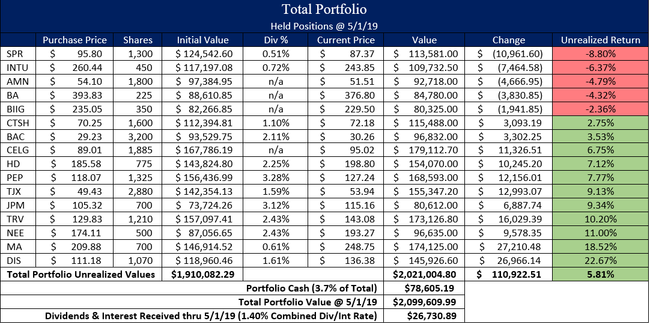

Total Portfolio Realized Gains
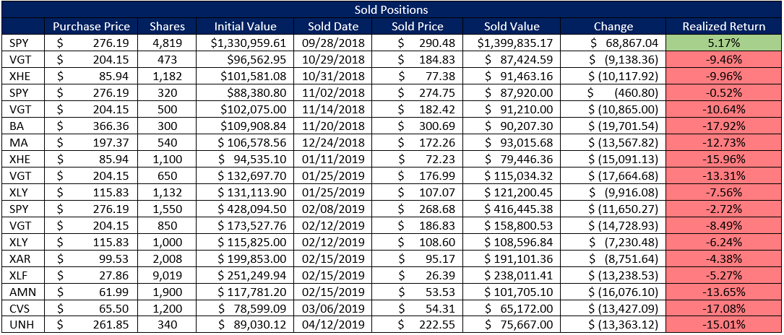

As can be seen in the chart above, we had a number of realized losses from the sale of positions, both individual stocks and ETFs. The most significant adverse impact on our portfolio has been the timing of our purchases of the ETFs. We were given our starting value just prior to the market’s overall downturn into correction territory. If we had been able to purchase the ETFs when our strategy was developed in late June, we would have broken closer to even on our ETFs instead of being down significantly from near yearly peaks.

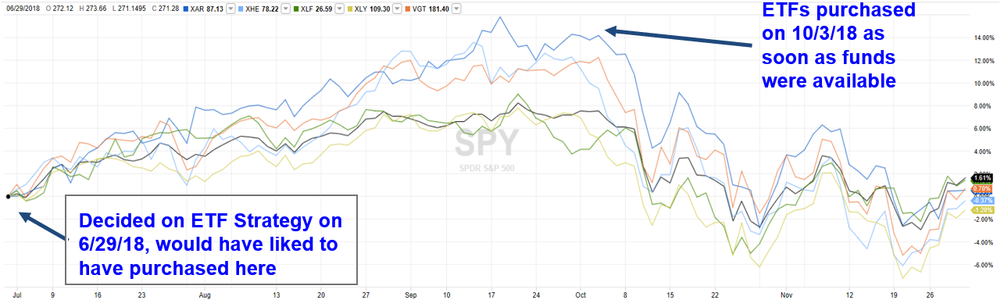

ECONOMIC OUTLOOK
Upon selecting potential investment opportunities for the Graduate Student Managed Fund, our team analyzed the current state of the global economy by focusing on macro-economic factors that will impact our investments in both the short and long term. Some of these economic factors and trends include:

The United States & Global Economy
Solid economic growth and strong corporate results, particularly in the U.S., boosted global equity markets to all-time highs at the end of 3rd quarter. Tax cuts continued to support corporate profits, but the policy environment was becoming less positive as the Federal Reserve continued to hike interest rates and U.S.–China trade escalation exacerbated late-cycle pressures. The global expansion had become less synchronized, and the mature business cycle was putting pressure on U.S. equity markets. October thru December saw a continuous down trend as some sectors entered correction territory and others pushed into bear market territory. The market bottomed out on Christmas Eve but has had a substantial rebound in the first part of the year, pushing back to end of September highs.

Although, global growth remains positive it has become more uneven, and many major economies have progressed toward more advanced stages of the business cycle. Despite a strong economy, the U.S. became more mature into a late-cycle phase as the Fed continued to raise rates and reduce its balance sheet, although recession risk remains low. The Fed has taken a more dovish tone in the last couple of months and it now appears that further rate hikes are on hold with even the possibility of a rate reduction if the Fed does not get to its inflation numbers. Ample corporate liquidity is a huge positive but will ultimately not offset tightening central bank liquidity. China acknowledged slowing growth with a clear shift toward policy easing. China looks to be entering a growth recession. China’s slowdown, in addition to global monetary tightening and trade-policy uncertainty, has not seemed to affect the markets latest upswing.

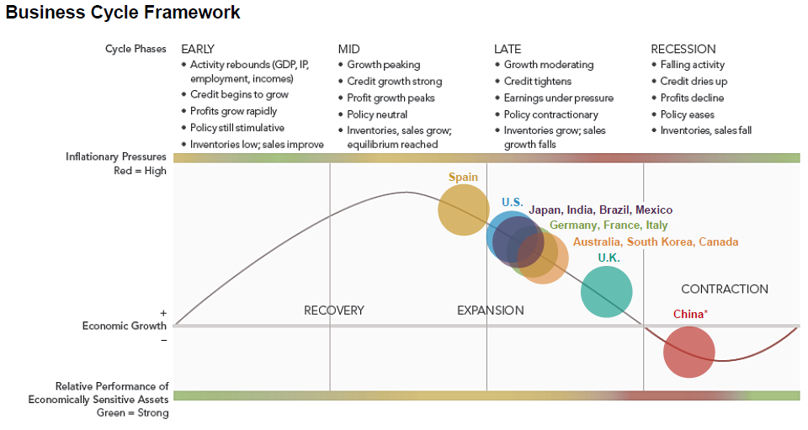

Economic Implications of the Trump Administration
The SMF team recognizes that a shift from a liberal to a conservative administration beginning in 2017 has had significant economic implications on domestic and international economies.

News coming from the White House changes daily as this administration continues to stoke controversy at nearly every step. There is practically no sector of the economy that is insulated from the potential of an “early morning tweet” coming from the President with some wild accusation or comment directed at a company or individual within a company, especially media related companies like Amazon (parent of The Washington Post), Facebook, Comcast (parent of NBC), etc. The barrage of attacks and constant rants of “fake news” coming from the administration are typically brushed off by the markets now but occasionally they do real damage to a stock. And it is not just the media companies, there have been tweets directed at many companies, like Delta, Boeing, Nordstrom, Lockheed Martin, General Motors, Ford, etc. However, in the last couple of months, it appears that news coming out of the Trump administration has started to become just ‘white noise’ that the market has for the most part seemed to ignore.

Stocks have been volatile but have been ending most weeks relatively unchanged. Rallies have been cut short by various news such as the release of hawkish Federal Open Market Committee (FOMC) minutes along with Italian budgetary concerns and weak Chinese gross domestic production (gdp) data. Then stocks rebounded sharply driven by Fed Chairman Powell’s dovish comments that rates were close to neutral, which contrasted his prior statement from October that rates were a long way from neutral. Uncertainty remains surrounding fed reserve rate policy, global growth slowdown and trade tensions particularly with China.

Federal Reserve and International Central Bank Monetary Policies
As of May 1, 2019, the federal funds rate stood at 250 bps. With labor markets tightening (as reflected in the 3.8% unemployment rate) and inflation steadily rising to the Federal Reserve’s 2% target, it seems unlikely that any rate increases will occur in 2019. We believe that, barring any unusual setbacks in the economy, the Federal Reserve has put further rate hikes on hold for the year. The SMF team recognizes that higher interest rates are used as a contractionary monetary policy tool to prevent the economy from experiencing high levels of inflation. Therefore, as interest rates and risk-free rates (i.e. 10-year Treasury yields) rise, the team would adjust our valuation assumptions accordingly with regards to WACC calculations and other rate-sensitive metrics.

Regarding monetary policy abroad, the European Central Bank (ECB) and Bank of England (BoE) have also held central bank interest rates at historic lows (currently 0 and 75 bps, respectively) following the Financial Crisis of 2008. Meanwhile, central banks in Japan and Sweden have enacted negative interest rates to stimulate economic activity and inflation. The SMF team has acknowledged this unconventional methodology to stimulate economic activity abroad and will continue to follow developments regarding central bank monetary policy.

SECTOR ANALYSIS
Sector Allocation
The strategic allocation of Portfolio assets across broadly defined financial asset and sub asset categories with different degree of risk, return and correlation will be the most significant determinant of long-term investment returns and portfolio asset value stability. With this in mind, we set target allocation levels for our portfolio by sector stemming from our team’s investment philosophy. The sector weightings allowed us to focus our efforts to then base our investment decisions primarily on selecting companies that exhibited strong business models that were trading at a discount relative to their intrinsic value.

Diversification across and within asset classes is the primary means by which we expect the portfolio to avoid risk of large losses over long term periods. To protect the portfolio against unfavorable outcomes within an asset class due to the assumption of large risk, we decided to take reasonable precautions to avoid excessive investment concentration.
- No single individual investment security should represent 10% or more of the total Portfolio
- No single investment sector should comprise more than 30% of the total Portfolio
- Within a sector, investment should be allocated to several sub-sectors, especially sectors with larger weight.

Relative to the S&P 500, our investments are not evenly spread across all sectors. This is because we decided not to invest in the Energy, Basic Materials or Real Estate sectors.

Our strategy is to utilize a Top-down method to first focus on desirable sectors, then use a Bottom-up method to narrow down to several good stocks within the desired sectors. We performed economic and market research on the sectors and compared performance (return and volatility) of each sector, to determine which sectors we wanted to overweight, which to keep at market weight and which to underweight. Lastly, we picked out the most outstanding sub-sectors based on market performance, to give guidance to potential individual stock selections.

Based on our research, we initially decided to overweight Information Technology, Industrials and Consumer Discretionary. They were the sectors with good previous performance in both short and long run. Also sectors with emerging industries or large growth potential are the ones we want to be invested in. The best example is the Information Technology sector, with many active and innovative companies investing large amounts of money into research and development every year. Sectors like Financials, Healthcare and Utilities, they are usually with stable growth but partly constrained by capital and/or regulations, so we kept them at market weight of the S&P 500. Sectors such as Consumer Staples, Energy, Telecommunications, Materials and Real Estate, we decided to underweight or put zero weight. Since they generally are less risky with little growth, or have single, concentrated growth in few sub-sectors, that cannot contribute much diversification to the portfolio.

However, in January, we re-evaluated our allocation methods and decided to alter our targets based on the market conditions and volatility. Therefore, we decided to overweight Consumer Staples, Consumer Discretionary, Healthcare and Financials. We kept market weight for Utilities and Industrials. We went with an underweight on Technology and Communication Services and decided to not invest in Energy, Real Estate or Basic Materials.

The following table highlights the current portfolio sector breakdown, target portfolio weighting, and S&P sector weightings of our portfolio as of May 1, 2019.

Sector | S&P Weight @ 3/29/19 | Target % | Over / Under
Consumer Staples | 7.3% | 12.00% | +4.7%
Consumer Discretionary | 10.1% | 14.00% | +3.9%
Health Care | 14.6% | 18.00% | +3.4%
Financials | 12.7% | 16.00% | +3.3%
Utilities | 3.3% | 4.00% | +0.7%
Industrials | 9.5% | 10.00% | +0.5%
Technology | 21.2% | 20.00% | -1.2%
Basic Materials | 2.6% | 0.00% | -2.6%
Real Estate | 3.1% | 0.00% | -3.1%
Communication Services | 10.1% | 6.00% | -4.1%
Energy | 5.4% | 0.00% | -5.4%

Upon determining the target sector weights, we also decided to settle on the proportion of each individual stock within a sector. Typically, we comply with an equal proportion rule, which means we must decide on how many stocks in total we will have in that sector, so each stock just occupies the reciprocal of that number. For example, we pitched Boeing (BA) in Industrials and expected to pitch two more in this sector, and the target weight of Industrials is 12%, so we would then allocate one-third proportion of the sector fund which means 4% (=⅓ *12%) of the whole portfolio to buy BA. This is not a steadfast policy and with fund manager agreement, the percentage could be higher or lower based on our portfolio holdings.

The fund may also require rebalancing periodically depending on market movements or changes to the economic environment. Additionally, the MSCI and S&P Dow Jones announced changes to certain equity sectors as part of a revision of their Global Industry Classification Standard (GICS), effective September 30, 2018. To reflect recent market trends, including the broad integration of traditional telecom and media companies, the telecom sector was expanded to the “communication services” sector and includes certain stocks formerly classified within technology and consumer discretionary.
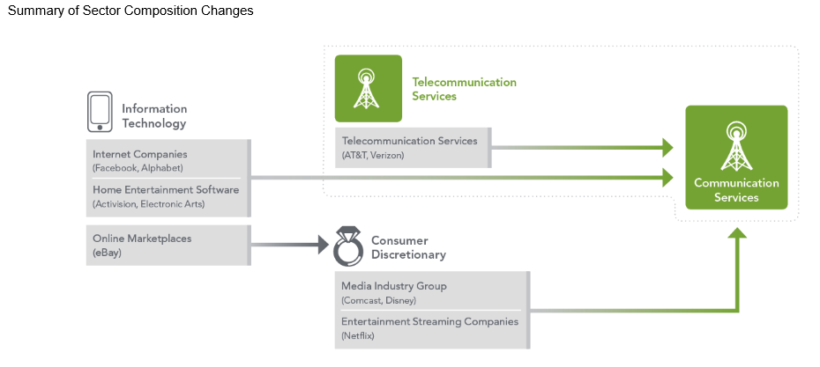
Consumer Staples
Consumer staples are what many of us consider essential products, such as toothpaste, shampoo, laundry detergent, and packaged foods. Many staples companies are multinational, with some garnering 60% of their sales from emerging markets, home to roughly six billion of the estimated 7.2 billion people in the world. A burgeoning middle class and faster population growth than in developed markets make these countries attractive end markets for large multinational staples companies.

Staples companies with sizable emerging-market exposure may offer some of the sector’s strongest earnings-growth prospects. Multinational companies look particularly attractive because they offer a mix of geographic and product diversification and, over time, can often gain market share over local businesses. Multinationals who adapt to local preferences are likely to be the biggest long-term winners.
Current Holdings: PEP
Industrials
The Industrials sector contains a broad spectrum of companies that produce goods or provide services to both consumers and business for industrial use. The types of companies included in this sector include industrial conglomerates, aerospace companies, heavy machinery companies, airlines, shipping companies, tool manufacturers, fire and security companies and defense companies.

Even though artificial intelligence (AI)—the ability of machines to perform tasks with human-like intelligence—is a product of the information technology sector, many of the key applications to date are in the industrials sector. Essentially any process that can be automated can potentially be improved with AI and many of the most promising applications are found in a variety of manufacturing environments. The goal is to produce more and better-quality products at a lower cost, with shorter downtimes. These benefits can be obtained using “smart” equipment that can monitor data about production processes and adjust in real time. While the adoption of AI is in its infancy, areas that have high and fast returns on investments such as lighting, robots and energy efficiency could experience rapid growth.

Current Holdings: BA, SPR

Consumer Discretionary
The Consumer Discretionary sector consists of companies that provide goods and services that are above and beyond needs to survive. A few types of companies that fall into this sector are consumer electronics companies, resort and gambling companies, and clothing companies. Going forward, we believe there are some broad economic factors that bode well for this sector, as well as some that could pose a threat.

Factors that could signal potential growth are low gas prices; meaning consumers will be driving more and be more willing to purchase larger, less efficient vehicles like SUVs which command higher prices. Second, improving residential housing conditions is good because it means people are spending more to improve homes, which creates jobs and adds to economic growth. Third, the economy is in a low interest rate environment (even though rates have increased, they are still historically low), meaning consumers have easy, cheap access to capital. This makes it easier to spend money on a house, a car, a condo, etc. Lastly, the economy is in a period of historically low unemployment. With more people working, they have increased discretionary income to spend on goods.

Current Holdings: HD, TJX
Energy
In the short term, there is uncertainty about the direction of oil prices as OPEC may not come to a consensus or adhere to the agreed upon quotas. With many energy companies around the world facing profitability challenges due to low crude oil prices, we believe investments in energy companies will be difficult to outperform the market unless they can demonstrate to have adjusted their cost structures to reflect the lower commodity price environment and can self-fund material production growth.

The ability of the United States to increase volumes puts the profitability of many international energy producers at risk. Only the companies that have embraced new, disruptive technology may offer a compelling combination of risk and earnings growth potential.

Current Holdings: n/a
Utilities
Traditionally, utilities were a staple of stability since they tended to be highly regulated and for much of the past decade, U.S. power supply increasingly exceeded demand, putting downward pressure on power prices across the country. The industry’s supply-and-demand profile appears to be changing which could drive better pricing power as old power plants retire and demand continues to grow. This dynamic should generally lead to improved earnings and better-than-expected cash flow for the surviving power generation companies, especially ones focused on renewable energies such as wind and solar.

Current Holdings: NEE
Financials
The Financials sector contains the category of stocks that provide financial services to customers, both commercial and retail. This includes banking, mortgage finance, consumer finance, specialized finance, investment funds and insurance companies.

In the wake of the 2007–08 global financial crisis, U.S. legislators passed many new rules for financial institutions. A decade later, we may be headed in the opposite direction, with regulatory rollbacks that could have a positive impact on the sector. The most comprehensive recent legislation to govern the sector was the 2010 Dodd–Frank Wall Street Reform and Consumer Protection Act for bank oversight. While helping to stabilize the financial system, Dodd– Frank has also significantly increased the costs of compliance and regulatory reporting and has pushed banks to hold much higher levels of capital. The capital build, in turn, has hurt returns on equity. In addition, the legislation has caused investment banks to shy away from risk, inhibiting trading activity and market liquidity.

Moving forward, newly appointed pro-growth, pro-business regulators seem likely to take a lighter touch in interpreting these rules, essentially loosening the constraints on banks. New regulators could reduce or eliminate these constraints which would give the banks more latitude to put their capital to the best possible use, potentially leading to better returns for investors. Although no one knows exactly how the regulatory landscape will unfold, rollbacks seem likely. Estimates are that big banks with more than $50 billion in assets could be among the biggest beneficiaries. Regional banks, which have tried not to exceed the onerous $50 billion threshold, could become more interested in mergers and acquisitions, and investment banks could benefit from increased trading activity. Stocks with valuations that are not factoring in the potential benefits of regulatory relief could provide some of the strongest opportunities for future appreciation.

Current Holdings: BAC, JPM, TRV
Healthcare
The biggest trend in Healthcare is the emergence of new technologies being used by health care companies to offer a more consumer-friendly approach to care. Companies are turning to technology-enabled services to improve efficiency and to modernize their business models, with a focus on proficient care coordination, overall cost reduction, and improved interoperability.

The major impetus for this trend is the rising cost of health care. Over the past two decades, health insurance premiums have risen at a staggering pace. With more companies choosing to offer high-deductible health plans, the burden of paying for health care is increasingly falling on the consumer. Patients are being asked to make more informed decisions about care, and providers are faced with a changing system that encourages high-quality clinical outcomes over greater utilization, and rewards providers for both effectiveness and efficiency. Health care companies are increasingly using tech-enabled services to help meet these new demands.

Current Holdings: AMN, CELG, BIIG

Information Technology
The Information Technology (Tech) sector includes companies that make hardware and software, as well as companies that provide services in data analytics, technology implementation, and technology process improvement. Over the past 20 years, tech has experienced more growth than any other sector. Moving forward, there are factors that support additional growth, as well as factors that could derail growth.

Specifically, there are two areas of tech that are expected to perform well in the foreseeable future. The first area is consumer facing technology companies that focus on social, mobile, and e-commerce applications. The second area is companies that can provide cost savings or revenue enhancement to other companies, such as cloud solutions or data analytics.

There are two factors that could negatively impact tech. The first is a downturn in the global economy. The tech sector is increasingly global, and if a large economy such as China’s falters, it could hurt the whole industry. The second factor is the potential of increasing interest rates over the next year. Increased rates mean increased costs of raising capital, which could make it more difficult for companies to invest in growth opportunities.

Current Holdings: MA, CTSH, INTU
Communication Services
The Communication Services sector, formally telecommunications, is made up of companies that provide communications services primarily through a fixed-line, cellular, wireless, high bandwidth and/or fiber optic cable network. The major divide in this sector is between wireless and wireline services, however, the major wireless providers (AT&T and Verizon) both offer wireline services in addition to their primary wireless businesses. Initially, we did not plan on allocating any of the portfolio to this sector. However, due to the GICS changes, we will be re-evaluating our allocation decision.

Current Holdings: DIS

We did not allocate any funds to the Basic Materials or Real Estate sectors.

INDIVIDUAL POSITIONS

NextEra Energy, Inc. (NYSE: NEE) – Abhishek Srivastava
On October 24, 2018, we purchased 500 shares of NextEra Energy, Inc. at $174.11/share.

The purchase was one of the most deliberated one as at the time of the purchase the outlook of the portfolio managers were bullish and they did not want to tie down investments in defensive stocks, which in general tend to pull down the overall portfolio returns. But at the same time some of the managers believed that given the brewing trade tensions across the world a possible turbulence in the US stock markets could not be ruled out and therefore we needed a partial hedging position in a sector like Utilities.

After some exhaustive technical and fundamental analysis NextEra Energy appeared as a clear winner. The stock combined the safety of a utility company with a growth rate that could often match that of a traditional technology company. In addition to that, the market position of the company and its future expansion and diversification plans added attractiveness to this stock.

NextEra Energy, Inc. is the holding company for Florida Power & Light and NextEra Energy Resources. NEE is primarily an electric power and energy infrastructure company that generates, transmits and
distributes electricity together with its subsidiaries. NEE also operates wind and solar power projects. It also purchases electricity for resale to its customers and provides risk management services related to power and gas consumption. Through its subsidiaries, NEE also invests in natural gas, natural gas liquids and oil production and pipeline infrastructure assets.

On the fundamental financial analysis level, the factors that strengthened the buy decision were improving gross margin, sharply reduced debt-to-equity ratio, a steadily rising return on equity and EPS that more than doubled in four years. The SMF undertook comparative analysis to its peers like Exelon Power (EXC), Duke Energy (DUK), The Southern Company (SO), and PG&E Corporation (PCG). On comparison NEE topped the chart on year-to-year comparison of return on equity. Next Era was also one with the lowest Price-to-Diluted EPS when compared to its peers.

Although utility companies are relatively less prone to sudden market risks, NEE, due to its business and revenue model and geographical location is prone to some risks. Firstly, Florida Power & Light, which contributes to about 70% of NEE’s revenue can be impacted by the vulnerable economy and housing market in Florida. A Super-Cyclone or any other natural catastrophe could also affect NEE’s transmission and generation facilities. Another risk is the company reported a deficit in its working capital in FY2017, which could cause financial instability and make it difficult for the company to meet its short-term obligations. However, low current ratios are often characteristic of regulated and stable power utility companies. Finally, the company and its subsidiaries face intense competition from other suppliers of electricity, electricity from alternative sources and self-generation sources. If the company fails to tackle competition effectively, its business and performance could be affected.

To date, we have an unrealized gain of 11.00% on NextEra Energy.

Mastercard, Inc. (NYSE: MA) – Kevin Hebreo
On November 1, 2018, we purchased 540 shares of Mastercard Incorporated at $197.37/share.
On January 25, 2019, we repurchased 550 shares of Mastercard Incorporated at $201.99/share.
On April 2, 2019, we purchased 150 more shares of Mastercard Incorporated at $238.73/share.

Initially, there was a substantial amount of positive gain until the detrimental correction during the months of October and November. During this time, Mastercard has fluctuated between a high of $209.86 and a low of $182.60 but generally has stayed very close to the original purchase price of $197.

Mastercard is a leading technology company within the global payments industry that connects consumers, financial institutions, merchants, governments, digital partners and businesses using electronic forms of payment as opposed to the traditional cash or check. Mastercard began the 2018 year with a price of $152.50 and rose more than 43% at the time of purchase. They continued to differentiate from competitors by making acquisitions and forming partnerships; most notably with the world’s largest E-Sport, becoming the first global partner, and Microsoft to aid companies in global trade and global supply chains.

Their biggest competitor may arguably be Visa and they have been in tandem all year long. Mastercard has outperformed Visa in terms of price, ROE and growth projections; while Visa has performed better with its dividend yield and debt-to-equity ratio. The reason behind choosing Mastercard over Visa, besides its outstanding performance, is its growth potential. In the payments industry, companies are either open-loop or closed-loop depending on whether they provide their clients with credit from which they gain interest or do not. Mastercard is an open-loop company, so they do not have the risk associated with its gain on fees derived from only processing payments. A company like American Express is a closed-loop so its revenues tower over Visa and Mastercard but its profits are lower due to added costs. Mastercard’s strategy to expand and increase its market share over Visa will be much more beneficial than Visa as their growth appears to have plateaued.

Mastercard is in a heavily regulated industry which is subject to various jurisdictions replicating those laws causing problems to certain aspects of the payment system. For example, India seek to gain more control over their citizen’s personal data and threaten to sue those payment companies who do not comply with their new regulation. Mastercard had to reconfigure their entire system to move all Indian personal data being stored worldwide to being centralized to India in order to accommodate potentially exposing them to breaches during the transfer. They are also subject to interchange rates and merchant surcharges which they have limited ability to counter. These could make the service to customers unfavorable and directly impact the results of their operations.

On December 24, 2018, we sold 540 shares of Mastercard at $172.26/share for a realized loss of 12.73% on Mastercard as a result of our stop loss parameter being triggered.

To date, we have an unrealized gain of 18.52% on Mastercard.

UnitedHealth Group (NYSE: UNH) – Tianjiao (Talia) Chai
On November 6, 2018, we purchased 340 shares of UnitedHealth Group at $261.85/share.

UnitedHealth Group is a diversified healthcare management company. It offers health care services and products through two distinct platforms, namely United Healthcare and Optum. United Healthcare platform provides health care coverage and benefit services; and Optum platform provides information and technology-enabled health services.

UnitedHealth Group has a consistent growth in revenues in the last five years. Effective cost management contributes to the overall growth of the company. In FY 2017, operating margin of the company was 7.56% and outperformed the Healthcare industry operating margin average of 4.74% for the same year. The increase is attributable to the increased Medicare Advantage year-over-year due to growth in people served through individual and employer-sponsored group Medicare Advantage plans.

Optum is a leader in the healthcare information emerging market. It develops software that can store and analysis healthcare information, which enable doctors to find the most effective treatment for their patients and cut down the cost at the same time. During the past five years, sales of OptumRX have become increasingly important to the company, and in 2017 accounted for 32% of the total sales at UNH.

The risks of investing in this sector is also obvious. First, the competitive factors for the company that can impact the businesses relate to the sales, pricing and marketing of the products and services, consumer satisfaction, and the quality of products and services. If the company fails to compete effectively to increase or maintain the market share, the results of the operations could be adversely affected.

Second, the company offers a range of managed care services, which requires secure transmission of confidential information over public networks. As a part of its business process the company must deal with its customers data, proprietary information, and patient data, which exposes it to the risk related to loss of confidential information and privacy concerns.

Last but not the least, the company’s businesses are regulated by various governmental and regulatory authorities in countries of its operations. Changes in government policy, legislation or regulatory interpretation may adversely affect the company’s product range, distribution channels, capital requirements and, consequently, reported results and financing requirements.
This stock triggered our stop loss parameter on April 12, 2019 for a realized loss of 15.01% on UnitedHealth Group.

PepsiCo Inc. (NASDAQ: PEP) – Suzan Talo
On November 7, 2018, we purchased 775 shares of PepsiCo Incorporated at $115.50/share.
On April 12, 2019, we purchased 550 more shares of PepsiCo Incorporated at $121.67/share.

PepsiCo manufactures and distributes nonalcoholic beverages, grain-based foods, and a variety of snacks. Its key brands include Pepsi, Gatorade, Mountain Dew, Tropicana, Quaker, Lay’s, Doritos, and Cheetos. The firm receives a slight majority of revenue from food, with Frito-Lay North America (around one quarter of sales) contributing above 40% of operating profit. It distributes its products through direct-store-delivery and customer warehouse systems, as well as third-party networks. Pepsi generates 58% of its revenue in the United States.
PepsiCo’s strong brands should allow it to maintain its growth momentum in the next few years. The company has a 5-year productivity program to improve operating efficiency. PepsiCo also has an excellent track record of consecutive dividend increase. However, its gross margin will continue to experience compression in the near-term due to rising commodity prices. Third-quarter results were in line with ongoing industry trends, with sales advancing 1.5% year over year. In September 2018, the company recorded a $1.75-a-share profit. The company has agreed to acquire SodaStream in a deal valued at roughly $3.2 billion.
The beverage group continues to face a variety of challenges. For example, changing consumer tastes have been altering the beverage market. Still, strategic actions have helped these companies maintain market share and find new growth avenues. Emerging markets are one opportunity that stands out as a long-term growth driver. What's more, industry consolidation continues to reshape this sector. The Beverage Industry sits near the middle of the pack for Timeliness. The industry expects solid growth in sales and earnings over the next decade. Further, these companies frequently return cash to stockholders through increasing dividends. Consequently, this group features companies that offer attractive total return potential out to 2021-2023.
Pepsi understands that growth is maximized in the US, so they target developing countries. The developing world continues to contribute to Pepsi's financial growth, as Asia/Middle East revenue jumped 7 percent, with beverage volume up 3.5 percent and snacks volume up 8 percent. Pepsi is a global leader in the food & beverage industry with 90 percent of retail sales from brands that are No. 1 or No. 2 in their category, with the largest contribution to profits coming from snack foods. Pepsi has been able perform strong compared to its peers in the past because of their ability to diversify their product offerings. They continue to diversify as they look to invest in businesses outside of sugary drinks. They recently acquired Soda Stream and have launched carbonated water brand “Bubly” and the popular water brand “LIFEWTR”. PepsiCo has fluctuated minimally since the purchase date with a high of $121 and a low of $110 since the purchase date.
To date, we have an unrealized gain of 7.77% on PepsiCo.

Cognizant Technology Solutions (NASDAQ: CTSH) – Reginald Joazil
On November 20, 2018, we purchased 1,250 shares of Cognizant Technology Solutions at $69.26/share.
On April 2, 2019, we purchased 350 more shares of Cognizant Technology Solutions at $73.76/share.

Cognizant is an IT services provider with headquarters in Teaneck, New Jersey. The company was founded in 1994, and provides such services as technology consulting, application outsourcing, systems integration, business process services, and cloud services. Cognizant operates across four industry business segments: Financial Services, Healthcare, Products and Resources, Communications, Media and Technology.

The Financial Services segment includes banking, capital markets and insurance services companies (responsible for 38.1% of 2017 revenue). The Healthcare segment consists of healthcare providers and payers as well as life sciences companies, including pharmaceutical, biotech and medical device companies (responsible for 28.8% of 2017 revenue). The Products and Resources segment includes manufacturers, retailers, travel and other hospitality companies, as well as companies providing logistics and energy and utility services (responsible for 20.5% of 2017 revenue). The Communications, Media and Technology segment includes information, media and entertainment, communications and technology companies (responsible for 13% of 2017 revenue).

This industry focus has been central to the revenue growth and high customer satisfaction at Cognizant. As the technology services industry continues to mature and shift from supporting the business to becoming one of the main sources of value, customers require service providers to have a deep understanding of their businesses, industry initiatives, customers, markets and cultures and the ability to create solutions tailored to meet their customers’ individual business needs. The markets for technology, digital and outsourcing services are competitive. Various competitors in all or some of such markets include: systems integration firms; contract programming companies, application software companies, cloud computing service providers, large or traditional consulting firms, professional services groups of computer equipment companies, infrastructure management and outsourcing companies, and boutique digital companies.

The direct competitors of Cognizant include, among others, Accenture, Atos, Capgemini, Deloitte Digital, DXC Technology, EPAM Systems, Genpact, HCL Technologies, IBM Global Services, Infosys Technologies, Tata Consultancy Services, and Wipro.

We issue a buy recommendation on CTSH based on the following key catalysts:
- End Market Growth: According to Gartner, IT services industry projects a 4%-5% CAGR. Cognizant is a leading IT services firm. Cognizant will benefit from the exemplified industry-leading growth for the coming years. We expect revenue growth to sustain for the next 5 years, and the firm can significantly outperform the overall global IT services industry.

- Customer-Centric, Collaborative Approach: To stay competitive on this market, Cognizant is reinvesting a huge portion of its margin into client-facing competencies such as onshore and offshore senior leaders, industry experts, MBAs, and flexible resource allocation. There is a tangible collaboration of our associates and teams across segments and practice areas. Such reinvestment contributed significantly in building better client relationships, and to that end, Cognizant has been recognized as a market leader in client satisfaction studies from third parties.

- Robust Core Business: With a competitive digital business framework which aligns digital-related skills in business, operations, and systems & technology, Cognizant provides clients with the appropriate tools and business partner to build out their long-term IT road map.

- Diversified economy of scope: Group revenue comes from its three main industries: financial services, healthcare, and manufacturing, retail, and logistics. Apart from the developing depth in existing industries, Cognizant could potentially capitalize on the expansion into new industries such as the public sector to provide additional growth avenues.

Cognizant relies also on the following keys aspects of their business to compete effectively:
• investments to scale the digital services practice areas;
• a well-developed recruiting, training and retention model;
• a successful service delivery model;
• entrepreneurial culture and approach to their work;
• a broad referral base;
• continual investments in process improvement and knowledge capture;
• investments in infrastructure and research and development;
• financial stability and strong corporate governance;
• continued focus on responsiveness to customer needs, quality of services and competitive prices;
• project management capabilities and technical expertise.
There are several risks that were analyzed before investing in Cognizant. Some of them are:
- Risks Relating to Cognizant Business
  - Intense competition from other service providers. the company must continue to develop innovative solutions that keep it one step ahead of the competition, execute on contracts to maintain its reputation, and be able to attract (and retain) the right IT professionals to the organization.
  - Operating margin decline, and difficulty to improve or sustain our profitability.
  - Legal, reputational and financial risks from security breaches or disclosure of sensitive data or failure to comply with data protection laws and regulations.
- Risks Relating to Intellectual Property
  - Services or solutions could infringe upon the intellectual property (IP) rights of others and may be subject to claims of infringement of third-party IP rights.
  - Difficulty to enforce or protect our IP rights, which may harm our ability to compete and harm our business.
- Risks Relating to our International Operations
  - Global operations are subject to complex risks, some of which might be beyond control.
  - Substantial portion of assets and operations are in India and are subject to regulatory, economic, political and other uncertainties in India. A Detrimental US immigration reform could affect the firm's revenue growth and margins.
  - Operating results may be adversely affected by fluctuations in the Indian rupee and other foreign currency exchange rates. Cognizant to restrictions on the deployment of cash across global operations and use of derivative financial instruments.

To date, we have an unrealized gain of 2.75% on Cognizant Technology Solutions.

The Boeing Company (NYSE: BA) – Kevin Hebreo
On October 18, 2018, we purchased 300 shares of The Boeing Company at $366.36/share.
On April 4, 2019, we repurchased 225 shares of The Boeing Company at $393.80/share.

Boeing is the world’s major aerospace firms which operates in four business segments: 1. Commercial Airplanes which develops, produces and markets commercial jet aircrafts and provides fleet support services (61% of 2017 Revenues) 2. Defense, Space & Security, which engages in research, development, production and modification of military aircraft and weapons systems (23% of 2017 revenues) 3. Global Services, which provides aviation services support, data analytics and information-based services too commercial and govt customers (16% of 2017 Revenue) and 4. Boeing Capital which seeks to ensure customers have financing to buy and take delivery of Boeing products. (1% of 2017 revenues)
Their biggest competitor at the time of purchase was Airbus SE. The reason the group decided to purchase Boeing instead is because of their increasing dividends, free cash flow and revenues during the past 5 years which has created a large gap between its peers. They also continued to secure long term government contracts with the Air Force and the Navy totaling $3B which increased their chances of being chosen for a $16B contract with the Air Force. They continued to be a key player in the increasing demand for air travel, increased trade, globalization and economic growth and country’s desire to launch domestic alternatives to the dominators.
The risks were very high with this stock because of the recent news of unfinished planes stored on company property due to slow suppliers. The ongoing threats of the trade war would have also placed a damper on the demand because a deal had been struck with China to build close to 8,000 planes. Any sort of changes in government spending would affect their profits greatly because 31% of Boeing’s revenue was made up of defense spending. What really caused their downfall was a crash in Indonesia involving Boeing’s 737 which killed all 189 passengers on board. Lion Air, the largest air-liner in Southeast Asia, had a $22 B order in place until their two-month old 737 crashed allegedly due to Boeing withholding information on an updated anti-stall feature and how to treat its malfunction. This incident will continue to affect the company as more details are revealed and the confidence in Boeing falters. Crashes are a common risk within the aviation industry and handling the situation carefully as well as delivering on the current contracts can curtail the decline.
This stock had very promising future cash flows but unfortunately, due to unforeseen circumstances, has plummeted its way out of our portfolio. This was the very first stock that was purchased and a stop loss order of 15% was placed on it. On November 20, 2018, the market opened at a price of $302, down $16 from the previous day’s close and well below our stop loss price of $313. The stock continued to fall to $297 before fully recovering and closing at $317 at the end of the day. The company remains fundamentally strong and will be considered for purchase at its lower price.
On November 20, 2018, we sold 300 shares of The Boeing Company at $300.69/share for a realized loss of 17.92% on Boeing.

To date, we have an unrealized loss of 4.32% on Boeing.

CVS Health Corp. (NYSE: CVS) – Ying (Cheryl) Chen
On January 11, 2019, we purchased 1,200 shares of CVS Health Corp. at $65.49/share.

CVS Health Corporation is an integrated pharmacy healthcare company. The Company provides pharmacy care for the senior community through Omnicare, Inc. (Omnicare) and Omnicare's long-term care (LTC) operations, which include distribution of pharmaceuticals, related pharmacy consulting and other ancillary services to chronic care facilities and other care settings. It operates through three segments: Pharmacy Services, Retail/LTC and Corporate. The Company delivers products and services by advising patients on their medications at its CVS Pharmacy locations; introducing programs for clients at CVS Caremark; delivering care to patients with complex conditions through CVS Specialty, and providing access to care at CVS MinuteClinic. As of December 31, 2016, the Company had more than 9,700 retail locations and more than 1,100 walk-in healthcare clinics.

CVS Health has undergone quite a portfolio change, from CVS to CVS/Caremark, to now CVS Health. Reflecting that emphasis on health, CVS has invested its acquisitions into multiple interesting businesses. Its $69 billion acquisition with Aetna has already completed in 2018, which may bring much synergy effect from PBM.

CVS is more and more focusing on Face-to-face Healthcare. It operates more than 1,100 MinuteClinics, walk-in clinics staffed by nurse practitioners. The drug store touts this relationship with medical care providers. And it is transitioning to more value-based care from fee-for-service medicine and emphasizes strategies that bring people into the store — something the e-commerce giant doesn't have.

However there still exists some risks. Competition is fierce in both pharmacy and insurance industry; the entry of Amazon is a big threat for existing. PillPack has already done a pretty good job of mastering the complexities of the pharmacy business. If Amazon needs more expertise, you can bet that it will get it.

And, pharmacy and insurance industry are highly regulated by governmental and regulatory authorities in countries of its operations.

Last, we already have United Healthcare (UNH) in our portfolio, which is the forerunner and leader in PBM, and in recent years CVS has gradually moved main part to PBM, so buying CVS is sort of overlapping and may not contribute enough diversification effect.

This stock triggered our stop loss parameter on March 6, 2019 for a realized loss of 17.08% on CVS.

The Walt Disney Company (NYSE: DIS) – Michael Misluk
On January 25, 2019, we purchased 1,070 shares of The Walt Disney Company at $111.18/share.

The Walt Disney Company (Disney) is a global media & entertainment company with four divisions: Media Networks, Parks and Resorts, Studio Entertainment and Consumer Products & Interactive Media. The company owns and leverages well-known brands, ranging from Mickey Mouse and Frozen to ESPN and ABC. In the last twelve years, Disney has acquired Pixar, Marvel, Lucasfilm and recently most of Twenty-First Century Fox’s assets, to be the largest content provider in the world.

A fully employed consumer with rising wages is a positive indicator for media consumption. Consumers have acquired the high-end digital devices needed for optimal viewing and consuming of digital content. Consumers overall, particularly millennials, are accessing digital content via Over-the-Top (OTT) platforms and content providers should benefit. Disney is excellent in their ability to monetizing their media content and should be well positioned over the next three to five years.

There were three main catalysts for wanting to purchase the stock. First, the acquisition of the majority of 21st Century Fox’s assets will significantly expand its content portfolio. They will have telecasting rights of MLB and the NBA in the United States; Premier League, Serie A, Bundesliga and UEFA Champions League in Europe and the Indian Premier League. Fox’s television business is expected to strengthen the TV slate globally and Disney’s international footprint will increase substantially in Europe and India. Second, Disney’s Studio Entertainment segment has many big movies slated to be released over the next 18 months, such as: Captain Marvel, Dumbo, Avengers 4, Aladdin, Toy Story 4, The Lion King, Frozen 2 and Star Wars: Episode IX. The success of blockbuster hit movies also tend to bode well for the Consumer Products division as well as the theme parks which have new attractions tied to them such as Star Wars Land and Toy Story Land. Lastly, ESPN+ and Disney+ will have exclusive content that is highly desirable and should be able to attract a wide range of subscribers. The recent termination of a distribution agreement with Netflix will enable it to offer rich content exclusively from Disney, Pixar, Marvel, Star Wars, and National Geographic; including all theatrical releases starting with the 2019 slate.

There are risks to the company that we did want to make sure we took into consideration. While ESPN+ and Disney+ could be huge catalysts, the service will face significant competition in the streaming market from Netflix and Amazon Prime. Netflix enjoys a first-mover advantage and has a solid original programming portfolio. Amazon enjoys a huge subscriber base thanks to its Prime membership bundling. With new entrants, Apple and Walmart, they may be late to the party and may have difficulty in signing up new subscribers. A fresh NBA agreement and increase in contractual rate for NFL programming are driving programming costs higher, which could hurt profitability. Cord-cutting remains a significant concern for Disney’s cable network business, which also hurts advertising revenue growth. Lastly, an economic slowdown in global consumer spending, particularly in China, could provide a headwind for Disney’s Consumer Products & Interactive Media division as well as their Parks & Resorts division.

To date, we have an unrealized gain of 22.67% on Disney.

AMN Healthcare Services (NYSE: AMN) – Michael Misluk
On February 8, 2019, we purchased 1,900 shares of AMN Healthcare Services at $61.99/share.
On February 20, 2019, we repurchased 1,800 shares of AMN Healthcare Services at $54.10/share.

AMN Healthcare Services, Inc. (AMN) provides healthcare workforce solutions and staffing services in the United States through a number of award-winning brands. The company operates through three segments: Nurse and Allied Solutions, Locum Tenens Solutions, and Other Workforce Solutions. The company offers travel nurse staffing; rapid response nurse staffing and labor disruption services; staffing for daily shift work or on as needed basis; locum tenens staffing for specialties, clinicians and dentists on an independent contractor basis; physician permanent placement services; and executive and clinical leadership interim staffing, healthcare executive search, and advisory services. In addition, the company offers managed services programs; vendor management systems; workforce optimization services; medical coding, case management and health information management consulting solutions to hospitals and physician medical groups throughout the United States.

The healthcare sector is expected to add four million jobs in the next decade. AMN is recognized as the largest U.S. staffing firm in the healthcare industry with a diverse client base of over 100 managed service programs including many blue-chip healthcare systems. As the market dynamics of supply/demand (e.g. aging population, medical breakthroughs, nursing shortage) shift, AMN’s diverse portfolio of offerings will work to their advantage over the next three to five years and beyond.

An aging population is going to increase utilization of healthcare services in the future. With the current and project labor shortages in the healthcare industry, workforce solutions are going to be a prime need for hospitals, provider groups and medical systems. Temporary healthcare staffing is projected to be a $17 Billion market with a $5 Billion market of comparable services. AMN's educational and experience requirements add to the quality of its worker pool, and clients view the firm as a top choice to fill higher-end positions. On the other side of the equation, workers are attracted to AMN as a provider of jobs because it can provide a significant number of premium positions than its peers because of its preferred provider status. These factors feed upon each other and have created a formidable employment network. AMN has one of the largest and widest nationwide client bases in the industry enabling them to build a quality supply of temporary healthcare workers across all types of healthcare needs. AMN's ability to provide almost any type of medical worker is also highly attractive to its customers, as they can use one vendor for most of their placement needs. The managed services relationships have been a major focus for AMN Healthcare, and the firm has become one of the premier HR managed services providers as a result.

If trends continue, healthcare workers (especially nurses) will be in significant demand. The spread between what AMN can charge customers and what it pays temporary workers may diminish and pressure margins if the firm then needs to exorbitantly increase its pay rate in order to maintain a steady inventory of quality workers. There is a possibility that Medicare and Medicaid could lower the reimbursement rates across the healthcare industry including the rates at which it will pay for labor. This could have a negative effect on the rates that AMN is able to contract with their labor force and what they charge to their customers.

On February 15, 2019, we sold 1,900 shares of AMN Healthcare Services at $53.53/share for a realized loss of 13.65% on AMN as a result of our stop loss parameter being triggered.

To date, we have an unrealized loss of 4.79% on AMN Healthcare Services.

Celgene Corporation (NASDAQ: CELG) – Reginald Joazil
On February 8, 2019, we purchased 1,400 shares of Celgene Corporation at $87.25/share.
On April 12, 2019, we purchased 485 more shares of Celgene Corporation at $94.09/share.

Celgene Corporation, a biopharmaceutical company, discovers, develops, and commercializes therapies for the treatment of cancer and inflammatory diseases worldwide. It offers mainly REVLIMID, an oral immunomodulatory drug for triple myeloma (MM), myelodysplastic syndromes (MDS), and mantle cell lymphoma; POMALYST/IMNOVID to treat multiple myeloma; OTEZLA, a small-molecule inhibitor of phosphodiesterase 4 for psoriatic arthritis and psoriasis; and ABRAXANE to treat breast, non-small cell lung, pancreatic, and gastric cancers. The company was founded in 1980 and is headquartered in Summit, New Jersey.

Celgene is a leader in the therapies to treat cancer and immune inflammatory related diseases. Celgene succeeded to maintain this position by an outstanding commercial execution and more importantly in delivering positive clinical and regulatory outcomes on its portfolio of assets. Celgene focus mainly on two therapeutic market segments: The Hematology & Oncology segment and the Inflammation and Immunology segment. To address a broad swath of unmet medical needs and to boost innovation in those areas, Celgene has been spending heavily on R&D. Referring to Celgene's financial statement, you'll see that Celgene spent $5.7 billion on R&D last year, representing an increase of 75%% over 2017.

Celgene has an impressive operating performance history. With revenue and profit growth consistently averaging 15-20% per year. This growth is expected to continue through 2020, given a young portfolio and growing clinical pipeline. For the FY 2018, revenue has increased by 18%, which continues a long run of strong growth. Celgene milestones are impressive. Early this week, Celgene has released its 2019 revenue guidance revenue is expected to reach $17.2 billion in 2019 compared to 15.3 billion, in 2018 which represents 12.4% year-over-year growth.

Celgene has many very promising treatments under development. Celgene expects to launch 10 blockbuster drugs over the next few years. Half of those could generate peak annual sales of $2 billion or more. In total, Celgene could add another $16 billion or more in peak revenue through 2030 just with these 10 pipeline candidates. Celgene stock now trades at less than 13.2 times EBIDA. Its price-to-earnings-to-growth ratio is very low. Looking at the revenue and earnings Celgene generates in the biotech industry; this stock looks really attractive. There are reasons to be optimistic about its stock and its growth prospects. Celgene has generated strong and predictable free cash flow for the past 10 years. The strong cash flow generation has shown Celgene ability to pay its debt.

To date, we have an unrealized gain of 6.75% on Celgene.

Home Depot (NYSE: HD) – Lucy Adjei
On February 12, 2019, we purchased 775 shares of Home Depot at $185.58/share.

Home Depot is the world's largest home improvement retailer, with $108 billion in revenues in FY 2018, selling various building materials, home improvement products, lawn and garden products, and décor products, as well as provide installation, home maintenance, and professional service programs to do-it-yourself and professional customers. HD is beginning to understand how to integrate e-commerce with in-store purchases and delivery to job sites and investing into supply chain to ward off competitors and drive productivity and efficiency.

Although Home Depot’s top competitor is Lowe’s in the home improvement domain, the retailer faces competition from a number of other players who also supply similar products. This includes names such as Amazon, Costco, Best Buy, and Wal-Mart. Its net income has doubled in the last decade, compared to a 55% boost for Lowe's. Return on invested capital has surged to twice Lowe's figure, and its revenue growth has beat Lowe's since 2011.Home depot has competitive advantage over its competitors in the home improvement space in terms of product offering and e-commerce. The Home Depot has the most comprehensive range of products as compared to its peers. Home depot believes its digital strategy is critical to the survival of the business. Rather than building up a stand-alone web presence and shopping app to complement its stores, Home Depot has taken a different route by actively driving traffic from its physical locations to its online options.

Home Depot is collaborating with supplier partners to bring innovative and exclusive products to its stores, which is impacting the ticket size at its stores positively. It introduced tools powered with lithium-ion batteries for outdoor use and has seen an extremely positive response from customers. With innovation being a key component of their growth strategy, HD is expanding its collaboration to more stakeholders to bring its customers better and products and services.

Given higher mortgage rates and scarcity of attractively priced homes, households are likely to invest in their homes with remodeling and renovation leading to an anticipated record high spending on home remodeling. HD is well prepared for this boom; it has integrated e-commerce with in-store purchases and delivery to job sites and investing into supply chain to ward off competitors and drive productivity and efficiency.

Home depot’s market is largely in the U.S and makes more than 90% of its revenue from the U.S. This presents a risk in sense that should there be an economic depression like the 2008 economic crisis, Home Depot will be greatly affected and the projected returns will not be achieved. In this climate of continuous growth of the economy Home Depot will deliver must investors must be cautious of the possibility of a slow U.S economy affecting their expected returns. This also presents an opportunity for Home Depot to venture out into more foreign markets especially emerging markets to boost their growth.

To date, we have an unrealized gain of 7.12% on Home Depot.

TJX Companies (NYSE: TJX) – Abhishek Srivastava
On February 12, 2019, we purchased 2,880 shares of TJX Companies at $49.43/share.

The TJX Companies, Inc. is an off-price apparel and home fashions retailer in the United States and across the world. It operates stores under the T.J. Maxx, Marshalls, HomeGoods, Winners, HomeSense, TK. Maxx, and Sierra Trading Post names, as well as operates e-commerce sites tjmaxx.com, tkmaxx.com, and sierratradingpost.com.

There are a number of reasons we felt this was a good investment. TJX is the largest off-price retailer of apparel and home fashions worldwide with an efficient business model that is eclectic with ever changing selection which surprises and allures consumers. TJX stores rapidly turn over limited quantities of products that are all sold at bargain prices. Also, T.J. Maxx mixes brands on the same rack, giving it more flexibility and creating a treasure hunt for shoppers. This creates a sense of customer delight, hard to replicate by online retailers. The company retails its products through a combination of domestic and international segments. Diverse retail and marketing channels help to increase brand awareness, store traffic and sales.

In FY2018, the company reported an inventory turnover ratio of 6.1, which was higher than its major competitors, JCPenney and Macy’s both who only had a ratio of 2.9. With the given inventory turnover ratio, the company takes only 59 days to sell its inventory. Lastly, TJX is an excellent dividend stock. While the yield is only 1.65%, it’s history of 20% dividend increases is very impressive, especially with a payout ratio of only 28%. The company also has been buying back its stock having reduced its diluted outstanding shares by 54% over the last 20 years.

We also identified risks to the company to be aware of but still felt good about the long-term prospects. High debt remains a major concern for the company. At the end of FY2018, the company had a total long-term debt of US$2,452 million. However, the rate of revenue has so far outpaced the growth of debt. Also, TJX’ s debt is very cheap that costs only about 1.5% to carry. Next, TJX faces competition from local, regional and national retailers, apart from low-cost operators, both in the regional and in foreign countries. The company also competes with e-commerce retailers, wholesalers and catalog businesses. TJX operates in many parts of the world and is exposed to fluctuations in foreign exchange rates. To minimize risks from currency fluctuations, the company involves in foreign exchange hedging activities by entering into foreign exchange forward contracts. Lastly, any negative change in consumer spending levels will drive down revenue for the company.

To date, we have an unrealized gain of 9.13% on TJX Companies.

Bank of America (NYSE: BAC) – Kevin Hebreo
On February 15, 2019, we purchased 3,200 shares of Bank of America at $29.23/share.

Bank of America is a financial holding company currently operating in four business segments: 1. Consumer Banking, which is comprised of Deposits and Consumer Lending, offers various credit and investment products to small businesses and consumers (40% of revenues), 2. Global Wealth and Investment Management, which is comprised of both Merrill Lynch and U.S. Trust’s financial advisors tailoring solutions to meet client needs who have over $250,000 in total investable assets (21% of revenues), 3. Global Banking, which provides range of lending products and services, capital management, treasury solutions, and underwriting services for commercial entities (21% of revenues), and 4. Global Markets, consists of sales and trading services for clients in the fixed-income, credit, currency, commodity and equity businesses (17% of revenues).

The team was in between Bank of America and J.P. Morgan eventually purchasing both. The reason Bank of America was purchased is because at the time of research, the stock was paying a higher dividend at 2.11% than the industry yield of 2.9%. Its Return on Equity was at 11.6% and the Return on Assets at 1.24% which again was higher than the benchmark. It still holds one of the best efficiency ratios which has continuously improved. Analysts have predicted $22.7 Billion for quarterly earnings in Q4 of 2018 and earnings beat those expectations by over $300 million. Profit was earned of about $7.3 billion for the quarter which broke a person record. Another main reason why Bank of America was purchased is because of the lowered legal risk compared to other banks such as J.P. Morgan and Wells Fargo for money laundering and fraud.

With that said, the risks associated with the stock include a tremendous amount of market risk due to performance of the U.S. & international financial markets including the volatility of the interest rates and GDP growth. The company relies on secured funding sources such as the repo-market and asset securitization transactions. If they are not able to maintain that relationship, adjust to changes in regulation, or access the capital markets then they will be at serious liquidity risk. Another risk would be changes in the credit rating which would increase borrowing costs and make it difficult to access additional funding. Banks are subject to potential losses due to insufficient reserves and may face reputational, operational and legal risk doing business in emerging markets.

To date, we have an unrealized gain of 3.53% on Bank of America.

JPMorgan Chase (NYSE: JPM) – Yizhen (Chelsea) Zhou
On February 15, 2019, we purchased 700 shares of JPMorgan Chase at $105.32/share.

JPMorgan Chase is one of the largest and most complex financial institutions in the United States, with more than $2.5 trillion in assets. It is organized into four major segments- consumer and community banking, corporate & investment banking, commercial banking, and asset and wealth management. JPMorgan's consumer-facing lines of business include home lending, auto lending, credit cards, and small business services. The company's wholesale lines of business include investment banking, treasury and securities services, corporate and commercial real estate lending, and trading of fixed income, equity, and credit products (including a wide variety of derivatives) as well as its asset and wealth management operations. JPMorgan operates, and is subject to regulation, in multiple countries. JPMorgan Chase Bank operates 5260 retail branches in 23 states. The majority of its revenue comes from the US.

Over the past year, the underperformance of investment banking industry widened. Stocks in the BI global investment-bank peer group lost 30% in 2018, trailing the broader MSCI ACWI’s 9% loss. However, JPM still had a strong performance even with the headwind from industry. Over the past decade, JPMorgan's management team has performed better than virtually all its large global peers. JPM 's balance sheet is strong, with a common equity Tier 1 ratio well above regulatory minimums and more than half a trillion dollars in high-quality liquid assets. Credit quality remains pristine, and performance is strong across the company's lines of business. Moreover, looking at multiyear chart, I found JPM stock was subject to a plenty of volatility and mean reversion. Right now, its stock price is below the 200 days moving average and 100 days moving average. In 2019, JPMorgan is expected to have new drives for revenue growth. The firm's new Sapphire Reserve card contributed to millions of new accounts over the past 12 months, assets under management recently reached a record high, and core loans are growing at a healthy pace as consumer and business confidence rises. Increasing net interest income is also materializing as the Fed raises rates.

As a systemically important firm, JPMorgan is likely to remain under the regulatory microscope for years to come. Regulatory relief will help smaller banks at the expense of "too big to fail" institutions. Legal risk and It's difficult to quantify potential exposures (let alone losses) created by the firm's trading activities, as evidenced by the London Whale incident. Reversion to the mean seems to be a powerful force in the competitive banking industry, and there is no reason why JPMorgan should be permanently immune to the kinds of problems that have cropped up at its competitors.

Compared to the industry peers, JPM has a strong financial performance. The three-year daily returns are above benchmark S&P 500. It is entering 2019 with good momentum across most of its business, which should help lift revenues. To date, we have an unrealized gain of 9.34% on JPMorgan Chase & Co.

To date, we have an unrealized gain of 9.34% on JPMorgan Chase.

Travelers Companies (NYSE: TRV) – Kevin Hebreo
On February 15, 2019, we purchased 1,050 shares of Travelers Companies at $128.62/share.
On April 2, 2019, we purchased 160 more shares of Travelers Companies at $137.73/share.

The Travelers company is a holding company which provides insurance products and services in both the commercial and personal property industry to businesses, government units, associations and individuals. Their three main lines of business are the Property/Casualty which makes up 34%, Business Insurance which makes up 57% and Bond and Specialty which makes up 9%. Property Casualty is distributed through independent agents, direct marketing and/or salaried employees who compete against foreign and domestic insurers. The pricing of products is developed based on an estimation of expected losses, the expenses associated with producing, servicing and managing claims, and reasonable profit margin to support the business. The strategy is based on long-term return and growth rather than premium volume or market share. Business Insurance provides PC, worker’s comp, and general liability to Select Accounts (Small Business), Middle Market (Mid-Sized), National Accounts (Large-Sized), National Property (Agricultural and Difficult to Place) and International. Bond and Specialty provide surety, fidelity, management/professional liability and risk management services utilizing various degrees of financially underwriting approaches. The pricing is developed around proprietary data gathered and analyzed over many years.

The reason Travelers was considered for purchased was because of its consistent ability to generate underwriting profits in commercial and personal lines of insurance due to management’s focus on shareholder returns and superior underwriting practices. Their revenue has risen from $7.8 Billion to $7.45 Billion, an increase of 4.5%, and has gained 7% since mid-December. At the time of review, Travelers has exceeded earnings expectation for the fourth quarter. Catastrophes reported were higher than normal due to the rampant California Wildfires and Hurricane Michael and yet they reported higher profits for the year. They are the second largest US commercial property/casualty insurer and the third largest of personal property/casualty. Berkshire Hathaway holds Travelers insurance as their only insurance stock and they are a reputable firm built on investing in highly profitable insurance companies.

The risks associated with this company are those from catastrophe losses since it affects their ability to operate, their financial position, liquidity and/or their ability to raise capital. If they are unable to accurately estimate claims reserves due to changes in legal, regulatory, and economic environments. The insurance industry can be adversely disrupted by economic downturns causing inability to operate or raise capital adequate enough for business continuity. Another risk can be credit and interest rate risk can be directly related to reduced returns and material realized/unrealized loss.

To date, we have an unrealized gain of 10.20% on Travelers.

Spirit AeroSystems Holdings (NYSE: SPR) – Reginald Joazil
On February 15, 2019, we purchased 1,121 shares of Spirit AeroSystems Holdings at $95.54/share.
On February 20, 2019, we purchased 179 more shares of Spirit AeroSystems Holdings at $97.38/share.

Spirit AeroSystems Holdings, Inc. designs, manufactures, and supplies commercial aero structures in the United States and internationally. The company operates in three segments: Fuselage Systems (53% of ’17 revenue), Propulsion Systems (24%), and Wing Systems (23%). The company also provides components for military aircraft. Boeing and Airbus accounted for 95% of ’17 revenue with foreign revenue accounting for 18%. Spirit AeroSystems Holdings, Inc. also offers low observables comprising radar absorbent and translucent materials; rotorcrafts that include forward cockpits and cabins; and other military services, such as fabrication, bonding, assembly, testing, tooling, processing, engineering analysis, and training. The company was formerly known as Mid-Western Aircraft Systems Holdings, Inc. Spirit AeroSystems Holdings, Inc. was founded in 1927 and is headquartered in Wichita, Kansas.

SDP continues to expand its market share by increasing its defense and fabrication business. The recent agreement reached agreement with Boeing on long-term pricing of spare parts used in maintenance, repair and overhaul activity will ensure a predictable cash flow for the company in a long-run. Moreover, 2018 has been a successful year for SDP, the company succeed to expand deliveries not only with Boeing and Airbus but also with the defense sector. We observed in 2018 annual report net increase in the non-recurring and defense-related activity. For the FY 2018, revenue has increased by 3% while the backlog delivery of the company is estimated to be $48 billion. Inorganic growth continues to support the company expansion. Lastly, SDP has made the strategic acquisition of acquisition and integration of Asco. This acquisition expands SDP Airbus content on A320 and A350 wings, adds new defense content on the F-35 and broadens SDP commercial capabilities to help grow the fabrication business. We expect that SDP will realize attractive cost synergies from this acquisition. Analysts are expecting high return on investment and the post-synergy EBITDA multiple under 8x.

SDP has an impressive operating performance. While the revenue increase by 3% in FY2018, the adjusted EPS (fully diluted) $ per share increased by 17%, which is impressive. We are expecting that this cost-synergy will continue through 2019. SDP massive capital deployment in 2018 made a bullish about this stock. Among the major capital deployment decisions, we can list:
- Repurchased 9.3 million shares in 2018
- Increased quarterly dividend from $0.10 per share to $0.12 per share
- $1 billion share repurchase authorization remaining
- Cumulative Shares Repurchased of ~$2.4 Billion

Dependency on Boeing and, to a lesser extent, Airbus, as our largest customers, our sales, cash flows from operations, and results of operations will be negatively affected if either Boeing or Airbus reduces the number of products it purchases from us or if either experience business difficulties or breaches its obligations to us. Interruptions in deliveries of components or raw materials, or increased prices for components or raw materials used in our products could delay production and/or materially adversely affect our financial performance, profitability, margins, and revenues.

To date, we have an unrealized loss of 8.80% on Spirit AeroSystems Holdings.

Intuit Inc. (NASDAQ: INTU) – Alisher Ganiev
On March 22, 2019, we purchased 350 shares of Intuit Inc. at $258.72/share.
On April 2, 2019, we purchased 100 more shares of Intuit Inc. at $266.36/share.

Intuit develops and markets well-known and trusted software products such as QuickBooks for small-business accounting, TurboTax for preparing personal tax returns, and Mint for managing personal finances. The firm is targeting the additional needs of small businesses with payroll and payment processing products in addition to growing its self-employed user base. Intuit was founded in 1983 and is based in Mountain View, California.

Intuit aims to be the operating system behind small businesses. The company has an entrenched market-leading position in self-prepared tax and small- to midsize-business accounting software. The firm has been able to carve out a wide economic moat. Key to the company's success have been the inherent switching costs and network effects associated with its software. Shifting to alternative software costs customers the time and effort required to learn a new product, additional training costs, operational disruption, and the risk of transferring business-critical data. Moreover, Intuit has strengthened the stickiness of this relationship by skillfully intertwining the functionality of its multiple products, such as payroll, making users more likely to adopt additional products as their needs expand. As a result, returns on invested capital is expected to remain significantly above the company's cost of capital over the long term.

Intuit's wide moat is underpinned by high switching costs and positive network effects. Learning to use the majority of its applications takes time and effort. Therefore, SMBs and end users would not only incur additional software and training costs but would also face operational disruption and the risk of errors in transferring financial information if they switch to an alternative product or competing application. To strengthen the stickiness of its products, Intuit has skillfully intertwined the functionality among its multiple products, making users of one of the firm's applications more likely to adopt an additional product as their needs expand. For instance, QuickBooks users are likely to adopt Intuit's payments and payroll services, and Quicken users are more easily lured into transferring their yearlong financial information into TurboTax. Furthermore, the pervasiveness of Intuit's applications generates positive network effects because the commanding market share of its products provides a strong and self-reinforcing incentive for accountants and end users to use Intuit's applications.

Intuit's tax products are subject to a short and stringent development cycle during which the company has to thoroughly incorporate tax code changes into its products. In addition, wider government support for free filing alternatives could place a cap on Intuit's growth in the tax segment. Moreover, free personal financial management tools offered over the Internet have forced Intuit to give away basic versions of its products or bundle some offerings with other products. Lastly, because the firm collects and stores personal financial information, a security breach could tarnish consumer trust of the company.

To date, we have an unrealized loss of 6.37% on Intuit.

Biogen (NASDAQ: BIIB) – Ying (Cheryl) Chen
On April 2, 2019, we purchased 350 shares of Biogen at $235.05/share.

Biogen Inc. develops, manufactures, and commercializes therapies, focusing on neurology, oncology, and immunology. With its pipeline full of biotech drugs, Biogen aims to meet the unmet needs of patients around the world. Biogen has several drug candidates in phase 3 trials in neurology and neurodegenerative diseases and has launched Spinraza with partner Ionis.

BIIB is currently undervalued compared to history average. It sharply dropped about 26% on March 21,2019 due to declaration of discontinuance of Alzheimer's trials, which dragged down its many stats much below history average. But based on its diversified revenue distribution, stable growth, strong R&D strategy and leading position in Biotech sector, it is fair to believe the stock is undervalued.

Biogen is expected to complete the pending acquisition with Nightstar within 2019. BIIB has sufficient free cash flow to fund acquisition, and this pending acquisition may bring two ophthalmology gene therapy drugs into Biogen’s pipeline.

Also, Biogen has extremely strong financial performance. It has stably increased revenue, around 35% of ROE and 20% of ROA, which easily exceed the estimated WACC of 7%. And its low debt to equity ratio can support its R&D expenditure as a solid back up.

However, for companies in pharmaceutical sector, risks are always besides. There may be new drugs appear with strong efficacy in the future, but, the introduction of new products from the firm's growing late-stage pipeline should offset new competition for established drug.

Then, there always exists much uncertainty of drugs approval from FDA, but the stringent regulation makes this industry high threshold from outside as well, which keeps the competitive position of Biogen relatively stable in the industry.

Last but not least, there is chance that phase 3 trials may cannot be transformed into production, just like the news of fail of Alzheimer's trials. This happens for biotech sector all the time. We believe that Biogen is spending a large amount of money on Research & Development every year to create and work towards more patents and products to the market.

To date, we have an unrealized loss of 2.36% on Biogen.

LESSONS LEARNED
Lessons Learned

Looking at the team at our recent meetings and observing the difference and growth that has happened over the last eight months is incredible. This process has been grueling and challenging and to see the results this soon in our decision making is amazing. The first learning for the team has been the improved knowledge of investment analysis and asset valuation. Through our classes and meetings, we have each learned and developed a framework for valuing and assess assets. The discounted cash flow, dividend discount, and relative company comparable analysis methods of valuation have been highly used by the team in picking stocks and making decisions on which positions to move in. Understanding that the strategy of company as well as other forms of values are as important as technical valuation.
The second lesson we learned as a team was the importance of timing. Timing has been one of the main challenges we faced as a team, from the timing of our actual purchases after a request have been put through to the timing of the decision to purchase. We have learned the essence of moving in and out of positions as quickly as possible. In the case of Boeing, we hit our stop loss on Thanksgiving Eve. At the time, we were unclear about the process of re-entering a stock that had been sold out on us. We did not know if it would look bad to repurchase something that we had taken a loss on. As a result, even though we still liked the company from a fundamental viewpoint, we did not get back into the position. This was a mistake as the stock rebounded and would have been a great performer to the portfolio if we had acted at the time.
The margin of safety is another important lesson we learnt in the past semester seeing as two of our stocks hit stop loss and recovered well shortly after that. We learned that gauging the right margin of safety for each stock was very important and having a blanket 15-20% was not very efficient. Certain stocks, like Boeing, which are a bit more volatile should be given a higher margin of safety based on their historical trend and how quickly they recover from huge price losses. For those kinds of stocks, we found that getting the right margin of error is nearly as important as the other types of valuations.
Finally, the SMF has being a great learning experience for the team. We have not only learned how to research and value assets, we have learned to ask the right questions when our team mates pitch a stock. In researching, we have learned the various resources available and how to use such resources as Bloomberg and Morningstar Direct. We have also learned to be skeptical of assets that look too good and to research deeper finding their strategies and what their competitive advantages are thereby finding out if a stock that looks highly undervalued is really undervalued or has no opportunity for growth.

