Ulta Beauty (NASDAQ: ULTA)
Sector: Consumer Discretionary
Target Price  $312.27 | Current Price  $268.23 | 52 Week High  $278.63 | 52 Week Low  $146.77 | P/E  44.33 | Market Cap.  $16.69B | Dividend Yield  N/A | Beta  .95
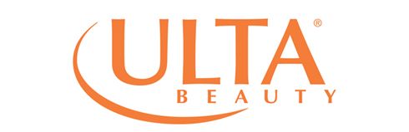
Business Description
Ulta Beauty is the largest beauty retailer in the United States and operates under three reportable segments: retail stores, salon services, and e-commerce. They offer an “All Things Beauty, All in One Place” experience to customers with over 20,000 products from over 500 brands that cover prestige, mass market, and salon segments. Stores are large, generally 10,000 square feet, all of which have a full service salon, self-service product displays, and non-commissioned sales associates.

Industry Trends
The beauty products and salon services industry represents approximately $127 billion in sales. Currently this is a highly fragmented market with more than 70,000 places in the U.S. to buy beauty products. The retail industry as a whole is ready for growth, with disposable personal income increasing 3.4% in the past year and the economy adding an average of 181,000 jobs per month in 2016 (Deloitte). There is also much room for growth in online retail. Kiplinger recorded online retail sales growth of 14% during the holiday season of 2016 and is projecting similar growth for 2017. Additionally, customer relationship management and digital marketing tools are becoming increasingly prevalent.

Investment Thesis
Ulta Beauty will deliver long-run value due to its competitive strengths that differentiate the company and its consistent ability to have high growth while currently only holding a 4% share of the beauty market. The company offers a differentiated merchandising strategy with a broad appeal for customers looking at any price point. It provides a unique guest experience with a full service salon and self-service displays in every store. Ulta has a loyal and active customer base with a comprehensive rewards program. Strong vendor partnerships allow the company to offer a wide range of products including exclusive products. Lastly, the experienced management team at Ulta sets the company up for success in keeping up with industry changes.

Valuation Assumptions  WACC: 8.98%  Terminal FCF Growth Rate: 2.75%  Estimated EBITDA: $797.10  Industry Avg EV/EBITDA: 23.50x | Key Financials  Total Operating Margin: 13.4%  FCF/Debt: NA  Net Debt/Equity: NA  FCF Yield: 1.17  Net Debt/Adj EBITDA: NA
Corporate Social Responsibility
ESG Disclosure Score: 11.16 (Industry Average: 14.51)
Governance Disclosure Score: 48.21 (Industry Average: 47.99)
Percent Women on Board: 45.45 (Industry Average: 24.81)
Percent of Female Executives: 22.22 (Industry Average: 23.93)
Percent of Independent Directors: 90.91 (Industry Average: 81.60)

5-Year Stock Performance
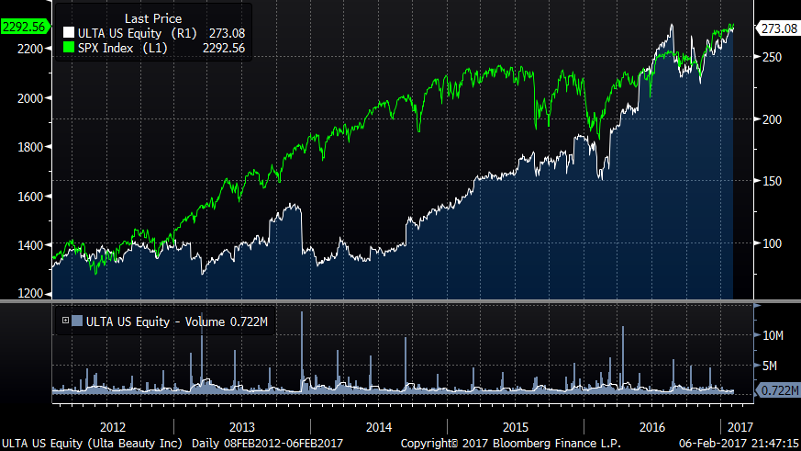

Competitive Analysis
Ulta Beauty competes with department stores, specialty stores, drug stores, mass merchandisers and online businesses of national retailers and pure-ecommerce businesses. Its competitors include Sephora, Macy’s, Amazon, Estee Lauder, L’Oreal, Coty, and Procter & Gamble. No one competitors sells as many different types of products or offers the same services as Ulta.

Competitive Advantages
Ulta’s main competitive advantages are its customer experience, market penetration, and product offerings. Ulta is the only company in the market that offers non-commission based beauty consultants to help guests choose beauty products ranging across the entire spectrum, from mass market to prestige products. Additionally, Ulta has full-service salons in each of its stores. This allows guests to experiment with a new look, and purchase all materials necessary to maintain that look, all in one place. Ulta also benefits from having nearly 1,000 stores across the U.S. and increasingly strong base of ULTAMATE Rewards members. The convenience of its stores and benefits of its rewards program allows Ulta to best target beauty enthusiasts. Lastly, Ulta is unique in that it offers more than 20,000 products ranging from Maybelline to Dior.

Risks
Ulta Beauty faces risks that exist in the beauty industry. Selling discretionary products and services, Ulta needs a good economy to continue its high growth. There are also few barriers to entry for beauty products and salon services making the market highly competitive. Ulta also must effectively gauge beauty trends in order to have its stores stocked with the appropriate products in the right quantities during such trends. As well, social media reputation is very important for this industry. Negative commentary regarding Ulta or its products could adversely affect growth as well.

Report Prepared By:
Jason Mraz and Tami Stawicki on 02/12/2017
Sources: Bloomberg

