STAG Industrial (NYSE: STAG)
Sector: REIT
Target Price  $30.42 | Current Price  $24.08 | 52 Week High  $25.51 | 52 Week Low  $14.99 | P/FFO  15.29 | Market Cap.  $1.9 BN | Dividend Yield  5.8% | Beta  1.02
Business Description
STAG is a REIT that invests in and operates industrial single-tenant properties in the United States. 87% of all properties owned by STAG are either warehouses or distribution properties, and the average asset price of each property is between $5-15 million. Additionally, a common characteristic among STAG properties is that a majority are in secondary markets (high exposure to the mid-west) where the average rentable space is between 25-200M net rentable square footage. In terms of industry exposure, STAG’s tenants are diversified across industries, with the greatest exposure to automotive, air freight, and industrial equipment.
Industry Trends
The REIT industry ended 2016 with total returns of 9.3%. While the REIT market faced a rate focused valuation in 2016 it is expected to return to fundamental valuation in 2017. A large portion of REITs are dealing with bond maturities in the face of rising interest rates to come. The retail REIT sector has been facing problems with tenant bankruptcies and decline in brick and mortar retail trends. However the industrial REIT sector looks positive due to the executive administration’s job and manufacturing outlook and proposals. The industrial REIT sector has been preforming well with decreasing vacancy rates and increasing effective rent rates. The industrial REITs ended the 2016 year with 30.2% total return. Other economic indicators such as unemployment and consumer confidence contribute to positive overall industrial REIT sector outlook. The RMZ index ended the week at 1163, not far off from the 52 week high of 1280.

Investment Thesis
STAG Industrial will deliver long run value due to its potential future market opportunities that are under tapped, disciplined management and financial philosophy, and its aggressive growth strategy. STAG is positioned for growth, with market penetration of only 1% of its target asset classes in a very fragmented market. The management team has led a disciplined system of maintaining strong balance sheets and returning value to shareholders. Lastly STAG is only in the beginning of its growth stage with launching an IPO in 2011 and now having over $1.9B in the acquisition pipeline. Its current price is undervalued and has upside potential.
Valuation Assumptions  WACC: 7.00%  Perpetuity Growth Rate: 2.2%  3 Stages of Growth: 25%, 15%, 10%  NOWC: adjusted as portion of revenues  Depreciation: 50%-40% of revenue | Key Financials  DCF Stock Price: $30.44  DDM Stock Price: $27.82  Stock Price Multiples: $32.99  Weighted: 1/3 each  Intrinsic Value: $30.42
Corporate Social Responsibility
% Nonexecutive Directors on Board 85% (Industry 76%)
Independent Audit Committee Chairperson – Present
Whistleblower Policy –Present
Code of Ethics and Governance Policy- Present
Community Ranking by CSR Hub 60 out of 100

5-Year Stock Performance
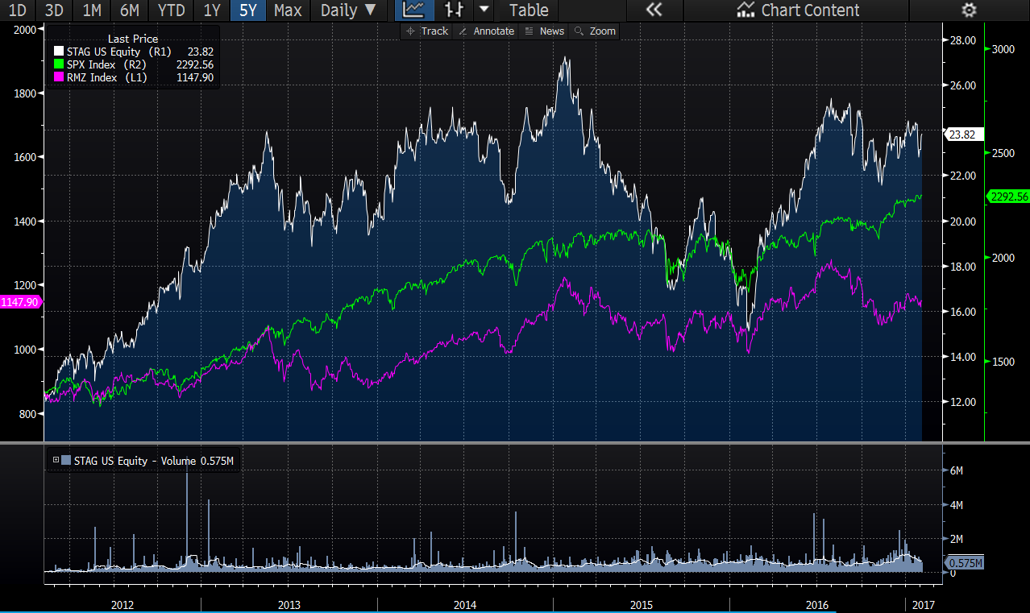

Competitive Analysis
STAG Industrial competes with a specified group in the REIT sector. The industrial sector, which finances and manages industrial warehouses and other industrials light manufacturing buildings, can be broken down into primary and secondary markets. STAG primarily competes in the secondary market. STAG’s main competitors include: Prologis Inc., Duke Realty Corp., DCT Industrial Trust, First Industrial Realty, Eastgroup Properties, Rexford Industrial Realty, and Terreno Realty. These competitors were also used in the comparables value analysis.

Competitive Advantages
STAG holds several key competitive advantages. Firstly, they maintain a very attractive dividend yield around 6% that is paid out monthly. A large portion of REIT’s value lies in their dividend yield as over 90% of FFO needs to be paid out as a dividend, and STAG’s yield beats out many competitors. A second competitive advantage for STAG is their portfolio diversification. Given the inherent riskiness of leasing to individual tenants, STAGs superior diversification strategy across industries, tenants, and geographies makes for a risk-averse investment thesis. Finally, STAG has strong financials and significant liquidity to fund future growth, with nearly $500M of immediate liquidity available and a conservative capital structure comprised of only 33% debt. STAG’s financial strength allows for flexibility in volatile economic conditions

Risks
The primary risk STAG faces is an economic downturn. The secondary markets are generally a leading indicator of economic pressures, meaning STAG could struggle if tenant defaults rise as demand is not as high in their target markets. Additionally, 60% of STAG’s outstanding leases expire within the next 5 years, meaning that the short-term will truly be a test for management’s competency. Management has stated that the supply-demand balance of their markets is currently fully stable, so they do not anticipate any issues in renewing leases. Finally, STAG pays out 99.8% of their FFO as dividends. This was an intentional strategy to garner interest among equity owners by issuing a high monthly dividend, and management will seek to lower this payout as cashflows increase.

Report Prepared By:
Sean Phelan and Roma Romaniv on 02/12/2017
Sources: Bloomberg, STAG Annual & Quarterly Reports, REIT Magazine, CSR Hub

