People’s United Financial, Inc. (NYSE: PBCT)
Sector: Financials
Target Price  $20.78 | Current Price  $17.70 | 52 Week High  $20.13 | 52 Week Low  $13.62 | P/E  21.64 | Market Cap.  $6,098.6M | Dividend Yield  3.83%
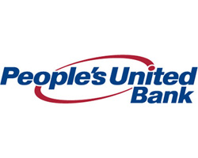
Business Description
People’s United Financial Inc. is the bank holding company for People’s United Bank. It is headquartered in Bridgeport, Connecticut and ha about $40.7 billion in assets as of 3Q 2016. The Company operates under three main segments: commercial banking, retail banking and wealth management services, that are compiled in to two reporting segments commercial and retail banking. These are provided to individuals, corporations, or municipal customers. The 396 branches are located within New England and south-eastern New York, of which 150 are full-service Stop & Shop branches.
The commercial banking segment offers real estate lending, commercial and industrial lending, and commercial deposits. Included is institutional trust services, corporate trust, insurance services provided through People’s United Insurance Agency (“PUIA”) and private banking. Commercial banking accounted for 73% of the total loan portfolio, with $21.2 billion which is divided amongst Commercial Real Estate, Commercial and Industrial, and Equipment Financing, with $10 billion, $8.2 billion, and $3.0 billion respectively.
The retail banking segment is its principal business, offering consumer lending and consumer deposit activities Consumer lending includes residential mortgage and home equity lending and retail banking consists of brokerage, financial advisory services, investment management services and life insurance provided by People’s Securities, Inc. (“PSI”) and non-institutional trust services. Retail Banking, as of Q3 2016, accounted for 28% of the total loan portfolio, with $8.2 billion. Residential Mortgage and Consumer make up Retail Loans and are $6.0 billion and $2.2 billion, respectively.
Wealth Management services are allocated between the retail and commercial banking segments. The treasury area monitors the company’s security portfolio and its borrowings.

Industry Trends
There is a positive industry outlook for PBCT, this is true for both the commercial and retail banking segments. In terms of PCBT’s commercial banking, 42% of the loan portfolio is based on the Prime Rate and 1-mo LIBOR rates. As interest rates increase, this will lead to greater spreads and higher profitability for the bank. Also, corporate profits are expected to continue to increase, driving greater loan demand and higher credit quality for companies, overall. In terms of retail banking, the 30-year mortgage rate has been decreasing, however as interest rates increase, People’s will see greater profitability as well. As the administration has stated they wish to pull back regulation, PBCT could see higher degrees of freedom and lower costs of compliance. The industry has been heavily consolidated but PBCT has participated in this with their recent acquisition of Suffolk Bank. Investment Thesis
People’s United Financial, Inc. is a strong buy due to its positive industry outlook, strong market share and geographic exposure and its high dividend. The company is set to profit with changing regulation and stronger economic conditions. Increases in interest rates will lead to higher profitability and despite the $50 billion asset threshold risk, we believe People’s is a profitable company now and in to the future.
Valuation Assumptions  WACC: 7.16%.  NII Growth Rate: 3.9% | Key Financials  DCF Stock Price: $18.62  Multiples Stock Price: $22.93  Acquisition Premium: $23.61
Corporate Social Responsibility
Independent Chairperson: 1.00, Yes (Industry Average: 0.25)
% of Women on Board: 16.4% (Industry Average: 14.2%)
Executive Tenure: 4.00 (Industry Average: 3.28)

5-Year Stock Performance
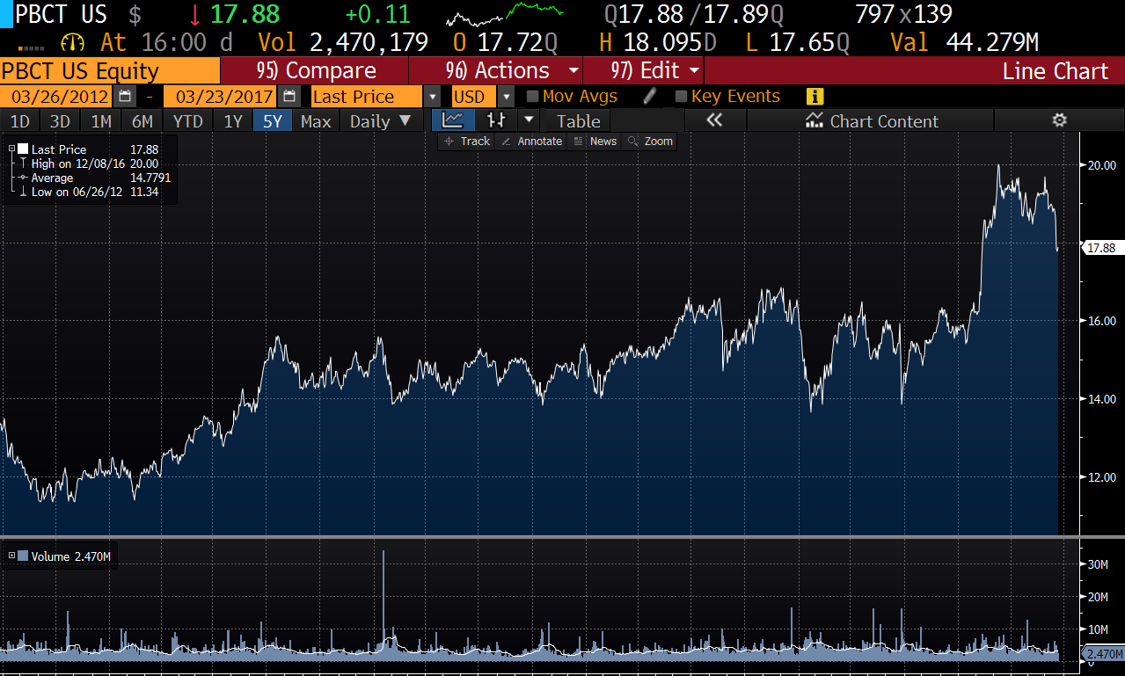
Competitive Analysis
People’s competes with both regional banks and big, national banks. Key competitors of similar business model are M&T and Webster Bank, and Bank of America as a large bank. To be able to remain competitive, PBCT must offer competitive rates and fees on their product offerings in order to maintain a solid customer base. People’s peers have better Net Interest Margins and Tier 1 Capital Ratios, but People’s draws on such a high quality asset base that they have a high efficiency ratio compared to their peers. They also have an above average loan to deposit ratio.
Competitive Advantages
People’s has a strong market share and geographic exposure. First, the company has a geographic advantage by being located in southwestern Connecticut. New England has a higher than average both GDP growth and median household income. Fairfield County, CT, where PBCT has the #1 market share, has even more of an above average median income, leading to a higher quality deposit base and less defaults on loans. In addition, the company has a relationship with Stop & Shop supermarkets, allowing the company to have branches within the stores which are open 37% longer and are 30% more cost efficient. This allows the company to maintain strong relationships with their customers.
Risks
As PBCT nears the $50 billion asset threshold, they will be subject to increased regulation and compliance costs. The company has stated they will not cross this until they feel ready, so they may self-impose their own growth as a result. Their margins and capitalization have been decreasing as of late, and with requirements set to increase under Basel III in 2019, PBCT may be under pressure. Moody’s also downgraded PBCT citing these factors.

Report Prepared By:
Sean Elliott and Taylor VanFleet on 3/23/2017
Sources: Bloomberg, Yahoo! Finance, 2016- 2017 PBCT Annual Reports, Value Line

