Anheuser-Busch InBev SA/NV (NYSE: BUD)
Sector: Consumer Goods
Target Price  $133.28 | Current Price  $110.89 | 52 Week High  $136.08 | 52 Week Low  $98.28 | P/E  22.44 | Market Cap.  $215.67B | Dividend Yield  3.08% | Beta  .97
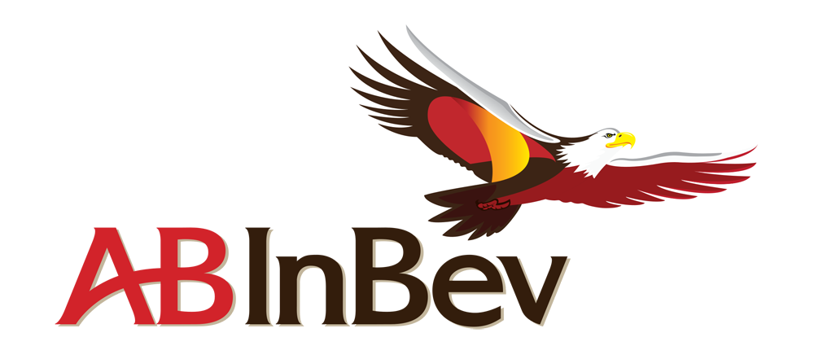
Business Description
Anheuser-Busch produces, markets, distributes and sells over 500 beer and malt beverage brands as well as soft drinks. Some of these brands include Budweiser, Corona, Stella Atrois, Beck’s Leffe, Hoegaarden, Castle Lager, Castle Lite, and Redd’s. These are other beverage brands are sold in more than 150 countries around the world. Budweiser was also name the #1 most valuable beer brand in the world. AB InBev is the world’s largest brewer by volume and one of the world’s top five consumer products by revenue. The company is headquartered in Leuven, Belgium but has offices and sites around the world.
In October 2015, Anheuser-Busch announced a successful all cash bid of $107B to buy SABMiller, and the acquisition was completed a year later on October 10th, 2016. Revenues are expected to grow 20% in 2017 as well as deliver synergies of up to $2.8B over the next 3-4 years.
Industry Trends
The breweries industry has seen more competition from spirits and wine which is anticipated to slow revenue growth. Breweries have been engaging in cost savings programs to streamline operations and reduce costs. AB InBev has participated in this trend with their Zero-Based Budgeting and Voyager Plant Optimization programs which aim to lower costs year over year while at the same time improve quality, safety and the environment. Craft brewing has become more critical to developing the brand name. BUD has engaged in this with producing more craft brands. The industry itself has been subject to increased globalization and exports have been forecasted to slow. AB InBev is prepared for this as their recent completed merger with SABMiller has given them a much larger distribution network. The consolidation of the industry has been a trend as well, and the majority of the industry’s market share is shared between Anheuser-Busch InBev and their biggest competitor Molson Coors Brewing Company.
Investment Thesis
We believe that BUD is a buy due to its strong market position in key markets. Also, the company has been expanding in to key emerging markets, such as China, and has positioned themselves favorably. In addition, the strategic merger with SABMiller increases efficiencies in and market share in an industry where cost savings and consolidation have been a profitable trend. They also offer a high dividend, which is attractive to us as investors.
Valuation Assumptions | Key Financials
WACC: 7.75%  Terminal FCF Growth Rate: 2.00%  Estimated EPS (2018): $4.54  Ave. 10 year Rev Growth Rate: 4.9% | ROA: .63%  ROE: 2.19%  ROIC: 4.98%  Net Income: $8.27B

Corporate Social Responsibility
Independent Chairperson: 1.00, Yes (Industry Average: 0.25)
Sustainalytics Rank: 79 (100 is best)
Social Disclosure Score: 63.16 (100 is best)
BUD is engaged in a Better World platform, which aligns their environmental, social and community efforts around three core principles; A growing world, A cleaner world, A healthier world.
Key highlights of 2016: The 4e program helped 20,000 shopkeepers in six countries develop skills needed to improve business sustainability. SmartBarley program works with 3,200 growers in nine countries to cultivate the highest quality barley with best yields and lowest cost. Steela Artois’ Buy a Lady a Drink program with Water.org aims to tackle the global water crisis and has helped provide clean water to more than 800,000 people in the developing world.
5-Year Stock Performance
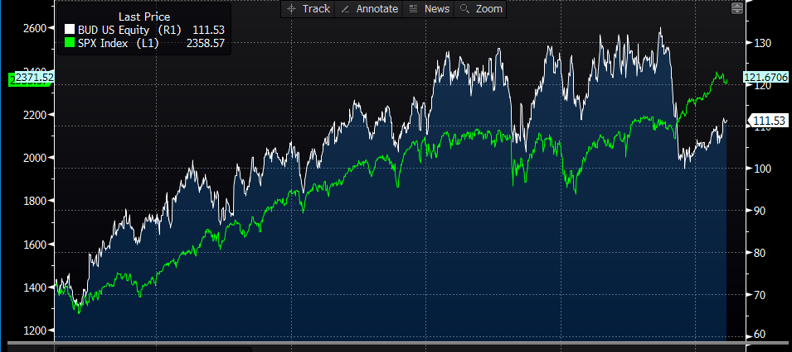
Competitive Analysis
AB InBev’s largest competitors are Heineken, Carlsberg, Tsingtao Group and Molson Coors Brewing Company. The industry itself only has a few players with a substantial international presence, which BUD has. Larger brewing companies often became an international name through direct exports, licensing agreements and joint venture agreements. The last few decades there has been increased consolidation within both developed and developing markets. AB InBev has participated in this through their various acquisitions over the years including Beck’s in 2002, merger with Grupo Model in 2013, and most recently SABMiller in 2016. These international companies must also compete with national, regional local and imported beer brands. As having the number one beer brand under their organization, AB InBev is one of the most recognizable brands in the world and has benefitted from this recognition to remain number one in three of the five biggest beer markets, as well as a top player in key developing markets as well.
Competitive Advantages
Anheuser-Busch’s company strategy is that of a global platform with strong market position in key markets. They are the #1 beer company by volume in the United States, Mexico and Brazil, which are three of the five most profitable beer markets in the world. They are also the #1 by volume in the fast-growing premium beer category in China. The company is also well diversified. 47.2% of their revenue comes from developed markets and 52.8% comes from developing markets such as Argentina, Brazil, China, South Africa where they continue to grow and gain market share. The company also benefits from a strong and recognizable brand portfolio. Through cost efficiency programs, Anheuser-Busch has been cost savings and more efficient operations. In addition, they have an experienced management team that have a record of accomplishment of delivering synergies through business combinations, which is important in a consolidating industry.
Risks
As a global company, BUD is subject to any global market downturns, as well as any fluctuations in exchange rates. Due to the reliance on raw materials for their production process, they are subject to changes in price and the availability of these as well. Changing consumer preferences could also impact the company. As a beer company, reputation and image is important to maintain. Also, there is a risk that the company is unable to capitalize on all or some of the synergies that are expected under the SABMiller settlement agreement.
Report Prepared By:
Rob Tavernier, Sean Elliott and Taylor VanFleet on 4/5/2017
Sources: Bloomberg, Yahoo! Finance, 2016- 2017 BUD Annual Reports, Value Line, IBIS

