Laboratory Corporation of America
(NYSE: LH)
Sector: Healthcare

Target Price  $161.35 | Current Price  $133.04 | 52 Week High  $141.32 | 52 Week Low  $97.79 | P/E  17.94 | 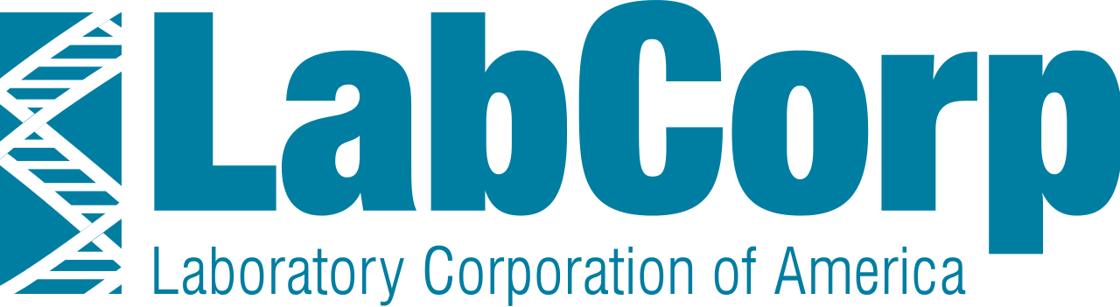  Market Cap.  $13.65 | Dividend Yield  N/A | Beta  1.1

Business Description
Laboratory Corporation of America (LabCorp) is the world’s leading healthcare diagnostics company. LabCorp pr ovides comprehensive clinical laboratory services and end-to-end drug development support. LabCorp operates in two distinct segments: LabCorp Diagnostics (LCD) and Covance Drug Development (CDD). LCD assists clients in diagnosis, monitoring, and treatment of diseases and medical conditions through testing in their independent clinical laboratories. LCD offers over 4700 tests within their 39 primary laboratories and 1700 patient service centers. LCD tests on average 500,000 patient specimens daily. CDD provides a range of drug development solutions as a contract research organization (CRO). Clients, mostly pharmaceutical companies, contract LabCorp’s CDD department services to conduct preclinical research through stages of clinical development and into commercialization. LabCorp reported $8.68 billion of revenue during the 2015 fiscal year. The breakdown based on percent of revenue in 2015 was 73% LCD and 27% CDD.

Industry Trends
LCD: The US clinical laboratory testing industry reported $75 billion in revenue in 2015. The LCD industry is highly saturated and competitive. There are 3 types of providers: Hospital-based labs (9,000), Physician-office Labs (122,000), and Independent Labs (6,000). LSD competes with all of these providers. Additionally, there is a trend of consolidation within the industry. Larger companies will continue to outperform smaller labs due to economies of scale and this trend will only continue as LabCorp and other large independent clinical lab testing companies continue to actively acquire. Furthermore, only large diagnostic companies like LabCorp can meet the demands of testing facilities from health plans.
CDD: This industry comprises of outsourcing R&D services from pharmaceutical companies. The industry drivers include: cost savings for pharmaceutical companies, which are increasing because of regulation and increased efficiency by CROs, the prolonged timeline of drug development so clients can focus on more lucrative efforts rather than drug development and testing, and the patent cliff that started in 2011 marking the patent expiration of more than 300 drugs. CROs are currently in high demand and CDD looks to take advantage of these industry trends.

Investment Thesis
LabCorp is undervalued and well positioned for future success for the following reasons:
- LabCorp is a low cost provider of medical services that are beginning to face increasing price transparency.
- Healthcare spending has significantly outpaced GDP over the past several decades. LabCorp is well positioned to capitalize in many areas of the healthcare industry as a diagnostics and drug development company.
- LabCorp’s acquisition of Covance allows them to better serve pharmaceutical companies and diversify their client base. With LCD and CDD, LabCorp is the only company that offers preclinical research into commercialization.

Valuation Assumptions  WACC: 10%  Terminal FCF Growth Rate: 2.2%  Estimated EPS: 7.53; EST P/E: 15.19x  Estimated BVPS: 48; P/B: 3.34x | Key Financials  ROA: 5.92%  ROE: 12.57%  Margin: 14.74%  Net Income 2015: $436.9M
Corporate Social Responsibility
Sustainalytics Rank: 29.3 (100 is better)
Institutional Shareholder Services Quality Score: 2 (1-10, 10 is higher risk)
Women Directors %: 11.1% (Industry average: 11.8%)
Average Exec. Compensation: $4.4 million (Industry average: $1.8 million)

5-Year Stock Performance
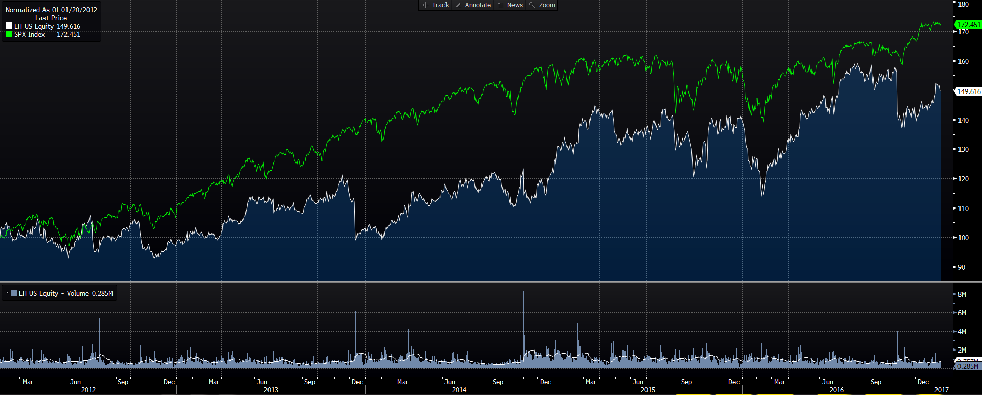

Competitive Analysis
Quest Diagnostics, Sonic Healthcare – Medical diagnostics and multidisciplinary medical practices companies, compete with LCD
Quintiles – Contract Research Organization, competes with CDD

Competitive Advantages
LabCorp enjoys a number of competitive advantages. They are constantly developing new, technologically advanced tests with a focus on applying molecular diagnostics to different testing areas. They are improving the user experience with the Lab Corp Beacon platform, and they are using population health analytics programs to supply intelligence tools to hospitals, physician practices, and ACOs.
After the Covance acquisition, LabCorp is vertically integrated, and positioned to help pharmaceutical companies develop drugs from inception all the way to market. Finally, their global presence allows them to assist with global clinical trials.

Risks
Operational Risk: LabCorp faces operational risks including cybersecurity risk and disruption of third party services used for transportation of samples.
Political Risk: LabCorp is impacted by changes in government healthcare policy. The current political climate is unpredictable, and although it appears likely that the ACA will be repealed, there is no indication of how the replacement will affect LabCorp.

Report Prepared By:
Sean Elliott & Rob Tavernier on 1/25/2017
Sources: Bloomberg, MorningStar, Yahoo! Finance

