Company: Texas Instruments, Inc. | Ticker: TXN Current Price: $50.28 | Sector: Technology | Industry: Semiconductors
Target Price: $56  Stop Loss: $40  52 Week High/ Low: $43.49 -$59.99 | TTM P/E: 16.88  Forward P/E: 17.43  EPS: $2.98 | Beta: 1.25  Credit Rating: A1  Rating Outlook: Stable | Market Cap: $51(B)  Avg Vol (12 Month): 8.675 mil  Dividend Yield: 3.02 %

Company Background:
Texas Instruments is the world's fourth largest semiconductor company, based on revenues. The company's semiconductors are used for various functions including: converting and amplifying signals, interfacing with other devices, managing and distributing power, processing data, canceling noise and improving signal resolution. TXN's product portfolio includes the types of products that are integral to almost all electronic equipment. TXN's product segments are analog, embedded processing, and other. Analog semiconductors change real-world signals -- such as sound, temperature, pressure or images -- by conditioning them, amplifying them, and often converting them to a stream of digital data so the signals can be processed by other semiconductors. Embedded Processing products are the "brains" of many electronic devices. Embedded processors are designed to handle specific tasks and can be optimized for various combinations of performance, power and cost, depending on the application. The devices vary from simple, low-cost products used in electric toothbrushes to highly specialized, complex devices used in wireless base station communications infrastructure equipment. Embedded Processing products are used in many markets, particularly industrial and automotive. Other products include smaller semiconductor product lines and handheld graphing and scientific calculators, Digital Light Processing (DLP) products primarily used in projectors to create high-definition images, and royalties received for patented technology that TXN licenses to other electronics companies. Specifically, industrial made up 31% of TI's revenue, automotive 15%, personal electronics 30%, communications equipment 13%, enterprise systems 6%, and other 5%.
Industry Outlook:
Revenues are expected to grow at low single digits for the semiconductor industry. The PC market should stabilize as tablet cannibalization slows. Consumer and communications markets should stay healthy while automotive and industrial markets improve. These latter markets are especially important for analog semiconductors. Overall, growth in semiconductors is highly correlated to global GDP.
Investment Thesis:
Texas Instruments is the leader in the higher margin analog chip market. TI has a wide economic moat in this area due to its proprietary designs and switching costs. TI’s size also allows it to sell to a wide range of industries, lowering its exposure to any one customer or end market. TI’s purchase of National Semi and investments in manufacturing will allow them to take on more orders and improve gross margins. Their embedded chip business is well positioned to take advantage of any growth in the “Internet of Things” and specific industrial uses such as self-driving cars.

Investment Risks:
- Cyclical chip industry
- Highly fragmented market with lots of competition
- Hard to expand market shares quickly due to switching costs

3-5 take away from last quarter investor call transcript:
- Steady decline in inventory, leading to higher cash flow
- Declining growth in iphone sales passes through to them
- Margin improvements from product mix shift toward industrial and automotive

Financial Performance: | Discounted Cash Flow
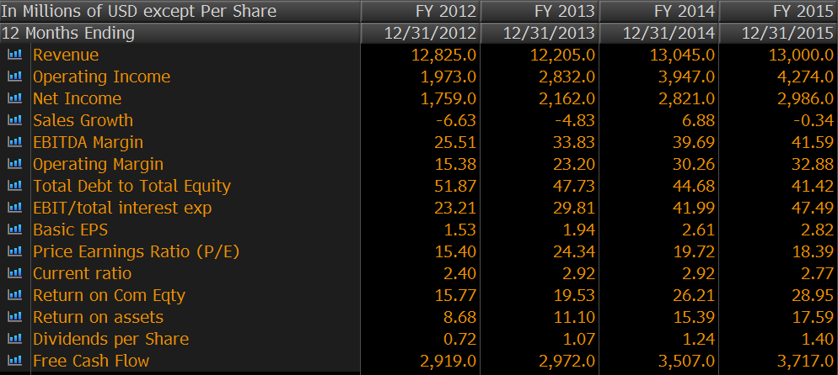 | 2011-15 2016-20  Avg Revenue growth -1% %  Avg EBITDA Margin 36% 42%  Avg Net Income Margin  Avg Debt/Equity  Avg Interest / EBITDA  Cost of Debt 1.2%  Tax Rate 29.17%  Cost of Equity 12.2%  WACC 9.6%  Perpetuity Growth Rate 4.0%  Analyst Opinion  Buy: 13 Hold: 21 Sell: 3  Rating Target  S&P Net Advantage 3 Star $57  Morning Star 4 star $57  Value Line Timeliness2 $65-$80

Relative Valuation | Total Return
FY2015 Microsemi Linear Tech Intersil Int. Device Industry Texas Ins  P/E 27.71 20.10 27.52 15.31 42.79 16.92  P/B 2.35 5.96 1.65 3.70 4.11 5.13  Dividend Yield - 2.93 4.04 - 1.64 2.78  PEG Ratio 0.56 2.74 3.52 0.56 1.52 1.77  EPS 1.10 2.04 0.44 1.12 1.47 3.01  Rev Growth (3 Yr) 7.48 5.25 -4.95 3.41 8.52 0.57  NI Growth (1 Yrs) 62.77 -0.32 2.72 95.07 41.72 7.14  Operating Margin 11.12 43.06 12.55 17.25 16.95 35.81  Debt / Equity 79.61 0 0 44.12 30.60 41.42  Market Cap 3.37B 9.82B 1.58B 2.24B 9.28B 51.14B | DIS Sector S&P 500  YTD -7.56 -10.11 -10.63  Last 3 Years 62.24 35.61 27.35  Last 5 Years 60.20 56.15 51.60  CSR Characteristics  Company Industry  ESG Disclosure Score 41.32 23.43  Governance Disclosure Score 66.07 51.07  Social Disclosure Score 22.81 25.15  Environmental Disclosure Score 41.32 16.83

