|  |  |  |  |
| --- | --- | --- | --- |
| ­Toll Brothers Inc.  Ticker: TOL US  Sector: Home Builder  Industry: Household Durables | Intrinsic Value: 43.70  Current Price: 36.58  Stop Loss: 28.50  Upside Review: | TTM P/E:  Forward P/E: 13.4  Beta: 1.3 | Market Cap: $6,485.87(M)  Dividend Yield: 0.0  52 Wk Range: 30.81-42.19 |
| **Business Summary:** Toll Brothers, Inc. is a builder of upscale single-family detached homes, townhouses, and condominiums located primarily on land it has developed. The company operates in 19 states and in 50 markets. Sold 5,397 single-family and attached homes in fiscal 2014. Single-family detached homes sell for between approximately $200,000 and $2,000,000. Company provides financing in conjunction with several mortgage banking companies. (Valueline)  **Industry Trends:** There’s a continuing recovery in this industry from the crisis. Revenues have increased annually through 2013, with macroeconomic factors suggesting the trend to continue. Large inventory of existing houses being on the market with more competitive pricing will continue to slump returns in the short-term. However, a continued increase in consumer confidence, softening lending standards and overall economic growth will benefit builders greatly. A consumer taste shift into renting versus buying will be the greatest risk moving forward.  **Investment Thesis:** Mortgages for purchases are recovering, new home sales while not at post crisis peak are strong, employment figures are good and wages are due for a bump. Most all economic factors point to a strong bounce back in the industry. Trepidation over interest rates should be subdued as mortgages are largely adjustable rate and fixed rate, despite likely hood of increase, are still at all-time lows. The company in 2014 made a strategic acquisition to expand operations in the west coast, 5,200 home sites. | | **Competitive Analysis:** The company is the premier luxury home builder in the country. On average Toll homes are $300,000 more expensive than the mean of the top 5 builders, definitively placing it in another market. The company assuredly has cost savings and business model advantages over its true competitors in scale, coverage and brand awareness. While the lower priced builders have experienced dramatic revenue growth since the crash this luxury market has yet to see comparable growth. As the market continues to recover I expect luxury home sales to do very well with this company being a large benefactor  **Pros:**   * Cyclical housing rebound may prove stronger than expected with Millennials aging into home buying years * Expanding City Living and Apartment Living brands should do well to capture customers who prefer to rent * Interest rate environment is a concern however at Toll’s price point customers are much less price sensitive   **Risk Factors:**   * Very capital intensive, especially in luxury front, so return on capital is not best in class * City Living and Apartment Living brands are yet unproven and increase risk for the company | |
| 5 Year Stock Performance: | | **CSR Characteristics**    ESG Disclosure Score: 16.53 (12.87 Industry)  Governance Disclosure Score: 51.79 (49.40 Industry)  Social Disclosure Score: 19.30 (12.28 Industry)  Environment Disclosure Score: 6.98 (4.26 Industry) | |
| Competitor Comparison: | |

**Mortgage Originations**



Source: Mortgage Bankers Association

Looking at the chart above, we are finally seeing a good trend of mortgages meant for purchases outpacing those for refinancing. While mortgage originations have been much higher in quarters after the bubble burst a majority of those were distressed refinancing.

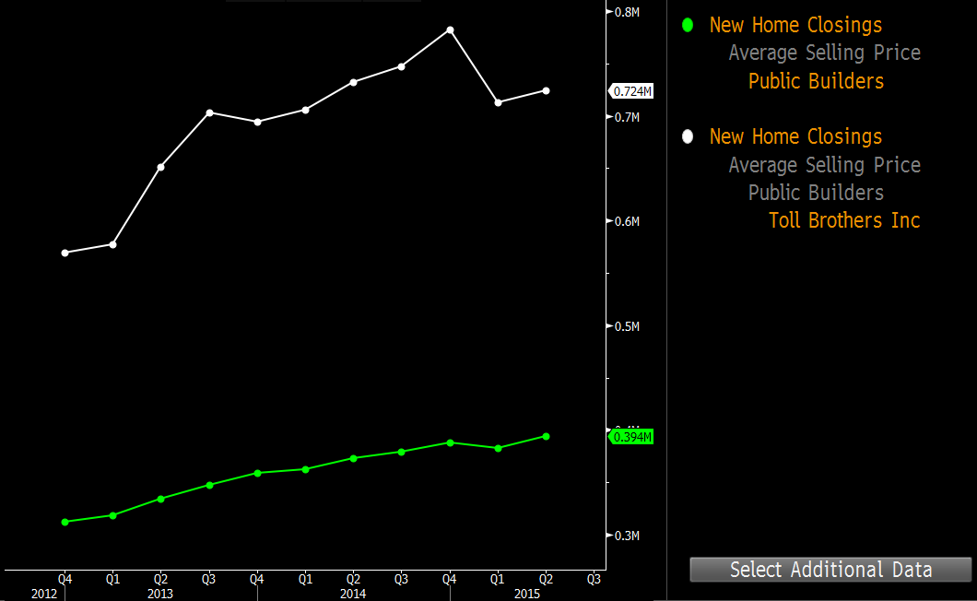

Source: Bloomberg

Of the five builders with the highest sales Toll averages the highest price by far. Toll is a luxury home builder, their competition in this market are niche and smaller builders. Therefore, Toll must have many cost savings advantages since they operate at a scale much larger than its true competition. Also this tells us direct comparison to other large public builders is inconclusive because of the assumed differences in materials/labor/structure utilized by the companies.

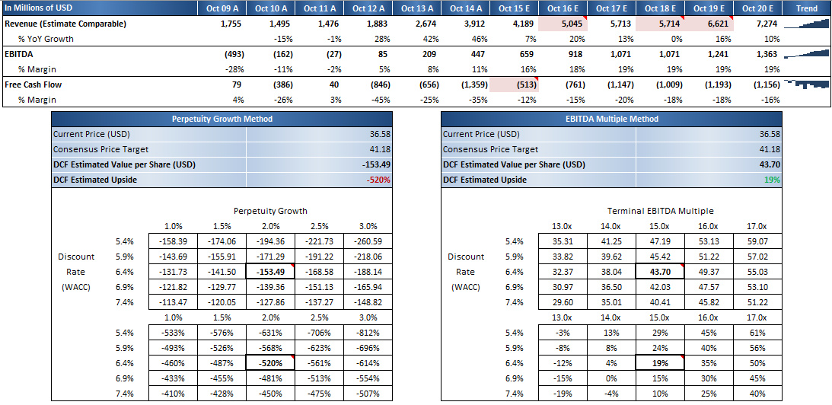 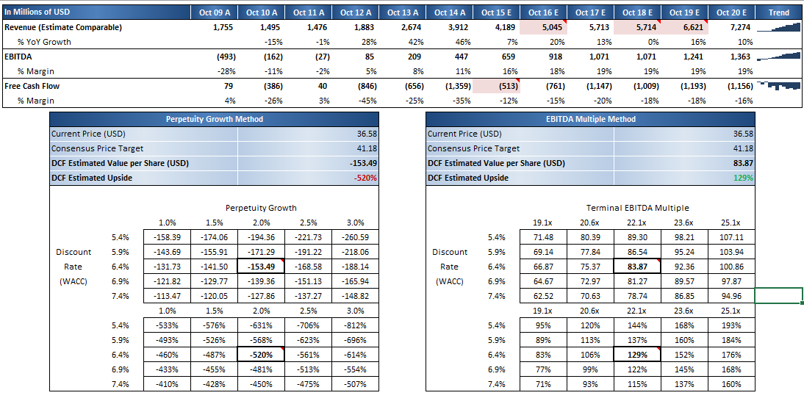

**Bloomberg DCF Analysis**