Company: TJX | Ticker: TJX Current Price: $71.89 | Industry: Consumer | Sub Industry: Apparel Retail
Target Price: $80  Stop Loss: $ 57.51  52 Week High/ Low: $ 63.53 – 76.93 | TTM P/E: 21.86  Forward P/E: 19.89  EPS: 3.28 | Beta: 0.66  Credit Rating: A+  Rating Outlook: Stable | Market Cap: $48.07B  Avg Vol (12 Month): 3.4M  Dividend Yield: 1.20%

Company Background:
- TJX Companies is the largest U.S. off-price family apparel and home fashion retailer. As of February 1, 2015, the company's core Marmaxx Group division operated 1,119 T.J. Maxx stores, 975 Marshalls stores, six Sierra Trading Post stores, sierratradingpost.com, and tjmaxx.com. TJX also operated 487 HomeGoods in the U.S.; 33 HomeSense and 407 T.K. Maxx stores and tkmaxx.com in Europe; and 96 HomeSense, 234 Winners and 38 Marshalls stores in Canada
- In FY 15 (Jan.), the breakdown of total net sales and profit by the four operating segments are as follows: Marmaxx, 64% and 70%, respectively; HomeGoods, 12% and 12%; TJX Canada, 10% and 10%; and TJX Europe, 14% and 9%. Net sales by product categories were as follows: clothing and footwear, 57%; jewelry and accessories, 14%; and home fashions, 29%.
Industry Outlook:
- Net sales are expected to increase 5.6% in FY 16 (Jan.) -- after some foreign currency headwinds -- and 6.9% in FY 17
- Apparel sales to grow 1% to 2% in 2016, supported by new fashion trends, and some easing of promotional activity. Off-price retailers are best positioned to gain market share in 2016, given their attractive value pricing, frequent in-flow of new merchandise, and ability to quickly move in and out of product categories based on customer demand
- Apparel retailers are expected to focus their expansion on outlet centers in order to reach cost-conscious consumers who might otherwise not shop their brands and to raise brand awareness among international shoppers.
Investment Thesis:
- TJX steadfastly focused on its key growth pillars, including continued retail expansion (through the addition of new store locations), and growth in same-store sales (which have risen for 27 consecutive quarters through October 31, 2015).
- Over the long term, it sees an opportunity to grow its store base by more than 50% to almost 5,500 locations across the U.S., Europe and Canada.
- In October 2015, the company acquired Trade secrets, an off-price retailer that operates 35 stores in Australia - for AUD $80 million (about US$59 million).
- TJX recently held about $2.1 billion in cash (over $3.10 a share), with a 1.2% dividend yield also adding to total return.
Investment Risks:
- The company could be vulnerable to a sharp pullback in consumer discretionary spending.
- Potential stagnation in market share growth, amid intensifying competition in a challenging retail environment.
- Severe foreign currency headwinds arising from the company's growing international operations in Canada and Europe.
3-5 take away from last quarter investor call transcript:
- Third quarter consolidated comparable store sales increased 5% continuing our strong trend this year and exceeding our plan.
- Year-to-date we have retired 19.1 million shares buying back 1.3 billion of stock. We continue to anticipate buying back 1.8 billion to 1.9 billion of TJX stock this year.
- TJX Canada comp sales increased 10% marking the third consecutive quarter of double-digit comp growth.

Financial Performance: | Discounted Cash Flow
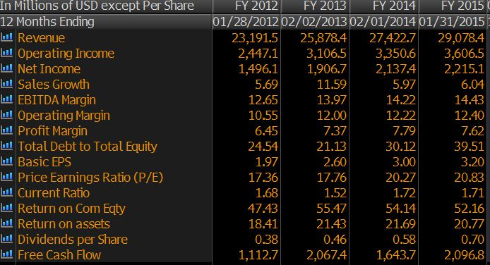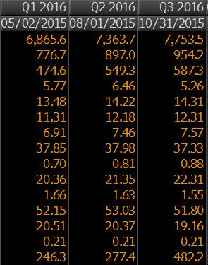 | 2010-14 2015-19  Avg Revenue growth 7% 7%  Avg EBITDA Margin 13% 14%  Avg NOPAT 7% 8%  Avg FCF/Margin 7% 7%  Cost of Debt 1.4%  Tax Rate 38%  Cost of Equity 8.4%  WACC 8.2%  Perpetuity Growth Rate (Terminal) 2.5%  Analyst Opinion  Buy: 22 Hold: 9 Sell: 0  Rating Target  S&P Net Advantage 5 Star $80  Morning Star  Value Line Timeliness2 $85-100

Relative Valuation | Total Return
FY2015 ROSS strores Burlington Stores Stein Mart Inc Industry TJX  P/E 22.52 26.68 10.25 19.67 21.89  P/B 9.32 - 4.32 6.49 11.05  Dividend Yield 0.82 0 77.49 15.95 1.12  PEG Ratio 2.08 1.21 0.76 1.51 2.01  EPS 0.54 0.20 -.01 0.33 0.88  Rev Growth (1 Yr) 7.08 6.22 -.99 3.80 5.26  NI Growth (1 Yrs) 7.75 1.22 -0.07 3.37 7.57  Operating Margin 12.08 3.15 0.23 5.70 12.31  Debt / Equity -3.81 - 245.93 48.92 -11.47  Market Cap 22.30B 4.15B 312.44M 15.02B 48.07B  Sources: Bloomberg, S&P NetAdvantage, VLIS, Morningstar | TJX Sector S&P 500  YTD 1.564 -3.56 -6.97  Last 3 Years 17.98 7.91 9.93  Last 5 Years 24.89 12.41 9.56  CSR Characteristics  TJX Industry  ESG Disclosure Score 28.71 18.98  Governance Disclosure Score 55.36 49.64  Social Disclosure Score 24.56 31.58  Environmental Disclosure Score 15.63 14.06  Prepared By: Akhil Sood, 02/17/2016

- Net sales are expected to increase 5.6% in FY 16 (Jan.) -- after some foreign currency headwinds -- and 6.9% in FY 17
- Over the long term, it sees an opportunity to grow its store base by more than 50% to almost 5,500 locations across the U.S., Europe and Canada.
- In October 2015, the company acquired Trade secrets, an off-price retailer that operates 35 stores in Australia - for AUD $80 million (about US$59 million).
- TJX recently held about $2.1 billion in cash (over $3.10 a share), with a 1.2% dividend yield also adding to total return.
- Year-to-date we have retired 19.1 million shares buying back 1.3 billion of stock. We continue to anticipate buying back 1.8 billion to 1.9 billion of TJX stock this year
- growth in same-store sales (which have risen for 27 consecutive quarters through October 31, 2015).
- Value Line : We think this stock will remain a relative outperformer for the coming six to 12 months. Its risk profile is another plus. TJX is ranked 1 (Highest) for Safety and scores high marks for nearly every stability indicator, including a well-below average Beta coefficient

