Company: Schwab (Charles) Corp | Ticker: SCHW Current Price: $ 21.80 | Industry: Financials Sub Industry: Investment Banking & Brokerage
Target Price: $ 29.5  Stop Loss: $ 17.44  52 Week High/ Low: $22.85-35.72 | TTM P/E: 23.13  Forward P/E: 14.8  EPS: $1.03 | Beta: 1.33 (Bloomberg)  Credit Rating: A (S&P)  Rating Outlook: Positive | Market Cap: $28b  Avg Vol ( 3 M): 10.64m  Dividend Yield: 1.02%

Company Background:
Charles Schwab operates in the brokerage, banking, and asset management businesses. The company runs a large network of brick-and-mortar brokerage branch offices and a well-established online investing website. It also operates a bank and a proprietary mutual fund business. Additionally, Schwab offers services to independent investment advisors. Segments: Investor Services (77% of ’14 Revs.); Institutional Services (23%). At the end of 2015, the company, through subsidiaries, served about 9.8 million active client accounts, and held client assets of approximately $2.51 trillion. Its banking subsidiary, Charles Schwab Bank (member FDIC and an Equal Housing Lender), provides banking and lending services and products
Industry Outlook:
- We have a positive fundamental outlook on the investment banking and brokerage sub-industry looking out over the next twelve months. Equity trading volumes have rebounded from weak results in most of 2014. Mergers and acquisitions (M&A) continue to be the strongest performer in 2015 following a record year in 2014 since the financial crisis.
- We believe both institutional and retail investors will continue to shift more asset allocations to equities from fixed income, which may boost market performance
Investment Thesis:
- Besides innovation with SCHW's platforms and products, the company is dependent on short term interest rates, as nearly 40% of its top line came from net interest income in 2015 versus 37.5% in 2014. We view favorably its stable asset-based revenues, and think earnings could rise materially after the Federal Reserve raises short-term interest rates, which we expect to happen sometime in 2016.
- The first 50-basis-point rate increase will reverse the majority of the annualized nearly $800 million of money market fund fee waivers, and about half of the company's interest-earning assets are floating rate.
- According to Morning Star, the moat rating for Charles Schwab is wide. Given its massive scale and industry-leading cost efficiency, the company can sustain severe competitive pressures
Investment Risks:
- Risks include a decline in trading volume and potential equity market declines. Current low short-term interest rates may extend well into 2016, which may limit SCHW's earnings growth.
- The economic recovery in the U.S. remains fragile in the meantime, and it is possible that rates will remain suppressed for an extended period. If so, investors will have to wait even longer for a strong and sustained recovery in Schwab's interest profitability
3-5 take away from last quarter investor call transcript: Q4 2015
- NI for Q4 2015 was $416 million, up 11% from $376 million for Q3, and up 19% from $350 million for Q4 2014
- NI for 12 months ended 12/31/2015 was $1.4 billion, up 10% from the year-earlier period.
- Attracted $134.7 b in core net new assets, up 8% from 2014; Adding in excess of $100 billion for the 4th consecutive year; Total client assets at year-end were $2.51 trillion, up 2%.

Financial Performance: | Discounted Cash Flow
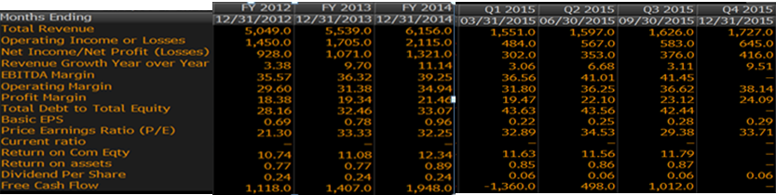 | 2010-15 2016-20  Avg Revenue growth 8% 10%  Avg EBITDA Margin 35% 36%  Avg Net Income Margin 20% 21%  Avg Debt/Equity 0.4 0.4  Avg FCF / Margin 20% 21%  Cost of Debt 1.00%  Tax Rate 36%  Cost of Equity 10.7%  Cost of Preferred Equity 5.6%  WACC 9.5%  Perpetuity growth rate 3.5%  Analyst Opinion  Buy:8 Hold: 5 Sell: 1  Rating Target  S&P Net Advantage Strong Buy $39  Morning Star **** $32  Value Line T: 3 S: 3 $35-50

Relative Valuation | Total Return
SCHW T. Rowe Price TD Ameritrade Industry  P/E 23.1 14.55 18.06 14.15  P/B 2.6 3.5 2.8 1  Dividend Yield 1.02% 3.15% 2.5% NA  PEG Ratio 0.81 1.93 1.08 1.18  EPS 1.03 4.63 1.49 0.23  5 yr-Revn Grth 8.4% 17.6% 5% NA  NI % 24% 29% 25% -  Operating Margin 38% 45% 40% -  Debt / Equity 0.4 - 0.4 2.1  Market Cap 28b 16.71b 14.40b 280.3m  Revenue TTM 6.5b 4.2b 3.19b 165.5m  Net Income TTM 1.45b 1.21b 814m NA  AUM $2.5 trillion 763.1b -- -- | SCHW Industry S&P 500  YTD -22.47% -15.655 -4.96%  2015 9.87% -3.11% 1.38%  Last 3 Years 32.82% 18.31% 15.13%  Last 5 Years 14.81% 5.89% 12.57%  CSR Characteristics  SCHW Industry  Business Ethics Policy 1 1  Governance Disclosure Score 51.79 51.07  ESG Disclosure: 20.18 19.74  Social Disclosure Score 13.33 15.33  Environmental Disclosure Score 8.04 6.7  Prepared by Neel Munot (Feb 10, 2016) using Bloomberg, Value Line, S&P Net Advantage, Morning Star, Yahoo Finance

