Polaris Industries Inc.  Ticker: PII  Sector: Consumer Discretionary  Industry: Leisure Products | Intrinsic Value: $151.21  Current Price: $107.83  Stop Loss: $87  Upside Review: $166.69 | TTM P/E: 17.58  Forward P/E: 13.52  Beta: 1.23 | Market Cap: $7.94 Bn  Dividend Yield: $2.07 (1.70%)
Business Summary: Polaris Industries manufacturers off-road vehicles for recreational and utility use. Vehicles include motorcycle, snowmobiles, and side-by-side vehicles. The company is present in the U.S., Canada, Mexico, Western Europe, and Australia. Polaris provides replacement parts and accessories for all products and sells through a network of independent distributors and dealers.  Industry Trends: Unemployment has steadily been decreasing since 2009 and now sits at 5.1%. Additionally, U.S. home prices have rebounded from the recession. Both are good pieces of news for the leisure product industry. When the workforce is employed, there are more discretionary funds available for recreation. Following suit, when home values rise, homeowners feel more comfortable spending cash. The industry as a whole has a large potential in developing countries. Low gasoline prices also make these vehicles more affordable to operate. Lastly, baby boomers will continue to be drawn to Polaris Vehicle activities.  Investment Thesis: Polaris is well positioned for substantial growth for the next 3-5 years. The company has been bolstering expansion efforts in Europe, which will also diversify of risk. Currently, the stock is experiencing a selloff based on slightly lower reforecast earnings for 4Q15 and recall of 53,000 RZR units. That being said, Polaris currently sits just above its 52-week low and is severely undervalued. Look forward to big gains once the market realizes the company’s true market value. |  | Competitive Analysis: Polaris is deeply rooted in the ORV’s snowmobile markets and also has a presence in motorcycles manufacturing. There are only a handful of companies that are involved in these markets. Polaris and Artic Cat are the only companies that are heavily involved in both ORV and Snowmobiles. Most other Polaris’s competitors only focus on one market, for example, Harley-Davidson is the world’s largest motorcycle manufacturer.  Pros: Polaris is very well diversified across markets. Additionally, there is very low threat of new entrants to the industry. This is due to the high capital requirements for R&D and manufacturing of products. Polaris has a strong brand identity specific to product appeal and because it can only be challenged by a handful of players, you can expect consistent growth. Lastly, Polaris has been acquiring its suppliers over recent years and has firm control over supply chain and dealer inventories.  Risk Factors: It can be argued that these products appeal to a niche market only in certain geographic locations with open-wilderness easily accessible. Additionally, the recreational products rely heavily on disposal income from healthy economies. Therefore it is vulnerable to down markets. Additionally, because Polaris is present in so many sub-industries, there is a risk that it could be spread its resources too thin.
5 Year Stock Performance:  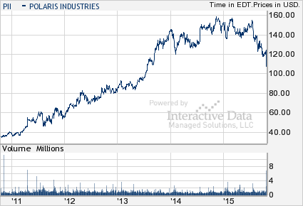 |  | Key Valuation Assumption  Est Revenue Growth: 11%  WACC: 8.7%  Expected Inflation: 0.0%  Terminal Growth Rate: 3.9%  10 Yr Risk Free Rate: 2.03%  Equity Risk Premium:  Tax Rate: 32.6%  Key Financial Data  Est 2015 EPS: 7.40  Est 2016 EPS: 8.61  2-5 Yr Est EPS Growth:  PEG (TTM): 0.93  Credit Quality: n/a  ROE: 54.1%  ROA: 22.2%  Price/Book: 8.98  Price/Cash Flow: 11.6  Debt/Equity: 25.9%  Current Ratio: 1.3  Quick Ratio: 0.4  CSR Characteristics  ESG Disclosure: 17.36/14.05  Governance Disclosure Score: 51.79/50.36  Social Disclosure Score: 19.30/15.79  Environmental Disclosure Score: 1.55/1.55  Prepared by Jason Harris (October 20, 2015)  Information from: Bloomberg, Value Line, S&P Net Advantage, Yahoo
Competitor Comparison:
