Company: Microsoft Corp. | Ticker: MSFT Current Price: $ 52.15 | Industry: Technology Sub Industry: Software infrastructure
Target Price: $ 62.06  Stop Loss: $49.62  52 Week high/ Low: $39.72/56.85 | TTM P/E: 37.10  Forward P/E: 16.4  EPS: $1.42 | Beta: 1.14 (Bloomberg)  Credit Rating: AAA (Moody)  Rating Outlook: slow growth | Market Cap: $433b  Avg Vol ( 3 M): 49.68m  Dividend Yield: 2.8%

Company Background:
Microsoft Corp is engaged in designing, manufacturing, selling devices, and online advertising. Its products include operating systems for computing devices, servers, phones and other devices. Hardware products include Nokia mobile phones, the Xbox video game console, and Surface tablet. Revenue sources in fiscal 2015: ~Devices and Consumer, 44.3%; Commercial, 55.4%; Corporate and Other, 0.2%.

Industry Outlook:
- Largest growth market for the industry is the cloud. This is a race for market share with Amazon, Google and Microsoft leading the field on disseminating their internet of things and cloud products/services.
- Operating system sales growth is expected to be slow for the year however hardware sales can reasonably see a good uptick in growth as business customers are left with aging machines and tasked to upgrade them
- Emerging market sales already have lower sales prices, with the continued relative strength of the dollar moving forward international profits will likely suffer
Investment Thesis:
- Cloud computing and the internet of things is Msft’s biggest growth factor, this can growth rate will be sustainable for the next few years as MSFT continues to battle for market share and beat out many competitors based on they ability to beat on price but more importantly service. Unlike an Amazon for instance MSFT can offer end to end coverage for firms who will look to bundle as the technology continues to mature and increase in complexity.
- That being said the outlook for Msft’s cloud business is largely factored in to its price today, the real opportunity here are the contributions to top line growth from msft’s surface product line and new commitment to keeping up with consumer tastes and preferences. MSFT suffered for their reluctance to enter the mobile market only just now struggling to find a foothold. Their Surface product line, augmented reality entry (hololens) and recent purchase of Swiftkey may indicate this new focus.
Investment Risks:
- Windows OS sales outpacing expectations for sales decline
- A movement from the windows OS universe will decrease their network effects
- Mobile efforts draining resources without payoff
3-5 take away from last quarter investor call transcript: Q3 2015
- Currency issues are a problem for everyone in the industry
- Surface sales grew 24% year over year, finally positioning itself as a solid option opposite the ipad

Financial Performance: | Discounted Cash Flow
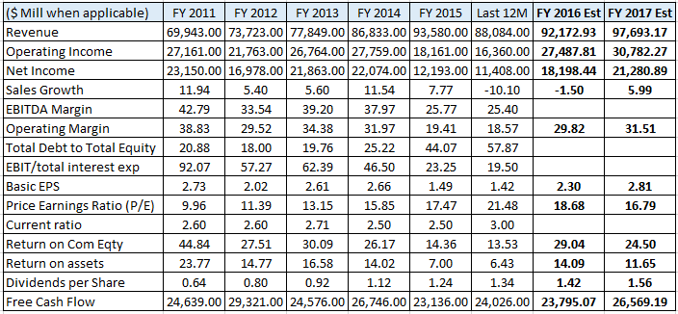 | 2010-15 2016-20  Avg Revenue growth 8.4% 4.2%  Avg EBITDA Margin 40.3% 38.5%  Avg NOPAT 28% 25.6%  Avg Debt/Equity 28.47  Avg FCF / Margin L3yr 29.08%  Cost of Debt (after tax) 1.46%  Tax Rate last filing 14.64%  Cost of Equity 11.75%  WACC 10.81%  Perpetuity growth rate 4%  Analyst Opinion  Buy: Hold: Sell:  Rating Target  S&P Net Advantage Hold $60  Morning Star *** $52  Value Line T: 2 S: 1 $70-60

Relative Valuation | Total Return
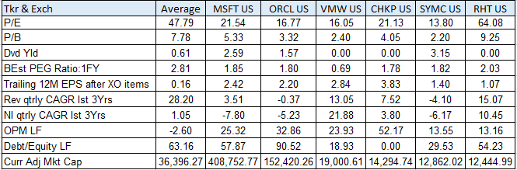 | 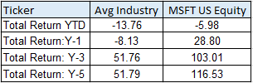CSR Characteristics  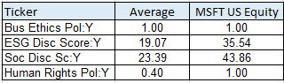Prepared by Edward Laclaustra (Feb 4, 2016) using Bloomberg, Value Line, S&P Net Advantage, Morning Star, Yahoo Finance

