Company: Honeywell International Inc. | Ticker: HON Current Price: $101.60 | Industry: Industrials | Sub Industry: Aerospace & Defense
Target Price: $117.10  Stop Loss: $82.08  52 Week High/ Low: $81.79-105.49 | TTM P/E: 16.99  Forward P/E: 14.25  EPS: 6.04 | Beta: 0.88  Credit Rating: A  Rating Outlook: Stable | Market Cap: $79.07B  Avg Vol (12 Month): 4.04M  Dividend Yield: 2.38%

Company Background:
Honeywell International, Inc. is a diversified technology and manufacturing company, serving customers worldwide with aerospace products and services and turbochargers and automotive products (39% of '14 sales); control, sensing and security technologies for buildings, homes, and industry (36%); and specialty chemicals, electronic and advanced materials, and process technology for refining and petrochemicals (25%).

Industry Outlook:
- Positive outlook on commercial aerospace and neutral on defense for the next 12 months
- Trade association IATA estimates global passenger air traffic grew 5.9% in 2015 after growing 5.2% for 2014 and sees growth of 7.0% in 2016
- Expected to see continued solid demand for new commercial jets, fueled by growth in the developing markets and a need to replace aging, less fuel-efficient aircraft in developed markets.
- Commercial aerospace shares selling at reasonable valuations.
- Year to date through August 14, the S&P Aerospace & Defense Index rose 3.0%, vs. a 2.8% decline for the S&P Industrials Index and a 1.7% rise for the S&P 1500 Composite Index. The sub-industry index rose 8.7% in 2014, vs. 8.4% for Industrials and 10.9% for the S&P 1500.
Investment Thesis:
- HON's building environmental and combustion controls, and its turbocharger products benefiting from a strong global trend toward energy efficiency
- Aerospace should benefit from rising global fleet sizes, demand for better fuel economy and aftermarket demand, while specialty chemical volumes should benefit from improving global demand for petroleum products.
- HON pays a solid dividend (2.3% yield at the recent price), which is expected to rise, in line with the EPS growth.
- HON reiterated its forward-looking guidance and announced a dividend increase in 2015.
Investment Risks:
- Risks include further weakening of the global economy, operational difficulties and less than-expected restructuring benefits.
3-5 take away from last quarter investor call transcript:
- Funded $160 million of new restructuring in 2015, and that includes $60 million in the fourth quarter, building on a healthy pipeline of new projects which will support strong margin expansion this year and beyond.
- In November, Honeywell was selected to supply its HTF series jet engines, auxiliary power unit, advanced cockpit technologies, environmental control system and cabin pressure control system to Cessna's new Citation Longitude business jet
- Acquired the remaining 30% stake in UOP Russell, a global leader in modular gas processing technology and equipment.
- Repurchased close to $2 billion in Honeywell shares during the year at attractive prices, which is nearly double the rate at 2014

Financial Performance: | Discounted Cash Flow
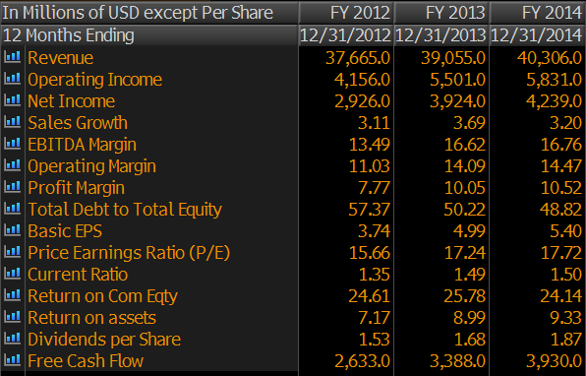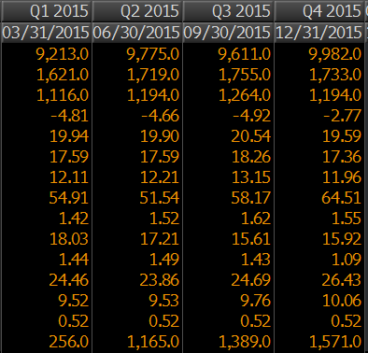 | 2010-14 2015-19  Avg Revenue growth 3% 5%  Avg EBITDA Margin 16% 22%  Avg NOPAT 10% 14%  Avg FCF/Margin 11% 15%  Cost of Debt 1.1%  Tax Rate 26%  Cost of Equity 11.1%  WACC 9.8%  Perpetuity Growth Rate (Terminal) 2.5%  Bloomberg Perpetuity Growth Rate 4.1  Analyst Opinion  Buy: 17 Hold: 5 Sell: 0  Rating Target  S&P Net Advantage 4 Star $120  Morning Star  Value Line Timeliness2 $110-135

Relative Valuation | Total Return
FY2014 Hanwha Techwin Co United Technologies Jiangsu Leike Defense Industry Honeywell International Inc.  P/E - 13.06 213.76 41.08 15.77  P/B 0.95 2.82 6.25 2.85 4.29  Dividend Yield - 2.94 0 1.51% 2.02  PEG Ratio - 1.49 - 1.54 1.49  EPS 0.55 3.86 0.02 0.79 1.55  Rev Growth (1 Yr) 7.11 -15.86 -2.23 -6.46 -2.77  NI Growth (1 Yrs) 5.25 22.92 2.95 10.32 11.96  Operating Margin 3.71 2.74 4.08 7.46 17.36  Debt / Equity 28.86 46.09 4.71 38.11 24.11  Market Cap 1.49B 77.14B 1.92B 20B 79B  Sources: Bloomberg, S&P NetAdvantage, VLIS, Morningstar | HON Sector S&P 500  YTD -0.94 -5.63 -9.19  Last 3 Years 15.37 8.39 9.12  Last 5 Years 14.11 7.40 9.30  CSR Characteristics  HON Industry  ESG Disclosure Score 25.21 24.33  Governance Disclosure Score 60.71 53.79  Social Disclosure Score 19.30 25  Environmental Disclosure Score 12.85 12.40  Prepared By: Akhil Sood, 02/10/2016

