Gilead Sciences  Ticker: GILD  Sector: Health Care  Industry: Biotechnology | Intrinsic Value: $129.86  Current Price: $101.73  Stop Loss: $86.0  Upside Review: $148 | TTM P/E: 10.9  Forward P/E: 8.83  Beta: 1.12 | Market Cap: $153.15 Bn  Dividend Yield: $1.8%
Business Summary: Gilead Sciences (GILD) primary areas of focus include human immunodeficiency virus (HIV); liver diseases, such as chronic hepatitis C virus (HCV) infection and chronic hepatitis B virus (HBV) infection; oncology and inflammation; and serious cardiovascular and respiratory conditions. It has operations in approximately 30 countries worldwide.  Industry Trends: Fundamental outlook for the biotechnology sub-industry for the next 12 months reflects favorable prospects for new and novel therapies to reach commercialization. The current period is seen as a strong period for the reporting of late-stage clinical results, and a more accommodating U.S. FDA for approvals. In 2014, the FDA approved 41 new therapies, up from 27 in 2013, the most since a record 53 were approved in 1996. These newly approved drugs have significant commercial prospects and represent major advances in therapeutic areas such as hepatitis C, multiple sclerosis and cancer. A favorable mergers and acquisitions (M&A) climate, as large pharmaceutical firms move to offset lost revenues from expiring drug patents and large biotechs bolster their drug pipelines amid maturing products.  The pharma and biotech sectors have recently faced significant market weakness, largely because of recent headlines about price-gouging, strong policy positions from presidential candidates, notably Hillary Clinton, and congressional investigations into drug pricing.  Investment Thesis: Gilead's focus on infectious disease has paid off in. With a small salesforce, inexpensive manufacturing, and selective research and development, it generates stellar profit margins, and the firm's pipeline is extending its reach into other high-margin markets like hepatitis C and hematological oncology. With the approval of hepatitis C drug Sovaldi in late 2013, Gilead's competitive advantages have strengthened, moving it into wide-moat territory. Gilead will see new competitive threats in HIV; Glaxo could introduce a Truvada/Tivicay single tablet regimen once Truvada patents begin to expire in 2018, and generic versions of Atripla should be available beyond 2021. However, we think Complera and Stribild will have a strong grasp on the market by this time, resetting the firm's HIV patent cliff into the 2020s. |  | Competitive Analysis: Increasing competition and pricing pressures in the HIV and hepatitis C markets are risks for Gilead. If Gilead's HIV franchise does not maintain its superior efficacy and safety status, a large portion of its sales foundation could be at risk. Key patents on Gilead's top marketed HIV products will expire by 2021, and the firm will need to see significant switching to newer products Complera and Stribild to counter the negative impact from generic competitors.  Pros: Very strong gross margin (87.2%) and operating margin (54.8). further the margin has been continuously increasing over past years. Strong cash position. Company beat industry benchmark on most of the financial factors (Rev Growth, Net Income Growth, Operating Margin, ROA, ROE, Debt/Equity).  Management is diversifying with acquisitions, including the $11 billion Pharmasset deal and key hepatitis C drug Sovaldi. While AbbVie launched its all-oral regimen in late 2014 and Merck is set to launch a competitive regimen in early 2016, Gilead's regimens set a high bar. Sovaldi and Harvoni saw $12.4 billion in sales in 2014 further Gilead will is expected to see nearly $19 billion in hepatitis C sales in 2015, or 80% of the global market  Risk Factors: 1) A large slowdown in Harvoni sales due to competition. 2) More than 60% of Gilead's U.S.- based HIV sales volume represents government purchases, and higher rebates on some of these sales were implemented in 2010. Austerity measures also had a higher-than-average impact on prices in Europe in 2010, and escalating overall health-care costs and tight budgets. 3) Possible government regulations putting pricing pressure on the company.
5 Year Stock Performance:  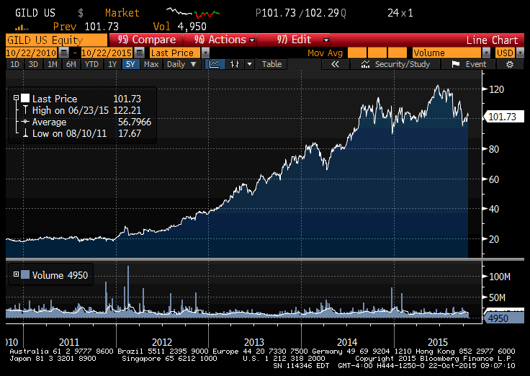 |  | Key Valuation Assumption  Est Revenue Growth: 4.7%  WACC: 9.4%  Expected Inflation: 2.0%  Terminal Growth Rate: 3.0%  10 Yr Risk Free Rate: 2.03%  Equity Risk Premium: 7.2%  Tax Rate: 25.0%  Key Financial Data  Est 2015 EPS: 11.73  Est 2016 EPS: 11.62  3-5 Yr Est EPS Growth: 53%  PEG (TTM): 0.53  Credit Quality: A3 – Positive ( Moody), A- Stable ( S&P)  ROE: 90.32%  ROA: 42.28%  Price/Book: 9.16  Price/Cash Flow: 11.19  Debt/Equity: 0.78  Current Ratio: 3.07  Quick Ratio: 2.56  CSR Characteristics  ESG Disclosure Score: 14.04 (31.19 Industry Average)  Governance Disclosure Score: 51.79 (59.38 Industry Average)  Social Disclosure Score: 8.77 (21.49 Industry Average)  Environmental Disclosure Score: 6.98 (37.21 Industry Average)  Prepared by Akhilesh Kumar (October 20, 2015)  Information from: Bloomberg, Value Line, S&P Net Advantage, Yahoo
Competitor Comparison:
 | GILD | GSK | PFE | Industry
Market Cap: | 152.15B | 98.76B | 206.36B | 128.42M
Employees: | 7,000 | 97,921 | 78,300 | 57
Qtrly Rev Growth (yoy): | 0.26 | 0.06 | -0.07 | 0.89
Revenue (ttm): | 29.19B | 36.11B | 48.20B | 6.34M
Gross Margin (ttm): | 0.87 | 0.68 | 0.82 | 0.59
EBITDA (ttm): | 20.32B | 10.21B | 19.61B | -5.56M
Operating Margin (ttm): | 0.66 | 0.22 | 0.3 | -1.29
Net Income (ttm): | 15.04B | 14.96B | 8.91B | N/A
EPS (ttm): | 9.48 | 6.15 | 1.41 | N/A
P/E (ttm): | 10.9 | 6.64 | 23.75 | 23.81
PEG (5 yr expected): | 0.53 | N/A | 3.19 | N/A

