Walt Disney Co.  Ticker: DIS  Sector: Consumer Discretionary  Industry: Media & Entertainment | Intrinsic Value: 128  Current Price: 110.09  Stop Loss: 91  Upside Review:140 | TTM P/E: 22.8  Forward P/E: 19.67  Beta: 1.13 | Market Cap: $185,816.3(M)  Dividend Yield: 1.2%  52 Wk Range: 86.98-122.08
Business Summary: Disney is a leading media conglomerate with key operations in theme parks, television, film, and merchandise licensing. Theme parks and Resort segment includes parks in the U.S., Europe, and Hong Kong as well as a cruise line. Another park is scheduled to open in China in 2016. Their media networks include ABC, ESPN, The Disney Channel, and ABC Family. Studio films are made under the Disney, Pixar, Marvel, and LucasFilm brands. Consumer products include merchandise licensing, books, video games, and retail stores.  Industry Trends: Revenues have been on an upward trajectory since the Great Recession. This is due to organic growth from strengthening macroeconomic factors as well as a wave of M&A activity. TV programming costs have been rising. Subscriber bases have been declining due to the secular trend of ‘cord-cutting’ and a-la-carte media consumption.  Investment Thesis: As consumer confidence continues to increase, there should be growing demand for the Disney’s content. Strong EOY coming with first new Star Wars movie in ten years. Disney is well positioned to remain leader in industry and trade at premium multiples. Recent price drop creates opportunity for near-term return as well as long term. |  | Competitive Analysis: Disney is the premier brand in entertainment. Their strategy as a content creator rather than content delivery should help them withstand changes to media delivery over the next few years. ESPN stands to be hit the hardest by switch to a-la-carte media consumption and Disney has already begun cost-cutting measures to prepare for possible lower revenues. Acquisitions of Marvel and the Star Wars franchise has created a strong pipeline of films for the next five years, with benefits also to the theme parks, television content, and consumer products segments.  Pros:  - Rising consumer confidence  - Strong brands with loyal fans  - Pipeline of content leading to growth across segments  Risk Factors:  - Capital intensive theme park business  - Abrupt shift to a-la-carte cable television structure  - Downturn in consumer spending hurts all aspects of business
5 Year Stock Performance:  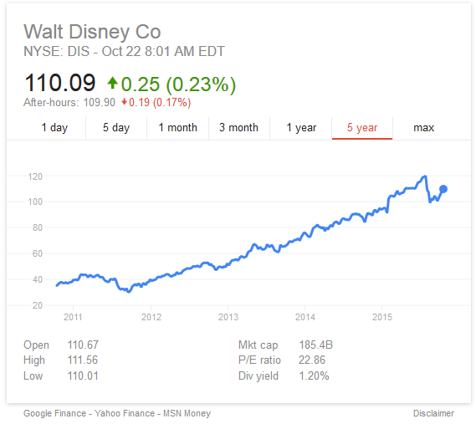 |  | Key Valuation Assumption  Est Revenue Growth: 8%  WACC: 9.4%  Expected Inflation: 1.8%  Terminal Growth Rate: 3.9%  10 Yr Risk Free Rate: 2.02%  Equity Risk Premium: 8.01%  Tax Rate: 33.34%  Key Financial Data  Est 2015 EPS: 5.08  Est 2016 EPS: 5.60  2-5 Yr Est EPS Growth: 8%  PEG (TTM): 1.37  Credit Quality: A2 (Moody’s)  ROE: 18.0%  ROA: 9.7%  Price/Book: 3.79  Price/Cash Flow: 17.5  Debt/Equity: 33.0%  Current Ratio: 1.11  Quick Ratio: 0.8  CSR Characteristics  ESG Disclosure: 35.54/19.90  Environmental Disclosure Score: 23.26/12.79  Social Disclosure Score: 38.60/18.71  Governance Disclosure Score: 60.71/53.57  Prepared by Chris Norris on 10/22/15. Information from Bloomberg, Yahoo, S&P, Valueline
Competitor Comparison:
