Company: DR Horton Inc. | Ticker: DHI Current Price: $ 23.41 | Industry: Consumer Disc. Sub Industry: Homebuilding
Target Price: $ 37.44  Stop Loss: $18.7  52 Week high/ Low: $22.97-33.10 | TTM P/E: 13.58  Forward P/E: 9.54  EPS: $2.06 | Beta: 1.17 (Bloomberg)  Credit Rating: Ba1 (Moody)  Rating Outlook: slow growth | Market Cap: $8.6b  Avg Vol ( 15 M): 7.265m  Dividend Yield: 1.16%

Company Background:
The largest homebuilder by market cap. Products range the entirety of the price scale however have a new focus on entry level homes with their Express Homes Brand that average at a price of $188,000. Overall their average price is approximately 300k and have a presence across America with the northeast being their smallest geographic region by sales.
Industry Outlook:
- Builder confidence index is near pre-crash levels, although has had slight decline from last announcement
- The uncertainty globally makes it increasingly seem as if the Fed will keep rates down for the immediate future which will be good for buyer mortgage rates
- New home mortgages have continually been on an increase pushing up home values
- Home sales have surpassed expectations at the end of 2015 and beginning of 2016 implying a very favorable outlook for the industry as a whole
- Despite global financial market unrest domestic indicators continue to point towards recovery which is favorable for home sales and more specifically mortgage underwriters as their standards continue to lax in the recovery
Investment Thesis:
- DHI has a very strong balance sheet with a D/E of 55 compared to industry average of 99. This coupled with a good amount of cash on the books is a good safety net in case the sector falls on harder times during the investment horizon.
- Housing has been very strong and DHI as the biggest player in the market stands to gain the most from this positive swing, their inventory of land is relatively large which will bode well in an environment of decreasing supplies of well located land to develop
- DHI’s new Express Homes Brand should be seen as an asset, while this lower price point will decrease margins it will help capture more customers in a time where pent up demand has been the story in the housing market. In the DHI investor call volume is indeed the concentration moving forward
Investment Risks:
- Fed rate increases may increase mortgage costs for buyers stumping top line growth
- Cost pressures like labor and land may outpace Revenue
- Wages remaining stagnant could inhibit growth pace in later 2016
- Very capital intensive industry making homebuilding a more volatile sub-sector
3-5 take away from last quarter investor call transcript: Q1 2016
- CEO concentration on volume as a revenue generator, margins will decrease but with the soft economic indicators this may be the best play
- Increased dividend by 28%
- Beat earnings expectations

Financial Performance: | Discounted Cash Flow
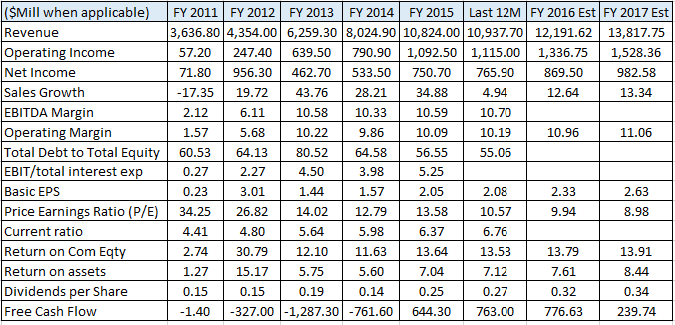 | 2010-15 2016-20  Avg Revenue growth 22% 14%  Avg EBITDA Margin 8% 11%  Avg NOPAT 6% 8%  Avg Debt/Equity 67.60  Avg FCF / Margin L3yr -9%  Cost of Debt (after tax) 1.65%  Tax Rate last filing 33.18%  Cost of Equity 8.88%  WACC 8.18%  EBITDA Multiple 8.9x  Analyst Opinion  Buy: 7 Hold: 14 Sell: 0  Rating Target  S&P Net Advantage Buy $30  Morning Star *** $23  Value Line T: 2 S: 3 $55-35

Relative Valuation | Total Return
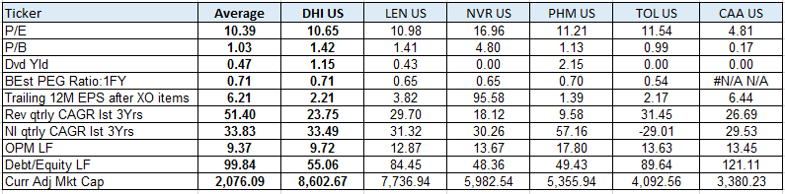 | 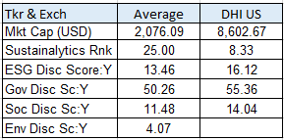  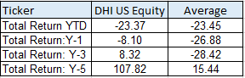CSR Characteristics  Prepared by Edward Laclaustra (Feb 11, 2016) using Bloomberg, Value Line, S&P Net Advantage, Morning Star, Yahoo Finance

