Company: Boston Properties Inc. | Ticker: BXP Current Price: $ 111.79 | Industry: REIT Sub Industry: Class A office
Target Price: $ 137.93-237.02  Stop Loss: @20%  52 Week high/ Low: $144.49/93.99 | TTM P/E: 28.93  Forward P/E:  EPS: $3.74 | Beta: .97 (Bloomberg)  Credit Rating: BBB+ (Fitch)  Rating Outlook: stable | Market Cap: $17.2b  Avg Vol: 947,095  Dividend Yield: 3.4% (including special dvd)

Company Background:
Boston Properties, Inc. is this largest by market cap public office REIT. They are fully integrated and self-managed with a portfolio that is largely focused on very high quality class-A office space with a small percentage of revenue coming from hotel, residential and retail properties. The company’s market is concentrated in Boston, Washington, DC and midtown Manhattan.
Industry Outlook:
- Class A office vacancies have been dropping steadily, especially in the CBD markets BXP deals in
- Effective rents have also been sky rocketing in the markets BXP is focused in
- Cap rates have also been on a declining meaning that there is more demand for these properties and decreasing potential yields
Investment Thesis:
- BXP is an especially good at managing their capital. This means developing and buying in market downturns and selling on upswings. Just today with they sold a property for $105 million, a price supported by these low market cap rates. Look for BXP to continue selling in the hot market and perhaps repeat another strong special dividend come December
- A majority of their assets are unencumbered by debt putting them in a great position to refinance the costlier debt on their books to take advantage of the continued low rates
- Despite vacancy rates improving overall BXP’s vacancy rates still have room to improve. This is favorable because of the trend of market rents, making same store rent increases an intriguing factor moving forward
Investment Risks:
- As a whole the company has a greater than industry average amount of debt. This won’t be as big an issue as long as the economy stays on its good recovery pace. If matters change for the worse then BXP could find itself in a difficult working capital position in 3 years’ time, as they have sufficient C & CE at the moment
- As with all REITs investors are yield seeking, meaning when rates rise there is typically a reactionary sell off. Exiting the position should be timed appropriately.
3-5 take away from last quarter investor call transcript:
- EPS beat estimates by $.01 at $1.28 and raised guidance for Q1 2016
- Macro outlook looks moderate but good, Q4 2015 GDP had a slowdown and jobs figures were soft
- Will continue strategy of selling non-core assets at attractive values while focusing on value add, the Kendall Center sale to MIT would represent approximately half of asset sales
- Will deliver FFO growth through aggressive leasing strategies and adding new buildings through development

Financial Performance: | Discounted Cash Flow
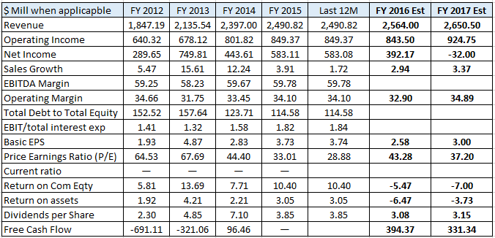 | 2010-15 2016-20  Avg Revenue growth 10% 4.9%  Avg EBITDA Margin 59.5% 59%  Avg NOPAT 33.9% 34.1%  Debt/Equity LF 114.6%  Avg FCF / Margin L3yr 44.77% 54.3%  Cost of Debt (after tax) 1.53%  Tax Rate last filing n/a  Cost of Equity 7.77%  WACC 5.79%  Perpetuity growth rate 2.5%  Analyst Opinion  Buy: 20 Hold: 7 Sell: 0  Rating Target  S&P Net Advantage Buy $135  Morning Star **** $124  Value Line T: 3 S: 3 $120-180

Relative Valuation | Total Return
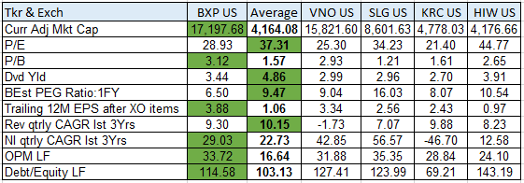 | 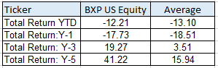CSR Characteristics  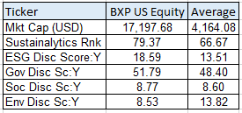Prepared by Edward Laclaustra (Feb 18, 2016) using Bloomberg, Value Line, S&P Net Advantage, Morning Star, Yahoo Finance

