Company: AvalonBay Communities Inc | Ticker: AVB Current Price: $ 173.30 | Industry: Financial Sub Industry: Apartment REITs
Target Price: $ 200.14  Stop Loss: $154.27  52 Week High/ Low:$186.89 / $ 156.10 | TTM P/FFO: 22.07  Forward P/FFO: 22.3  FFO/share: $7.84 | Beta: .82  Credit Rating: A- (S&P)  Rating Outlook: Stable | Market Cap: $23.7b  Avg Vol ( 12 M): 750,782  Dividend Yield:2.87 %

Company Background:
AvalonBay Communities, Inc. is a real estate investment trust (REIT) focusing on the management and development of residential apartment complexes. The communities and luxury properties are located in 11 states and the District of Columbia. As of Dec. 2014, AvalonBay had an interest in 277 communities with a total of 82,487 units, including 26 communities under construction, and three communities under reconstruction. --Valueline
Industry Outlook:
Many REITs reported average occupancy figures of over 95% for the first half of 2015, allowing a push on new rents to higher levels. Rental rate increases have been burdened in recent periods with new development supply entering the market. New development keeps going up so this fact could help keep rental rates from significantly increasing despite the change in market trends in their preference for renting especially amongst young adults. This increased supply may increase competition as well amongst apartment owners. Longer term, residential REITs largely have a positive outlook. As the economy continues to improve and employment stays low residential apartment will have a positive correlation. For the year 2014, the S&P Residential REITs Index was up35.3% compared to a 10.9% gain for the S&P 1500 Index. –SP Net Advantage
Investment Thesis:
The buy opinion for AvalonBay is based on extremely strong balance sheet compared to industry, confidence in management and positive outlook for industry. Essentially investing in AVB stems from this positive outlook in the prevalence of renting in the US. If this trend proves to be ongoing then AVB will be uniquely situated to gain from that environment. Despite an expanding supply rental rates are on track to improve 5% in the year. Currently AVB has 26 communities under construction and has development rights already established that could add 10,000 units to the portfolio, half of which is in the Metro NY area a historically strong real estate market. Their financial leverage allows them to be more flexible in the short-term than competitors, which is favorable given the unknowns in the capital markets.

Investment Risks:
- Increases in Interest rates sometimes have a reactionary sell off of REITs
- Lack of rental interest
- Worsening economy and employment figures leading to dampening demand
- Over concentration in NY area leading to increased exposure to local rental market
3-5 take away from last quarter investor call transcript:
- Solid numbers in third quarter including great topline growth. Double digit growth in core FFO for the 4th year out of the last 5
- Current prices for apartments may be at a premium, while they don’t use this has a significant source of revenue they do use this to fund development projects
- Southern California and mid-Atlantic are still in early stages of their recovery and or expansion cycle

Financial Performance: | Discounted Cash Flow
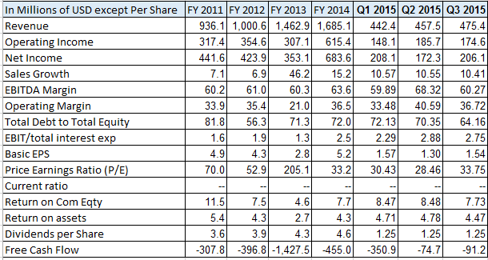 | 2010-15 2016-20  Avg Revenue growth 14% 5%  Avg EBITDA Margin 60% 65%  Avg Net Income Margin 32% 36%  Avg Debt/Equity 64% 64%  Avg FCF / Margin -12% 51%  Cost of Debt 2%  Tax Rate n/a  Cost of Equity 6.43%  WACC 6.5%  Perpetuity growth rate 4.4%  Analyst Opinion  Buy:38 Hold: 11 Sell:1  Rating Target  S&P Net Advantage N/A N/A  Morning Star ** $140  Value Line Timeliness:2 $185-250

Relative Valuation | Total Return
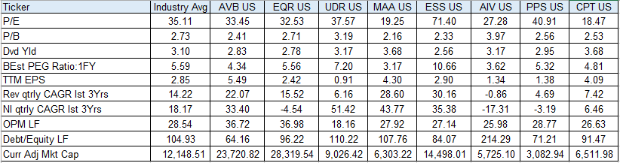 | AVB Industry S&P 500  YTD 8.86 8.65 2.70  2014 13.19 11.56 13.69  Last 3 Years 44.99 50.43 17.14  Last 5 Years 86.55 87.68 13.69  CSR Characteristics  AVB Industry  Business Ethics Policy 1 1  Governance Disclosure Score 57.14 53.79  ESG Disclosure: 32.64 18.13  Social Disclosure Score 43.86 13.82  Environmental Disclosure Score  Human Rights & Equal Opportunity 1 1  Prepared by Edward Laclaustra (Nov 12, 2015) using Bloomberg, Value Line, S&P Net Advantage, Morning Star, Yahoo Finance

