2012-2013
University of Connecticut
Undergraduate
Student Managed Fund

Medo Abdel-Latif Domenic Mazzola

Michael Bergin Nikhith Naidu

Paul DeSalvo Thomas Shippee

Brian Laureano

Dominic Mangano

Todd Massedge

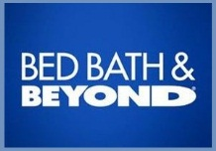
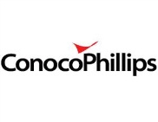
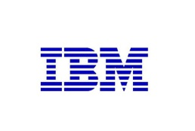
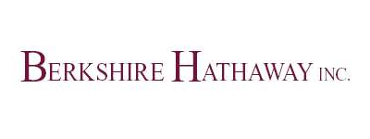
EXECUTIVE SUMMARY

Investment Philosophy

We evaluate our common stock investments in the same way one would evaluate the purchase of an entire business by looking for understandable, well-managed, and competitively advantaged businesses at prices well below their value to a private owner. We take a value investing approach to all our investment decisions and adapt that to the group's way of thinking.

Investment Strategy

We aim to outperform our benchmark, the S&P 500 index, by composing a portfolio of primarily U.S. equities. Each SMF manager is responsible for, but not limited to, finding suitable investments in two assigned market sectors. In evaluating investment opportunities, the SMF team focuses on risk in its various forms, including:

- Business Model Risk
- Balance Sheet Risk
- Management Risk
- Valuation Risk
- Obsolescence Risk
- Aggregation Risk

The SMF team seeks to build a portfolio of 15-20 businesses that, in addition to avoiding the above risks, possess substantial recurring free cash flow and sustainable competitive advantages over their competitors.

Current Market Conditions

Uncertainty is the most appropriate word when describing the state of our economy. The United States is faced with slow GDP growth (around the 2% pace) coupled with concerns pertaining to the European Debt Crisis, fiscal cliff, and monetary policy. Movements in the stock market have been more headlines driven than ever. Today, it is truly a global economy and a ripple effect occurs when there are any economic disruptions. With the current low interest rates and volatile stock market, investors have been on the sidelines unsure of where to put their money. Despite the others being in “wait and see mode”, we have continued to seek out undervalued investments with attractive fundamentals and believe that we can weather this storm

Process

Once a manager identifies an investment candidate, he brings that business to the SMF team to discuss its merits. The manager making the investment recommendation is responsible for managing the discussion, and for providing the team with enough information to make an informed vote. We seek investments that avoid the risk of permanent loss of capital while offering attractive appreciation potential. An investment candidate must receive an approval vote from at least 70% of the managers in order for a position to be added to the portfolio.

Investment Managers:

Medo Abdel-Latiff Dominc Mangano
Michael Bergin Domenic Mazzola
Paul DeSalvo Nikhith Naidu
Brian Laureano Thomas Shippee
Todd Massedge

Performance
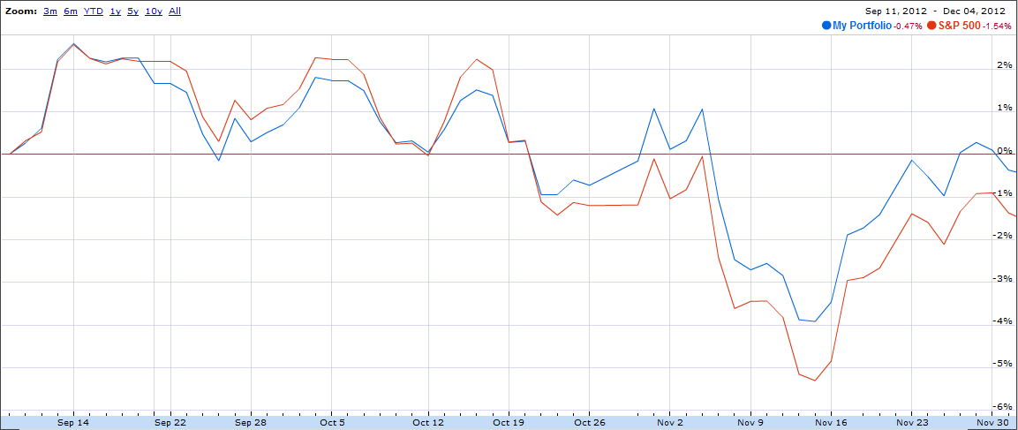
The Fund has outperformed the S&P 500 by 107 basis points since our first liquidation order on September 7th. This outperformance has been fueled by our investments in retail, and transportation.

Investment Philosophy

The Undergraduate Student Managed Fund (SMF) invests based on the principles and concepts of Value Investing. The Fund has adopted a thought process similar to the great value investors such as Benjamin Graham, Warren Buffet and Charles Munger. The Fund looks at a variety of industries and companies seeking stocks that are undervalued. The Fund prepares fundamental research based on business model strength and financial performance. In regards to qualitative research, the Fund analyzes business models, management intent, and risks associated with business strategy such as systemic risk. In addition, global and domestic news is taken into account when evaluating a potential investment. The Fund then collectively digests all researched information to more effectively understand how potential events can affect prospective investments.

Investment Strategy

The S&P 500 will be the main benchmark for the Undergraduate Student Managed Fund. In the past, the Student Managed Fund has outperformed the S&P 500 with a similar investment philosophy. All prospective investments will be assessed on a case by case basis to determine an appropriate portfolio allocation percentage.

In order to construct a portfolio of 15-20 quality investment we use the following key quantitative and qualitative metrics when assessing prospective investments:

● Strong and Sustainable Business Model
● High ROE & ROIC
● Strong Cash Flow
● Competitive Advantage in Industry
● Long Term Growth Capability
● Strong Management
● Solid Balance Sheet
● Minimal Company Specific Risks

In order to outperform our benchmark – the S&P 500 index– the portfolio is composed of U.S. equities, the S&P 500 ETF, and cash. The Fund has steered away from fixed income because of historically low yields, and much stronger opportunities in equities. Each SMF manager is responsible for the due diligence necessary to effectively evaluate businesses and investments. To carry out this investment philosophy and strategy, the SMF team focuses on risk in its various forms, including:

- Business Model Risk – the avoidance of unstable or uncompetitive business models
- Balance Sheet Risk – the avoidance of companies with unsuitable leverage
- Management Risk – the avoidance of poorly managed companies
- Valuation Risk – the avoidance of companies selling at an inflated price in relation to a reasonable range of true business value
- Obsolescence Risk – the avoidance of businesses with a product or service subject to rapid change or obsolescence
- Aggregation Risk – the avoidance of a common stock portfolio with highly correlated business risks, i.e. a portfolio of companies subject to interest rate risk, similar investment risk, or commodity risk

Investment Procedure
The managers of the Student Managed Fund were given the option to cover two sectors of their choice. Each manager was then assigned to look at all the companies in their assigned sectors to find one or two that fit our previously listed criteria.
From there the managers extensively researched their primary company of choice, compiled a one page report, and prepared a presentation to show to the other managers and Professor Terrion at our weekly meetings. After a thorough questioning, the managers then decide whether or not we should invest, need more information, or need a new stock.
If the group decides we have the proper amount of information, we then take a vote and will purchase the stock if at least 70% of the managers agree. At this point, we then start another discussion on how much capital we should allocate to that stock. We tend to issue more capital to stable, well-performing, well-established, and cheaply valued firms. Each company will receive approximately 5%-10% of the capital we have available.
The sectors and their analysts are listed below:
Consumer Discretionary/Services- Paul DeSalvo, Todd Massedge, Thomas Shippee
Consumer Staples- Medo Abdel-Latif
Energy- Michael Bergin
Healthcare- Medo Abdel-Latif, Todd Massedge
Financials- Brian Laureano, Michael Bergin
Transportation- Brian Laureano, Domenic Mazzola
Utilities- Nikhith Naidu
Materials- Todd Massedge, Nikhith Naidu
Industrials- Nikhith Naidu
Technology- Dominic Mangano
Fund Officers
For the Fall Semester, the officers for the Undergraduate Student Managed Fund are:
Lead Manager: Todd Massedge
Portfolio Manager: Medo Abdel-Latif
Treasurer/Secretary: Paul DeSalvo

Undergraduate Supervisor: Patrick Terrion
Fund Director: Chinmoy Ghosh

Portfolio Breakdown
Company Name | Date Invested | Symbol |  | Shares |  | Cost Basis |  | Price |  | Dollar Gain/Loss |  | % of Account |  | %Loss/Return
BED BATH & BEYOND | 11/20/12 | BBBY |  | 1220 |  | $70,195 |  | $57.53 |  | $1,442.85 |  | 5.48% |  | 2.06%
BERKSHIRE HATHAWAY INC | 11/20/12 | BRK.B |  | 1435 |  | $126,155 |  | $87.88 |  | $96.05 |  | 9.67% |  | 0.23%
COACH INC | 10/26/12 | COH |  | 1050 |  | $59,816 |  | $56.96 |  | $915.05 |  | 4.65% |  | 1.53%
COCA COLA COMPANY | 10/22/12 | KO |  | 2100 |  | $78,252 |  | $37.26 |  | $1,377.05 |  | 6.10% |  | 1.76%
CONOCOPHILLIPS | 10/22/12 | COP |  | 1405 |  | $80,440 |  | $57.25 |  | $(444.50) |  | 6.12% |  | -0.55%
GENERAL DYNAMICS CORP | 10/22/12 | GD |  | 905 |  | $61,001 |  | $67.39 |  | $(823.42) |  | 4.61% |  | -1.35%
CSX CORP | 11/23/12 | CSX |  | 2042 |  | $40,000 |  | $19.58 |  | $96.05 |  | 3.18% |  | 0.23%
INTL BUSINESS MACHINES | 10/22/12 | IBM |  | 380 |  | $73,456 |  | $193.2 |  | $(1,221.78) |  | 5.53% |  | -1.66%
WABTEC | 10/26/12 | WAB |  | 800 |  | $65,608 |  | $82.00 |  | $2,087.05 |  | 5.18% |  | 3.18%
WALT DISNEY CO | 10/26/12 | DIS |  | 1190 |  | $59,937 |  | $50.36 |  | $(841.95) |  | 4.52% |  | -1.4%
S&P 500 ETF |  | SPY |  | 4129 |  | $601,306 |  | $145.63 |  | $(14,368) |  | 44.93% |  | -2.88%
Cash Available: $1692
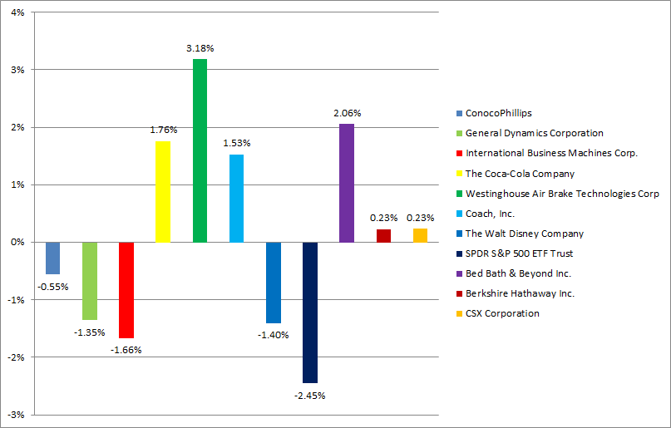

Over the past few months, we have seen strong returns in our investments in retail, transportation and consumer staples making WABTEC and Bed Bath & Beyond our biggest winners. Investors have shied away from technology recently amidst concerns about the economy and its effect on consumer’s willingness to purchase big ticket items, which in turn has caused IBM stock price to decline. Our holding in industrials, General Dynamics, has faced a decrease in market value after the election yielded another divided Congress, which weakened the chance of avoiding fiscal cliff and adversely affected General Dynamics since it relies on government spending.
We caution against making conclusions based on a short period of results. We believe that all of our holdings continue to pose strong value cases and will produce strong returns in the long term.
Equity Portfolio & Breakdown Approach
In our equity portfolio, we seek to take positions anywhere from 5% to 10% of our assets at cost. Generally, a 5% position would represent a position we feel has a tremendous upside but has some risks that our larger positions do not. Our largest positions, in the 9-10% range, represent the core of the portfolio – stalwart businesses with AAA style balance sheets trading below their true value.

The portfolio will ultimately be composed of 15-20 businesses engaged in diverse activities with minimally correlated risk exposure. We believe that a range of 15-20 good business the portfolio will be fully diversified to balance current market volatility. We evaluate each position as if we owned the entire business – and subsequently will not diversify to the same extent as most professional money managers. We prefer investing in a couple excellent companies we know will outperform, rather than a lot of companies that have a chance of outperforming.
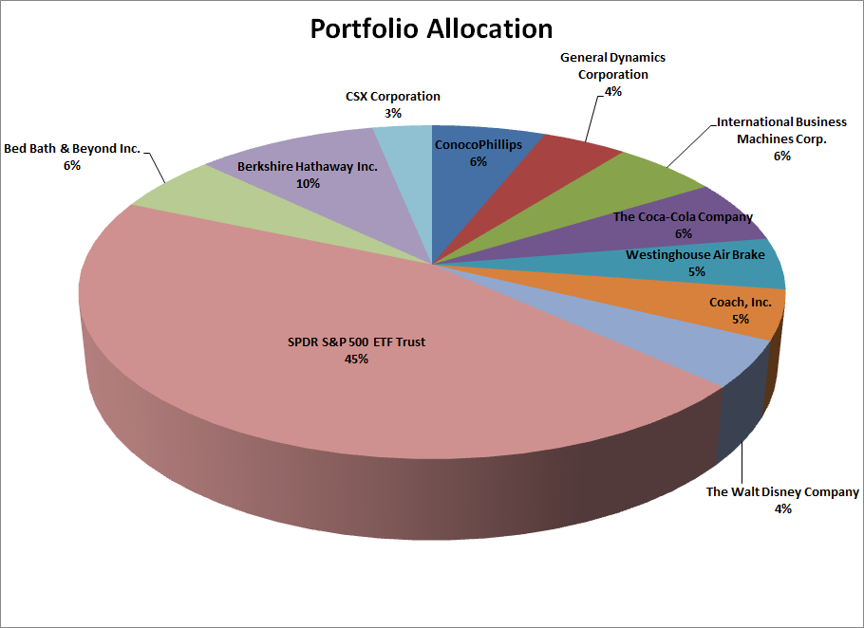

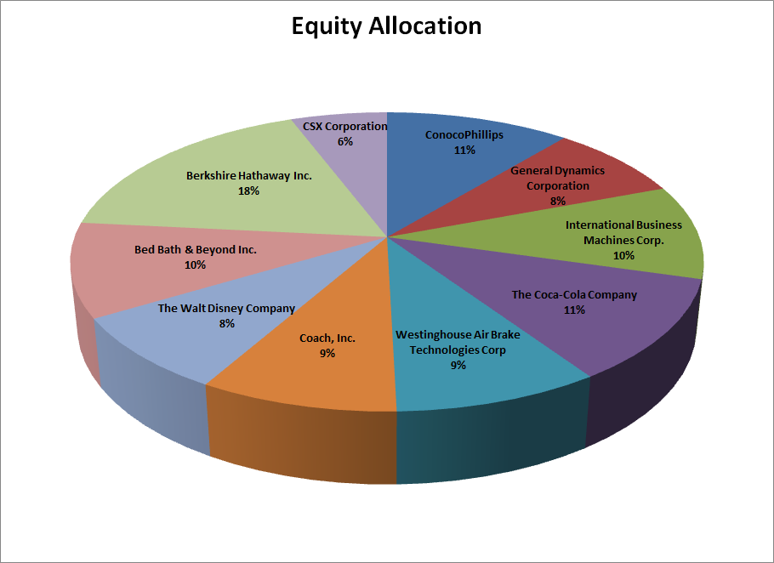

Sector Allocation

While we have assigned managers responsibilities similar to the breakdown of the S&P 500 sectors, we do not manage the portfolio around the sector weightings of the S&P 500. We do, however, seek a portfolio diverse in its risk exposure, and thus, will not overly concentrate in one industry. As a result, the sector breakdown is largely a residual of our attempt to find a group of well-managed business franchises selling for less than their true value.
The chart below shows the breakdown of the equity portfolio in terms of sector as of December 2nd, 2012 and their respective performance:
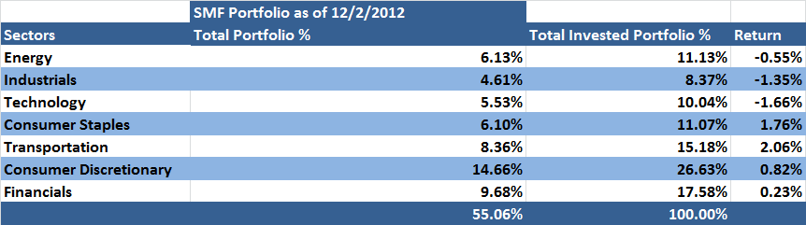

Risk Management
We are managing risk for the portfolio by investing a majority of the money in blue chip companies, diversifying our holdings, and avoiding common risks. We conducted detailed research on each of our sectors prior to selecting stocks to determine those with the least risk and most upside potential. We then conducted group discussions on each potential stock pick before voting. After we have selected our stocks, we closely monitor our positions and may buy more stock if we feel it continues to become more undervalued.
By investing in blue chip companies with consistent positive earnings, limited debt and steady cash flows we aim to limit the portfolio’s exposure to negative economic events that could impact the stock market’s and thus the portfolio’s movement. Also, we have invested in companies that have strong positive cash flow and high liquidity to limit the impact of any prolonged financial distress on the companies’ operations. The companies we have invested in have the ability to generate cash consistently in the future. Although stock prices will fluctuate in the short run given all the macro economic issues, ultimately increased earnings will translate into appreciating stock prices.
The companies that we are invested in are in different industries so the portfolio does not have significant aggregation risk. By allocating the money over several sectors and sub industries, we have protected ourselves against heavy losses in the event one industry suffers. We have avoided certain industries altogether because of the high risk of the industry including utilities, internet companies and basic materials companies. We also continue to monitor the financial situation of our holdings to determine whether or not they present increased risk to the portfolio.
Companies | Stop Loss Order
Berkshire Hathaway | 20%
Bed Bath and Beyond | 20%
Coca-Cola | 20%
Coach | 20%
ConocoPhillips | 20%
CSX | 20%
General Dynamics | 20%
Inl. Business Machines | 20%
The Walt Disney Company | 20%
Westinghouse Air Brake Technology | 20%

Economic Outlook
1.1 Introduction
Uncertainty is the most appropriate word when describing the state of our economy. The United States is faced with slow GDP growth (around the 2% pace) coupled with concerns pertaining to the European Debt Crisis, fiscal cliff, and monetary policy. Movements in the stock market have been more headlines driven than ever. Today, it is truly a global economy and a ripple effect occurs when there are any economic disruptions. With the current low interest rate environment and volatile stock market, investors have been on the sidelines unsure of where to put their money. Despite others being in “wait and see mode”, we have continued to seek out undervalued investments with attractive fundamentals and believe that we can weather this storm.
1.2 Monetary Policy
All eyes have been on the moves of Ben Bernanke as he has been one of the major market movers this year. Recently, we are faced with a low interest rate environment causing a search for yield; even if that means going into more risky assets. The current Federal Funds target rate is at a low of .25% (and will be until 2015) as the 10 year Treasury is currently yielding around 1.66% compared to the average of approximately 6.50%. Another round of Quantitative Easing (QE) was introduced in September targeting $40 billion of agency mortgage-backed securities a month. It is Bernanke’s view that QE3 will reduce the cost of borrowing for corporations, bring down mortgage rates (30 year is currently at 3.31% which is a record low), boost the stock market, and therefore, increase consumer spending. Although the intentions are sound, we are cautious because we recognize that banks are still reluctant to lend as a result of 2008 along with the increased regulatory requirements set forth by Dodd-Frank. It raises the question, is this program reaching the end consumer? Or, is the majority of this stimulus money staying within banks in order to meet their higher capital standards? We have no straightforward answer at this point, but must at least consider these limitations.
On a different topic, Operation Twist has continued with the purpose of selling a total of $667 billion short-term Treasury securities by the end of 2012 in order to purchase long-term Treasury securities. The intention of this program is to support the economy by lowering long-term interest rates.
The U.S. economy has shown signs of growth in employment, housing, consumer confidence, and spending. Despite this, we recognize that these indicators could be a result of the continued favorable, yet unsustainable, monetary policy. In addition, it is important to note the possibility of inflation due to the continued stimulus. Corporations have built cash reserves on their balance sheets because of current economic uncertain environment (pertaining to the fiscal cliff and the euro zone) but it is only a matter of time until velocity increases and those reserves are put to use. It is clear that the central bank is prepared to tolerate a higher inflation rate in the future in order to reduce unemployment. After careful consideration, the best word to describe our current viewpoint on the U.S. Economy is cautiously optimistic.
1.3 Fiscal Cliff
At this time, the forefront of the U.S. macroeconomic concern is the looming fiscal cliff. If the U.S. government is not able to avoid the cliff, our nation would go through approximately $607 billion in tax increases and spending cuts; which will severely impact the growth of our economy. If all occur simultaneously, it is said that the impact could negatively affect U.S. GDP by up to 4%-5% and unemployment by 1% from the current 7.9% rate. These taxes would increase for the 160 million Americans on payrolls and the average household could pay $3,500 more in federal taxes. We believe that this scenario would be unfavorable on the equity markets as corporate earnings would decline due to decreased household spending and tax implications. In light of this possibility, corporations have been holding off on investment and hiring decisions until there is more certainty. Building on this point, we have seen in mid-November that the fear of an increased capital gains tax (in some cases going from 15% to 23.8%) has negatively affected the stock market and caused a selloff of previously top performing stocks such as Apple. However, we predict that going off the fiscal cliff will positively affect current fixed-income prices as investors rush to search for predictable income.
The fiscal cliff will present excellent buying opportunities as investors are quick to panic. President Barack Obama and congressional leaders wrapped up their first "fiscal cliff" meeting since the election Friday with a confident tone that had both sides suggesting an agreement could be reached before January 1. It is our view is that policy makers will come to a resolution before we go off the cliff and sentiment will increase as a result of that. If our prediction is correct, we forecast a bullish start to 2013.
1.4 European Debt Crisis
The European Debt Crisis has still disrupted the marketplace. Fragmented European politics make the task of all seventeen Eurozone nations reaching decisions a difficult one. In spite of this, the European Central Bank has shown that they will step up and help tame the debt crisis. They have lowered the key interest rate to 0.75% and the rate paid on deposits to zero which has created more liquidity in the marketplace paired with a higher incentive to lend. In addition, the ECB announced Outright Monetary Transactions (OMT) in September which will allow the ECB to purchase sovereign debt from countries that formally request bailouts. However, countries such as Spain have been reluctant to accept OMT because they would then be required to adhere to strict budget requirements.
In our opinion, the major fear is the “contagion affect” that a default can have on the banking system. The ECB is aware of this concern as well and now has ability to now directly capitalize the banking system if necessary. Despite all of these preventative measures, we believe that the Eurozone will go through a contraction period as sovereigns attempt to balance their budgets and austerity measures are put into place. The current forecast from the IMF predicts the combined GDP of the euro zone’s 17 members to fall by 0.4% this year. We believe that these risk premiums are already priced in the market. In addition, it is our view that European Union will remain intact for the near-term but GDP growth will continue on its contraction stage.
1.5 Conclusion
In conclusion, current market environment is uncertain but we do remain cautiously optimistic on the U.S. economy. We believe that through our security selection process, we will have the ability to outperform our benchmark. Our fund seeks to have a true long-term investment outlook and we recognize that markets ultimately tend to revolve around two things: business valuations and growth. The laws of mathematics dictate that a 100% appreciation in value is lost by a 50% decline. Thus, we have chosen stocks that are undervalued and have a margin of safety as a backstop. We look forward to actively managing and monitoring our performance throughout our given timeframe

Sector Analysis
Basic Materials
The Basic Materials sector has continued to be heavily driven by market news, and external events. Stock prices in this sector rarely demonstrate a company’s individual performance, and often are heavily correlated with investor speculation. With the looming fiscal cliff and weakening dollar, investors may look to companies in this sector as a hedge on their portfolio. Yet, many companies in this industry have very inconsistent cash flows that rely on commodity prices and excessive capital expenditures.
As value investors, The Fund prefers companies with stable cash flows, high returns on invested capital, and large competitive advantages. At this time, we do not believe any companies in this sector demonstrate these qualities. We will not invest in this sector based off speculation, or fears of a recession. Since the S&P 500 is our benchmark, we prefer to be partially invested in to S&P 500 ETF, and have other stable, undervalued companies that will lessen the blow of a possible recession.
Current Holdings: None.
Consumer Discretionary/Services
The consumer discretionary sector is a large industry that covers a variety of companies. Due to this variety, some companies perform better in certain economic conditions than others. The economy has been slowly recovering since the recession of 2008. Major consumer economic indicators have been pointing higher since 2010, however, the growth is slow. For instance, Consumer Confidence has recovered to pre-recession levels in 2012. The consumer discretionary sector’s performance has recently been heavily correlated with news on the upcoming fiscal cliff. Companies in this sector are heavily dependent on per capita disposable income, and another recession may have a large impact on revenues. To counter this, we chose companies that performed well throughout the recent recession, and that have been growing internationally.
There are various trends in the industry including movement toward online and discount stores. Growth in E-Commerce revenue has grown at an annual rate of 10.4% since 2007. This growth in revenue is being felt by traditional big-box retailers who are now having trouble competing and are having to change their strategy. This disruption is felt around the industry and companies have had to readjust their strategy to ensure that they are able to compete effectively. Discount retailers are experiencing good growth as the recovery has been progressing at a slow pace. Notably dollar and variety stores have seen revenue growth of 4.2% annually since 2007.

Our players in this sector are currently our top performers. If the fiscal cliff is averted, we expect this sector to continue its strong performance. On the contrary, we believe that we purchased these companies at a large enough discount that their prices would not decline as rapidly as the S&P 500, if a deal was not reached.
Current Holdings: BBBY, COH
Healthcare
Healthcare is an integral part of the economy. From the periods between 1970 to 2008, the healthcare sector increased its share in GDP from 7.2% to 16.0%. The aging baby boomers will fuel this sector and will provide long term stability. However, this stability is threatened by federal government reforms efforts that could hinder profitability and existing loans. Moreover, this sector is also affected by social influences that include high regulation, and complicated cost structure.
State and Federal spending constitute about 45% of the total national health expenditure. During economic decline, healthcare expenditure also maintained as a source of countercyclical support. From the periods between 2001 and 2004, Medicare and Medicaid spending expanded at a rate of 7% per year, and in 2009 there was even more expansion as a result of American Recovery and Reinvestment Act that provided additional funding to cover any potential shortfalls in the state funding resources. For lenders perspective, this environment of consistent growth, low revenue volatility, and countercyclical behavior provide this sector with favorable attributes that are hard to find in other sectors.
With increasing regulations, and higher taxes from ObamaCare, the barrier to entry for new competitors will increase. The key driving force in this industry is specialization in both facilities and practitioner offerings. Companies within this sector try to maximize revenue by focusing on what they do best and outsourcing standardized and non-technical services in order to lower their costs.
Current Holdings: None.
Consumer Staples
We believe that it is essential to holding a stock with a defensive nature. We realize that defensive stocks tend to perform positively during tough economic times, and they also could perform negatively during improving economic conditions because consumers don’t typically spend money on certain items. This sector represents 11% of the S&P 500 and as of 11/07/2012; the sector has been able to provide a 10% return.
The sector has 3-sub industries: Household & Personal Products, Food Beverage & Tobacco, and Food & Staples Retailing. The soft drink industry has been experiencing difficulties due to declining per capita consumption, higher commodity prices, and the lingering effects of the subprime mortgage crisis that has suppressed spending. All of these factors will contribute to declining revenues within the domestic industry at an average rate of 1.3% per year from 2012 to 2017. Global expansion, specifically into emerging markets, can offset the economic hardships faced in the domestic market because of low per capita consumption and aggressive growth in income per capita.
We believe that during economic uncertainty, investors are more likely to invest in large companies with ample cash flow and high/steady dividends
Current Holdings: KO
Energy
The world price of crude oil is a big driver of profitability for this sector. Over the past five years, the price of oil has fluctuated, but continued to become increasingly more expensive. The price of oil has increased about 50% in the last five years, and with rising demands for energy it will continue to increase. Demand for energy will continue to increase as the global population grows, and as emerging markets such as China continue to expand. A threat to this industry is the ongoing movement to find an alternate energy source. Hybrid car manufacturing and a decrease in total vehicle miles in the United States will reduce industry profits. However, the increasing demand for oil will offset losses.

The industry has been busy over the last 5 years, with an annualized growth of 7.1%. The industry is highly sensitive to oil prices, which are in turn highly vulnerable to economic conditions, as depicted in the large industry wide dip in 2009 during the major economic slowdown. Although, this dip would be mitigated by a surge in demand form emerging economies causing crude oil prices to rise and is currently continuing. Tensions in the Middle East and speculation of threatened oil supply from large exporters has also aided in driving up oil prices. Even with a brief downtrend in prices earlier his year, prices are expected to remain at historic highs throughout the year with an estimated revenue growth of 4.9%. The natural gas segment also shows promise for growth. Discoveries of vast gas reserves in the Appalachian Basin have spurred industry wide excitement, with estimates of over 750 trillion cubic feet. Growth in demand from electricity producers as some began to transition from coal and other fossil fuels to gas as a source to generate power. Both oil and gas prices are projected to increase over the next five years, with gas at a slower rate. Industry revenue as whole is expected to climb at an annual average rate of 7.5% over the next 5 years.

Energy industry executives see the potential for great strides toward American energy independence in the coming years, but are concerned that the regulatory environment, along with trouble in the financial world and opposition to fracking (hydraulic fracturing), could slow that progress. Overall, however, significant new domestic discoveries in natural gas and oil have executives encouraged while emerging markets play a large role in keeping business relevant regardless of price fluctuations.

Current Position: COP

Industrials
Industrials, also known as capital goods, is a diverse sector that includes companies in industries such as aerospace and defense, and engineering and construction projects. The sector follows the business cycle which makes it dependent on the state of the economy. During economic expansion or boom, this sector will perform well, but during a contraction and bad economic conditions the sector will usually underperform. Year to date, the sector has gained 7.52%. The outlook for the industrials sector is uncertain because it is so directly tied to the economic outlook, which in turn is uncertain.
The aerospace and defense industry is dependent on military spending, which will likely be facing cuts in light of the upcoming fiscal cliff. Even if fiscal cliff is avoided, it is likely that defense spending will see substantial cuts, which in turn will hurt the outlook for companies in aerospace and defense. We have found; however, that for the most part the negative outlook for aerospace and defense is included in the valuation. We have chosen to invest in a company in this industry that will be negatively affected by the decrease in defense spending, but would still be undervalued relative to its intrinsic value.
Construction and engineering is strongly tied to demand for new homes. Currently, demand for new homes is on the rise and the housing market in the general appears to be picking up pace. The long term low interest rate horizon makes homes that much cheaper for consumers, which in turn may fuel a rise in new home construction. However, we have found that most companies that are exposed to the housing sector have the potential for a housing boom incorporated into their market values. We have not found any potential investments in this industry that are sufficiently undervalued as to warrant investment; however we will continue to monitor this sector and will invest if a suitable opportunity arises.
Current Holdings: GD
Technology
As one looks at the information technology sector, it becomes quite apparent that the outlook appears to be slightly positive. For the year to date the sector has grown by 10.33 percent slightly behind the 10.61 percent growth of the overall S&P 500. In general the technology sector is fairly broad with its outreach covering everything from software to physical hardware to information technology services; overall it is composed of 16 sub-industries. However, this wide coverage can sometimes make investing a little difficult as it exposes one to the ever changing and competitive nature of the technology sector. Thus, in order to be successful it is essential to determine where the risks and growth opportunities lie.
As with the market in general, the current uncertainty of the economic conditions has greatly affected the performance of the information technology sector. The main concern resulting from the unstable conditions has been a decline in both consumer and corporation spending. In essence, customers are now heavily considering the necessity of certain technological purchases. With this drop in economic activity, it can be expected that industries such as computer and hardware (21% of information technology sector) may struggle. Even with the recent release of Microsoft’s Windows 8 it is not expected that increase in hardware spending, especially in terms of corporations, will occur outside of eager consumers looking to adopt the new technology.
To build upon the idea of necessary consumer spending, it is expected that growth will be maintained in the IT services and software industries (roughly 25% of information technology sector). These industries, unlike computers and hardware, are seen as being essential to customers, particularly corporations. The products and services provided by these industries are considered to be crucial in maintaining efficient and competitive business operations. For example, companies looking to gain value from the immense amount of data produced on a daily basis will need to maintain their spending in these industries. In general, with information technology being one of core reasons behind companies’ success, it seems very promising the outlook is strong for the IT service and software industries.
With the uncertainty presented by the current economic market, it would seem that investments in this sector should remain focused on the safer side. In the short term, this would lead one to look for larger companies that have a strong performance record and balance sheet. By investing in such companies, one would expose themselves to minimal risk and opportunities for growth. A strong balance sheet would most likely contain a good amount of cash, which would allow the companies to gain value in these uncertain times through the use of stock buybacks and possibly acquisitions. However, if the economic standing were to improve this strategy could be loosened.
Beyond looking at the short term standing of the technology sector, it is important to consider where growth can be achieved in the long-term. Currently, there are quite a few opportunities to be explored in the future. The recent success of the tablet gives way to potential growth opportunities for the technology sector. Manufacturers of these devices will be able to wreak the benefits of increased sales as consumers begin to recognize the mobility and broad functionality of the tablet. With Microsoft’s recent expansion into the tablets, one might assume that large corporations who run their operations on the Windows operating system might begin to incorporate tablets more proficiently. The expanding tablet market will also open the doors for industries outside of computer hardware to grow. For instance, the semiconductor industry will most likely be required to expand to keep up with the increasing capabilities of the tablets. In addition to the tablet, another area of potential growth can be found with cloud computing. IT service companies will be able to expand their operations to smaller companies who are not looking to invest in physical storage hardware and simply want access to data solutions through the cloud. The low cost benefits the cloud represents for users will make it an attractive area for companies in the technology sector to expand their product offerings. To conclude, with the recent economic uncertainty it can be expected that certain areas of the sector will struggle, but the opportunities for the future do present tempting investment opportunities.
Current Holdings: IBM
Transportation
1.1 Introduction
The transportation sector mainly consists of the railroad, trucking, airline industries. This sector has historically been less volatile than the S&P 500. The largest industry within this sector is the trucking industry followed by the railroad industry.
Intermodal has become an increasing trend in the transportation sector. Intermodal transportation is when a shipper uses a standardized container to make a shipment and it goes through more than one form of carrier during a single journey (i.e. railroad, truck, ship). The market for intermodal has been growing steadily because it is more environmentally friendly and cheaper to ship than most methods of transportation.
According to a 2008 study from the US Energy Information Administration, the transportation sector contributes 27.0% of greenhouse gas emissions, second to electricity, which produces 35.0%. The total transportation sector consumes about 25.0% of energy every year, including energy from power trucks, trains, pipelines, aircraft and other transportation craft. However, rail's share of this total energy demand is extremely low at only 2.0%, far below passenger vehicles (58.0%), freight trucks (17.0%) and air travel (10.0%).
1.2 Railroad
A great quote from the Association of American Railroad is “Whenever Americans grow something, eat something, mine something, make something, turn on a light, or get dressed, it’s likely that railroads were involved somewhere along the line”. This industry is a leading indicator and is extremely sensitive to the well-being of the economy. Coal is the largest source of revenue for the railroad industry as it is used to generate about half of all U.S electricity. Coal shipments have recently declined due to lower natural gas prices and stringent environmental regulations. However, this year, rising diesel gas prices have made the trucking industry less attractive (rising from about an average of $2 per gallon in 2009 to $3.90 on a national scale) and the railroad industry more attractive. It would cost shippers almost $70 billion more per year if all freight moved by rail were shifted to truck. This is because on average, railroads are four times more fuel efficient than trucks. In 2011, railroads moved a ton of freight an average of 469 miles per gallon on fuel.
An important event worth discussing is the passage of the Staggers Rail Act of 1980. This removed many of regulatory restraints on the railroad industry (causing the industry to have a flexible monetization strategy in order to meet revenue requirements). The Staggers Act also legalized railroad-shipper contracts; all of these contracts represent privately negotiated agreements on rates, service levels, minimum annual traffic volume, etcetera (which creates a source of pricing power). These contracts have allowed railroads to become more efficient due to improved asset utilization (by planning using these contracts). Return on investment now averages around 7 percent; up from the 2 percent average in the 1970s. One would think that the Staggers Rail Act would cause these railroad companies to take advantage of their counterparties due to their pricing power; however, the opposite had happened. The average inflation adjusted U.S. freight rail rates fell 45% from 1981 to 2001. This means that the average consumer today can ship twice as much than it could for the same price paid 30 years ago.
According to the Department of Transportation, the demand for rail freight transportation will increase approximately 88% by 2035. In order to capitalize on this upward trend, we have sought out opportunities to purchase shares of companies within this space. However, the constraints worth noting in this industry include the possibility of rising labor costs (unionized labor), major weather disruptions, and increased federal regulations (Positive Train Control Mandate, EPA).
As the economy recovers, manufacturing production will pick up and consumers will begin to spend more, driving demand for industry transportation services. Furthermore, rising fuel costs will cause rail transportation to be comparatively cost-efficient for businesses that require bulk freight.

1.3. Trucking
Trucking is a cyclical industry that provides shipping services using tractor trailers. The majority of its revenue is domestically generated. This means that trucking companies have little exposure to foreign currency fluctuations.
A distinction to make in the trucking industry is truckload (TL) versus less than truckload (LTL). Truckload carriers typically fill a trailer of cargo from once consumer with a single destination. TL shipments are usually defined as those weighing 10,000 pounds or more. LTL carriers fill smaller amounts of cargo (less than 10,000 pounds) from many consumers to be shipped to multiple locations. The less-than-truckload transportation industry grew 11.6 percent in 2011, pushing total U.S. LTL revenue past $30 billion for the first time since the recession. The LTL segment is highly fragmented, with the top 20 participants accounting for roughly 50% of the estimated $27 billion market.
According to ACT research, this year’s truck fleet is the oldest it has been since deregulation in 1980. With a high cost of Class 8 fleet trucks and the increased cost of maintenance, we believe that the trucking industry’s profit margin will be negatively impacted in the future. Other important factors to consider include the current labor shortage (majority of current drivers are over 55 years old), Hours-of-Service law, and the price of fuel.
We believe that rail has a distinct advantage over trucking in fuel efficiency and environmental impact. High fuel costs and increased public awareness of greenhouse gas emissions have given rail the upper hand. The Rail Transportation industry has also invested heavily in new equipment and line upgrades over the past five years, further boosting its competitiveness and capacity. Therefore, the Trucking industry is expected to face stiffening competition, as railroads gain a larger share of the freight shipping market.

1.4. Air Transportation
The airline industry provides air transportation of passengers and cargo over regular routes and on regular schedules. Network carriers operate a significant portion of their flights using at least one hub where connections are made for flights on a spoke system. Regional carriers provide service from small cities, mostly using smaller aircraft and jets to support the network carriers' hub and spoke systems.
Air transportation primarily contains domestic carriers that focus on passenger service. Both passenger and cargo flights are expected to grow 3.2% in 2012 (below the 3.6% previously forecasted). The operating performance is dependent on the health of the international economy. The International Air Transport Association (IATA) projects overall airline profits of $3.0 billion in 2012 with net profit margin of 0.5% due to healthy growth in North and South America. The profit outlook is less than the $7.9 billion earned in 2011 and $16 billion earned in 2010. This may have to do with the decreased outlook for overall flight capacity.
Aircraft fuel is the largest operating cost. The Air Transport Association estimates that for every dollar increase in the price of jet fuel (a derivative product of crude oil), the US airlines incur an additional $445.0 million in fuel expenses. Despite this, airlines can typically cover the cost when traffic is at increased levels. To avoid sharp price fluctuations, airlines implement hedging strategies to limit fuel cost (which can be effective if done correctly). In terms of cost structure, the majority of airplanes have fixed costs (as opposed to variable) which are disadvantageous with unpopular flight routes. In response to this, air carriers have been cutting flights in many small airports that are unprofitable.
The airline industry has been plagued with economic and regulatory changes which have caused many to declare bankruptcy, consolidate, or leave the market. This can be attributed to excess capacity, a weak economy, and low cost competition. Since the September 11th terrorist attacks, airlines have been mandated with stricter security regulations which have caused increased wait times and heightened security measures. A research report conducted by the University of Cornell, published in 2005, suggests that the new baggage-screening process has reduced passenger volume by 5% industry.
International traffic is expected to grow 4.2% per year, in contrast to domestic travel that will growth at a more modest clip of 2.7% annually through 2032. This projection assumes a steady economic recovery with no major calamities like a large rise in oil price, swings in macroeconomic policy or financial meltdowns.
We do not intend to hold positions in the airline industry due to its volatility, unprofitability (often times), cost issues (labor unions, fuel costs), and weak outlook.
Current Holdings: CSX, WAB
Utilities
The Utilities industry consists of investments in the companies that handle the administration of public services such as water and power. Utilities are necessities that consumers require irrespective of economic conditions and therefore do not benefit from an economic boom, and do not suffer from an economic recession. In addition, companies in the utilities sector are subject to stringent regulations that control their prices. Therefore, companies in this sector tend to have very stable fundamentals.
The YTD movement of the Utilities sector on an aggregate level is -5.69%. Based on our research, we have found that most companies in the Utilities sector are overvalued. We believe that the current uncertain market conditions induce investors to invest heavily in Utilities due to their stability, which in turn drives up their prices and makes them highly valued. We will continue to monitor this sector and may seek to invest if an opportunity that aligns with our investment goals appears.
Current Holdings: None.
Individual Position Analysis
Bed, Bath and Beyond
We purchased 1220 shares of BBBY for a price of $57.53 per share on November 20th.

Bed Bath & Beyond Inc. and subsidiaries is a chain of retail stores, operating under the names Bed Bath & Beyond, Christmas Tree Shops, Harmon and Harmon Face Values, and buybuy BABY. In addition, the Company is a partner in a joint venture which operates two stores in the Mexico City market under the name "Home & More." The Company sells a wide assortment of domestics merchandise and home furnishings. Domestics merchandise includes categories such as bed linens and related items, bath items and kitchen textiles. Home furnishings include categories such as kitchen and tabletop items, fine tabletop, basic housewares, general home furnishings, consumables and certain juvenile products. The Company offers a breadth and depth of selection in most of its product categories that exceeds what is generally available in department stores or other specialty retail stores.

Bed Bath & Beyond has shown it is the strongest player in the Home Furnishings industry by coming out of the recession in a healthy condition. Due to its strength during the recession, BBBY has managed to dominate the home furnishing market with 36% of the revenue. Through the recent acquisition of Cost Plus, Bed Bath & Beyond shares have been trading at a low valuation. It is currently trading at a P/E of 13.1 which is below its historic 5-year average of 16x. The company is expanding without taking on any debt and has been returning value to shareholders in the form of a healthy share buyback program. Lastly, Bed Bath & Beyond has one of the highest Return to Equity Ratio compared to its competitors.

As of December 2nd, we have realized a 2.06% gain on BBBY.

Berkshire Hathaway
We purchased 1,435 shares of Berkshire Hathaway Inc Class B at a price of $87.88 per share on November 23, 2012.
Berkshire Hathaway is a holding company with a wide collection of subsidiaries engaged in a number of diverse business activities. The firm's core business is insurance, run primarily through GEICO (auto insurance), General Re (reinsurance), Berkshire Hathaway Reinsurance, and Berkshire Hathaway Primary Group. The company's other businesses are a collection of finance, manufacturing, and retailing operations, along with railroads, utilities, and energy distributors.
Berkshire owns 13% of American Express, 8% of Wells Fargo, 9% of the Coca-Cola Company, 4% of Procter & Gamble, and 6% of IBM.
The company averaged an annual growth in book value of 20.3% to its shareholders for the last 44 years, while employing large amounts of capital, and minimal debt. Berkshire Hathaway stock produced a total return of 76% from 2000–2010 versus a negative 11.3% return for the S&P 500.
As of December 2nd we have realized a return of .23% on our position in Berkshire Hathaway.
Coca-Cola
On 10/22/2012, we purchased 2100 shares of Coca-Cola (KO) at a price of $37.26
Coca-Cola is the world’s largest nonalcoholic beverage company. The company sells a variety of sparkling and still beverages and generates about 70% of its revenue and 80% of its operating profit in international markets. Following the asset swap with CCE, Coke now owns about 80% of its distribution in North America. Coca-Cola markets, manufactures, and sell beverages concentrates both in the United States and International markets. With its vast distribution network, Coca-Cola is able to introduce its products to 200 countries.
The Company has been devoted to invest in emerging markets as it announced that it plans to heavily invest in China and India. The company intends to invest approximately $4 billion into China over the next 3 years and $5 billion into India for the next 8 years. The per capita consumption in these emerging markets is a fraction of what the consumption is in the domestic market and so expansion is vital. Contrary to popular belief, Coca-Cola’s top brand in these countries is not carbonated drinks; Coke’s top brand in China is premade tea, and in India the growth potential is in the bottled water industry.
Moreover, Coca-Cola is in a better position, financially, when compared to its peers. The company has a higher gross margin, 62% compared to its peers with only 50%, Coca-Cola’s bottom-line operating performance is also higher than the industry’s median, a pre-tax margin of 23.2% compared to peer median of 12.9%, this suggests that Coca-Cola has a relatively tight grip on operating costs and pricing power advantages.
As of December 2nd, we recognized an overall return of 1.76%
Coach Incorporated
We purchased 1050 shares of COH at a price of $56.96 per share on October 26th.
Coach has grown from a family-run small leather goods business to the largest company in the accessory market. The company's core products are handbags, which represent 65.0% of revenue. The remainder comes from accessories (about 28%) and a small portion (about 7%) comes from other products, such as eyewear, footwear and fragrance. The company typically has three to four collections per quarter and four to seven styles per collection. The company also has a strong international presence, receiving 18% of revenues from Japan, and 6% of revenues from its new initiative in China. Coach has continued to buy out its distributors internationally in order to control the flow of products being sold, and to remove itself from third-party risk. They now own their distributors in Japan, China, Hong Kong, Macaw, Singapore, Taiwan, Malaysia, and Korea, with joint ventures in Spain, Portugal, Great Britain, France, and Ireland.
The lower-priced Poppy bags, which feature more vibrant colors, help add a youthful design to Coach's product offerings. The company has invested heavily in designing a marketing strategy around the Poppy brand. Most recently, the company opened two temporary, stand-alone Poppy locations in key department stores and expects to open more of these pop-up locations in the future. Coach has also recently created a new brand initiative under the name “Reed Krakoff”, and has begun opening specialty stores across the world.
Coach's factory outlet strategy has also helped the company broaden its demographic reach without diluting the strength of its core, full-priced offering. Coach has more than 100 factory stores in the United States, which offer the Coach merchandise at discounted prices and target a more value-oriented consumer who would not typically purchase a Coach bag. During the past five years, the company has experienced growth in its factory store segment. Its existing factory store consumers are buying more than they did in the past and customers who are new to Coach are also increasing their sales.
As of December 2nd, we have realized a gain of 1.53% on our position in Coach Inc.
ConocoPhillips
On October 22nd we allocated $80,440.99 to buying 1,405 shares of ConocoPhillips for $57.25 a share. ConocoPhillips, a Houston-based company, is the largest independent Oil & Gas Company in the world based on proved reserves & production of liquids & natural gas and third largest producer of oil & gas included integrated. ConocoPhillips was created through the merger of Conoco Inc. and the Phillips Petroleum Company on August 30, 2002 and was the fifth largest integrated oil company until spinning off its midstream and downstream assets to a new separate company, Phillips 66. At December 31, 2011, E&P operations were producing in the United States, Norway, the United Kingdom, Canada, Australia, offshore Timor-Leste in the Timor Sea, Indonesia, China, Vietnam, Libya, Nigeria, Algeria, Qatar and Russia
After the spin-off of its midstream and downstream businesses, ConocoPhillips has become a pure-play exploration & production company. The company conducts exploration activities in almost 30 countries and supplements its income with equity stakes in other oil & gas and chemical companies. About 55% of its production consists of liquids and about 45% consists of natural gas. Of the 55% in liquids, 30% is tied to Brent or international prices, which tend to be higher than North American crude markers (WTI). Of the 45% in natural gas, 20% is tied to natural gas. Margins between international natural gas prices and domestic prices are huge, with average disparities at $9.76/btu (British Thermal Unit). This stems from the fact many countries, specifically ones in Asia, index natural gas prices to crude oil prices and not the U.S. Henry Hub Index.
The company’s Crude Oil and Natural Gas Liquids production and sales is the most valuable segment. It has significant production capacity with the ability to sell well in excess of 200 million barrels of crude oil and natural gas liquids over the next few years. Coupled with high crude prices, this will translate into substantial cash flows for the company. The company is cash into the lower 48 states with almost $3.9B in CAPEX, but is also making a statement about its confidence in Asia Pacific and Middle East opportunities with a cumulative $2.05B in CAPEX coupled with $2.09B in Europe and the North Sea. As of December of 2011, the company had 3.462B barrels of crude oil and natural gas liquids, 3.486B barrels of oil equivalent in natural gas, 1.439B barrels of oil equivalent in Bitumen.
As of December 2nd, we have realized a return of (.55%) on our position in ConocoPhillips.

CSX
We purchased 2100 shares of CSX at a price of $19.71 per share on November 23rd.
CSX currently operates approximately 21,000 miles of track in 23 states plus the District of Columbia and the Canadian provinces of Quebec and Ontario. This means that over 2/3rds of Americans live within CSX service territory. Over the past 3 years CSX has become the most efficient railroad in the U.S. decreasing their operating ratio from 77.6 in 2007 to 70.9 in 2011, a substantial improvement which will lead to increase profitability in the coming years with the potential to further reduce its ratio.
In the third-quarter of 2012, CSX reported profits of $455 million, down 2% over the same period last year. As a result of improved operational efficiency this decrease did not affect earnings per share in fact it climbed to $0.44 compared to $0.43 in 2011. CSX expects increased earnings and margin growth for fiscal year 2012. Decreased coal shipments and increases in fuel prices combined with lower overall volumes have slowed CSX growth over the past year, but they are positioned to benefit from a shift away from the trucking industry due to rising oil prices in 2013. CSX also has strong growth potential as they continue to increase the amount of track over which they can double track and double stack, resulting in increased operational efficiency. We believe that CSX is currently trading well below its intrinsic value with a current P/E ratio of 9.7 versus a historical and industry average of 14.
As of December 2nd, we have realized a .23% gain on our position in CSX.
General Dynamics
We purchased 700 shares of General Dynamics at a price of $67.39 and 205 shares at a price of $67.40.
General Dynamics is a diversified company that generates most of its revenues from defense contracting but also sells to US Commercial enterprises and foreign nations. General Dynamics faces significant competition in these markets from companies such as Northrop Grumman, Lockheed Martin, Boeing, Rockwell Collins and BAE Systems. As a consequence of the competition, it is not uncommon for General Dynamics to try to stay relevant to its industry by investing heavily in R&D, working closely with its competitors and making numerous acquisitions. In 2011 alone, General Dynamics acquired 6 companies in order to complement and grow its existing businesses. The company is split into four divisions, aerospace, combat systems, marine systems, and information systems and technology.
General Dynamics missed its earnings estimate for Q3 of $1.77/shr by $.07/shr. This was as a result of a slight drop in margin due to a sales mix that was increasingly composed of US commercial and foreign as opposed to US Government which returns slightly higher margin. General Dynamics met expectations exactly on all other metrics for Q3. The company’s stock price did not decline following this report; however, following the election, the stock price fell. This is because the election resulted in a highly divided house and therefore a lower chance that fiscal cliff and a decrease in defense spending would be averted.
We believe that this company is undervalued even if fiscal cliff was an absolute certainty. Specifically, even in the case of fiscal cliff, we estimate that the company would have positive growth combined with a strong 11% free cash flow yield. Historically, the company has returned over 70% of free cash flow back to shareholders in the form of share buybacks and dividends. We believe that this company poses a strong value case even if the 10% cut in defense spending that fiscal cliff mandates is implemented, and we expected that in the long term, the stock price will rise to meet the company’s intrinsic value.
As of December 2nd, we have realized a return of (1.35%) on our position in General Dynamics.
International Business Machines
We purchased 380 shares of the International Business Machine for $193.28 each.
IBM is a global leader in providing Information Technology services and products. With a business model focused on providing highly beneficial service to their customers and creating value for their shareholders, IBM has recognized immense success. Their business operations are quite diversified and can be broken up into five main segments: Global Technology Services (GTS), Global Business Services (GBS), Software, Systems and Technology, and Global Financing. Through the growth of their business, the company has also expanded globally to over 170 countries. By combing this wide spread and global set of operations with their customer and shareholder focused business, IBM has become a safe and consistently growing company.
As an investment IBM presents both safety and a chance for value to be gained. By looking at their historical performance it can be seen that IBM has generated a fantastic free cash flow and return on equity, respectively equaling roughly $15,738 billion and 73% in 2011. Also, they have traditionally bought back shares annually, resulting in a higher value per share. Even more important, IBM seems focused on continuing this strong financial performance. For example, in October 2012 they increased their stock buyback fund to $11.7 billion. Furthermore, they plan on improving their highest gross margin sector, software (88.5% gross margin), to represent 50% of their annual profits. With these plans, IBM seems set to create value for their shareholders and achieve their goal of producing earnings per share of $20 by 2015 (currently $14.29). Yet it seems that IBM is not only focused on improving their financial standing, but they have also concentrated their attention to improving operations.
IBM’s growth in business operations appears to be highly concentrated around their Smart Planet initiative. IBM is using Smart Planet to improve its business offerings so that their customers can not only react to the changes in their businesses, but actually anticipate them to function more profitably. IBM’s is achieving Smarter Planet by improving their business analytics tools and expanding their cloud computing offerings, so that their customers are able to process the immense amounts of “big data” in value creating ways. Additionally, IBM is expanding their global footprint by moving internationally into growth markets. These markets are expected to represent 60% for global GDP growth in the next four years, so for a globally successful company like IBM, it seems appropriate that they enter these markets. With these reasonable growth initiatives and IBM’s strong track record, it seems safe to assume that they will be able to continue to grow operations around their customers’ needs and remain as a valuable investment for years to come.
As of December 2nd, we have realized a return of (1.66)% on our position in IBM.
Westinghouse Airbrake Technologies
We purchased 800 shares of Westinghouse Air Brake Technologies at an average price $82.01 making our total position equivalent to $65,608.95 (on a cost basis).
Wabtec (WAB) is one of the world’s largest providers of value-added, technology-based products and services for the global rail industry. Their products are found on virtually all U.S. locomotives, freight cars and passenger transit vehicles, as well as in more than 100 countries throughout the world. Their products enhance safety, improve productivity and reduce maintenance costs for customers, and many of their core products and services are essential in the safe and efficient operation of freight rail and passenger transit vehicles.
Wabtec’s core strategies include expanding globally into adjacent markets, increasing after-market sales, developing new products and technologies, and seeking value-added acquisitions. Thus far, they have been able to expand their international presence at a rate of 20% over the last five years (reaching $916 million in 2011 or 47% of total revenues). In addition, they have built their product offerings with a stable mix of original equipment market (OEM) and after-market parts. A total of 57% ($1.1 billion) of revenues came from after-market products and services which have been proven to be less cyclical and have higher margins. Wabtec has also improved their productivity through the implementation of the “Wabtec Performance System”. The performance system includes 600 kaizen activities (as of 2011) coupled with lean manufacturing processes and has led to increased margins by more than 2% in the past five years.
Wabtec expects PTC revenue to exceed $200 million in 2012 compared to approximately $125 million in 2011 (with contracts in both the U.S. and Brazil). It is estimated that in 2012 that UNP will spend $335 million, NSC will spend $250 million, and BNSF will spend $300 million on PTC. We believe that these present excellent opportunities for Wabtec to capitalize on their product offerings.
Wabtec has acquired four businesses in 2011 which have approximately $180 million in revenues. With their new $600 million credit facility, they can continue to seek value-added acquisitions in the near future.
In conclusion, we feel that Wabtec is an attractive investment due to its revenue growth relating to Positive Train Control, emerging market penetration, free cash flow, strong balance sheet (low debt, cash balance, etc.), and its defensive business model (mix of aftermarket and international sales).

As of December 2nd, we have realized a return of 3.18% on our position in Wabtec.
The Walt Disney Company
We purchased 1,190 shares of The Walt Disney Company at $50.36 per share on October 26th, 2012.

The Walt Disney Company is a diversified worldwide entertainment company operating in five business segments: Media Networks, Parks and Resorts, Studio Entertainment, Consumer Products, and Interactive Media. The company recently acquired Lucasfilm Ltd. for $4 Billion, which granted them the rights and studio equipment of the Star Wars and Indiana Jones franchises. The company also has rights to various different television stations such as ESPN, Disney Channels Worldwide, and ABC.

Disney is gearing up for the holiday season by packing their stores to the brim with new merchandise. In the early portion of October, Disney redesigned its mobile and PC websites to better accommodate the consumer shopping experience during the holidays. They incorporated an iPad app that allows consumers to shop on the go, as well as share their interests and purchases. With the acquisition of the Star Wars franchise, Disney has opened the door to an entire library of characters to leverage products from. Lucasfilm Ltd. is estimated to produce $800M in revenues each year for Disney. The company will be able to take Lucasfilm’s library of Star Wars and Indiana Jones to produce many new spin off movies, entertainment products, games, and toy/clothing products. Also, Disney will now be able to incorporate Star Wars and Indiana Jones characters into their current and up and coming theme parks; both domestically and internationally.

As of December 2nd, we have realized a return of (1.40%) on our position in DIS.

Lessons Learned
Up to this point, our group hasn’t encountered many difficulties. Our selection process has been very efficient, and we have quickly been able to make purchasing decisions. We have encountered a few difficulties in physically submitting the orders, but that is something out of our control. Going forward will plan on doing a few things:
- Continue to submit orders earlier: We currently get our orders in a week in advance to give Professor Ghosh time to place our orders. We plan on increasing this time in order to account for the three day layover period when we liquidate part of the S&P 500 ETF.
- Continue our research: We plan on researching companies over the December break in order for each of the managers to have a second company to invest in by next January. This will hopefully allow us to be fully invested by mid-February.
- Continue to focus on company strength: Our group has been very successful so far in identifying reasons a company may be undervalued. By focusing on a company’s strengths, we are able to determine whether a company is undervalued because of internal issues.
We are very confident in our strategy of staying partially invested in the S&P 500 ETF. By only liquidating when we need to money, we are able to stay on pace with the S&P 500, instead of losing ground by holding cash for an extended period of time.

