**Recommendation: BUY**

**Total Annual Return Est.:**

|  |  |
| --- | --- |
| 3 year FV | 9.0% |
| 5 year FV | **5.4%** |

**Financial Snapshot:**

|  |  |
| --- | --- |
| Price | **$457.65** |
| DCF Value | **$588.92** |
| Buy Target | **$500.58** |
| Sell Target | **$677.25** |
| TTM P/E | **27.4x** |
| Forward P/E | **22.9x** |
| Div Yield | **0.3%** |
| Market Cap | **$58.5 Billion** |
| 52 Wk Range | **$302- $467** |
| EPS Growth | **11%** |
| PEG | **2.4** |
| Credit | **N/A** |
| Current Ratio | **1.84x** |

**Investment Theme:**

Searching for companies have relatively lower risks in financials sector and can keep high profitability even in unstable economic situation.

**Overview:**

MA has relatively less risk exposure than other companies in financials sector. MA operates the second-largest, open-loop card network in the world. Its clients are financial institutions that issue MasterCard cards to their clients and process card transactions. MA has been able to increase revenue over the past five years, despite the recession. The rise in revenue was driven by higher fees on transactions, and steady volume. Volume was supported by the expansion of card services in the United States and around the globe, offsetting any drop in transaction activity driven by the recession.

MA’s financial health is in good shape and improving. The company continues to operate without debt. In additional, its strong profitability brings more cash reserves. The MA’s board remains active with its share-repurchase program. Since Q4, 2011, it bought back approximately 304,600 shares at least.

MA, trading at $457.65, results in a P/E ratio of approximately 27.4x based on trailing-twelve months EPS. Despite the tough economic conditions in many markets, MA benefits from strong secular trend of moving toward electronic payments. Increasing revenue and earnings will support the company’s high P/E ratio. My discounted cash flow valuation that assumes a 9% annual revenue growth rate and a WACC of 7.77% and results in an intrinsic value of $588.92. Raising the WACC to 8% changes the intrinsic value to $557.39.

The primary risk to the performance of MA is global economic growth. Should major markets in which MA operates see a major and prolonged economic downturn, revenue growth will be significantly less than expected. Our group remains cautiously optimistic regarding the global economy and do not foresee significant negative impacts to MA.

**2012 Q2 Results:**

MA failed to meet Wall Street expectations of $1,877 MM in revenue despite revenues of $1820 MM. However, MA’s EPS of $5.65 beat a consensus EPS of $5.57. 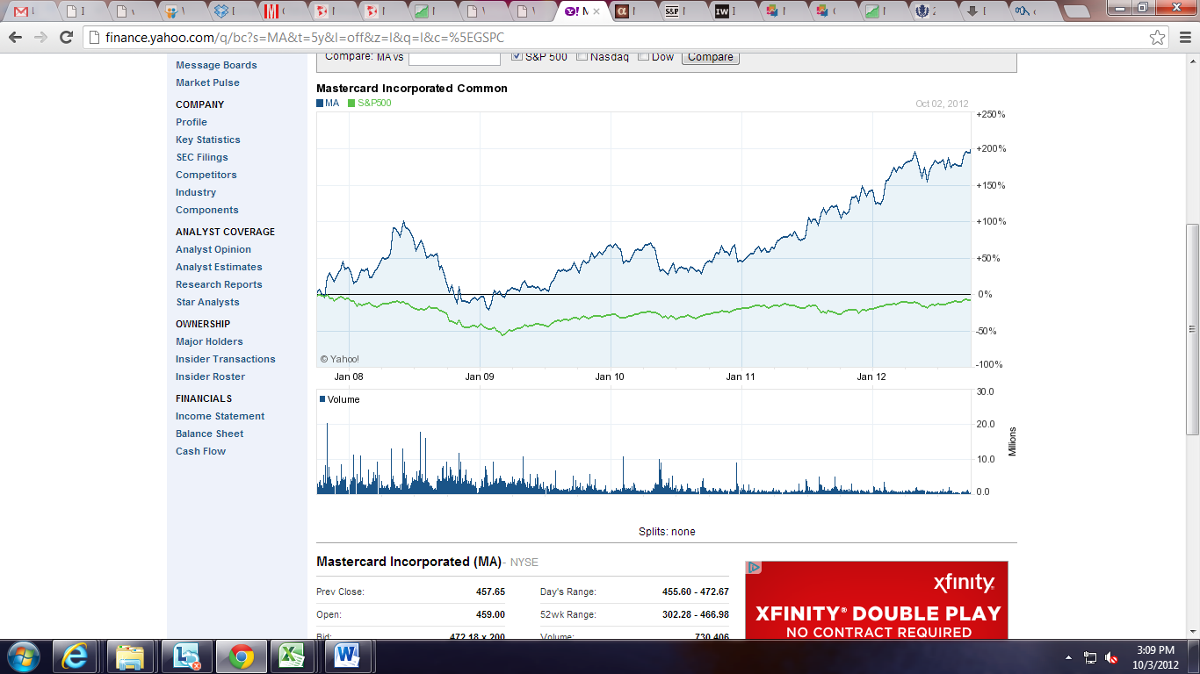

Investment **Thesis:**

Consumer finance industry outperformed S&P and all the other industries in financials sector. Although the P/E ratio is higher than industry average, the company’s stock is still undervalued. The transition to electronic payments from cash globally, international expansion, market share gains, mobile payments and prepaid card would drive the company’s strong growth rate of revenue and earnings. MA’s business is highly defensible and characterized by recurring revenue, high incremental margins, low capex and high free cash flow. MA has relatively less risk exposure than other companies in financials sector. Compared with Visa, the major competitor of MA, MA has higher international exposure and higher management effectiveness.

**Pros:**

* No credit risk exposure from consumers. MA does not issue credit cards directly.
* Significant international exposure. Oversea markets contributed approximately 60% of total revenues in 2011.
* Strong financial performance. Revenue grew 21% in 2011. MA continues to operate with no debt. MA expects to grow EPS through accelerated share purchase.
* MA would have a $1.5 billion buyback after its current share repurchase program ends
* Great growth penitential. Cash and check transactions account for 85% of the world’s $15.7 trillion of total global payment transactions. Even in the U.S. and Western Europe, more than 50% of personal consumption expenditure is still in paper form. Considerable growth opportunities in emerging market. New technologies such as mobile wallet will bring new growth.
* More and more business alliances. MA enhances its business operation across geographies by entering into partnership agreements with companies like Deutsche Telekom.
* MA still see at least 10% CAGR revenue growth, 50% operating margin for 2013-2015

**Industry Trends:**

The industry is susceptible to the general economic fluctuations due to its reliance on transaction volumes. Industry revenue declined as the Great Recession began in 2008. The downward trend worsened in 2009 due to lower transaction volumes and increased competition among operators. With the economy beginning to recover, the negative trend has reversed since 2010. Revenue growth is expected to jump 4.9% in 2012. Driven by a growing number of broadband connections and the emergence of online shopping portals, the credit card market in emerging countries has grown stupendously during the past few years. The future of this market remains buoyant, despite the recent economic downturn.

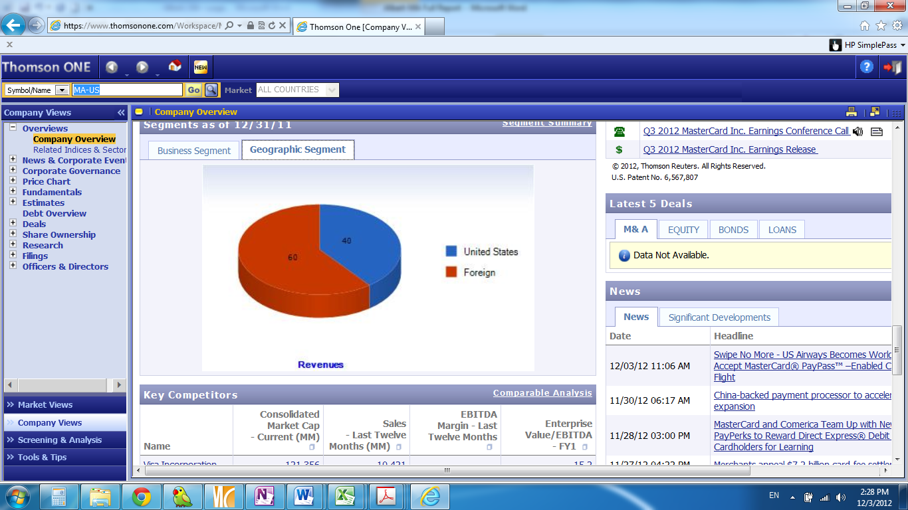**Business Summary:**

MA provides a variety of services in support of the credit, debit and related payment programs. MA follows a three-tiered business model as a franchisor, processor and advisor. MA does not issue credit cards directly; instead it licenses its brand to banks issuing co-branded cards. The firm generates income by charging merchant fees on individual transactions and by charging the credit card issuers licensing fees, which are both dependent on the volume and value of the transactions. MA has been able to boost revenue over the past five years, despite the Great Recession. The rise in revenue was driven by higher fees on transactions, and steady volume. Volume was supported by the expansion of card services in the United States and around the globe. MA’s 60% of total revenue comes from overseas.

.

**Management Review:**

AjayPal S. Banga, President and CEO of MA, despite his limited experience in the card business, has all the qualifications to head MasterCard. Prior to becoming CEO on July 1, 2010, Banga served as President and COO of MasterCard Incorporated and MasterCard International. Before joining MasterCard, Banga served as CEO of Citigroup's C Asia-Pacific businesses and was a member of the bank's senior management team. Banga and his management team dedicated a lot of their time in develop MA’s business in oversee markets. What’s more, the team also was very aggressive on acquisitions.

**Financial Trend Analysis:**

Higher fees on transactions and steady volume have driven the revenue increase. MA’s revenue keeps increasing even in the recession. Card services expansion in the United States and worldwide supported volume, offsetting any drop in transaction activity driven by the recession. However, the economic downturn had a material adverse impact on the company’s profitability. In 2008, the company got its first negative net income in the company’s history. When the economic situation became more stable in 2009, MA’s financial situation is getting better accordingly. The company’s revenue and earnings increased very fast from 2009 to now. But the Europe debt crisis and unstable economic situation in the U.S. may adversely affect trends in consumer spending in the future. It may materially and adversely impact MA’s revenue and profitability.

**Financial Health:**

MA’s financial health is in good shape and improving. The company continues to operate without debt. MA doesn't rely on capital markets to fund its operation, and the cash it generates from operations is sufficient to fund any additional investments. The MA’s board remains active with its share-repurchase program.

**Competitive Analysis:**

The industry is highly concentrated. Based on total transactions in 2010, the top 4 companies are Visa (62.2B) MasterCard (32.1B) American Express (5.1B), Discover (1.7B), and JCB (0.8B). Visa is the company’s the biggest competitor. The two companies have similar business model.

Compared with Visa, MA has

* More international exposure: MA 60% from oversea market. V 40% from oversea market.
* Higher management effectiveness( high ROA and ROE)
* More new products: MasterCard PayPass, Google Wallet

**Projections and Valuation Summary:**

My valuation assumption begins with a 9% average revenue growth rate over the six year projection period. The 9% is comprised of growth opportunities in emerging market and uncertainties around the overall economic outlook. Considered more competitions between big players in the industry and Dodd-Frank Act’s adverse effects on MA, MA’s costs are expected to increase in the future. But we still believe that MA can still keep a relatively high margin. Capex and depreciation are expected to remain at relatively constant levels compared to revenue. The resulting annual free cash flow growth rate over the projection period is 10%. Beyond the projection period, a 3.5% terminal growth rate is assumed. My assumptions also include:

* No more big M&A in the following years;
* No need/plan to raise funds from debt or stock market.

In calculating cost of equity, the assumed beta is 1.04. The risk free rate is assumed to be the current yield on the 10 year Treasury, which is 1.63%, and the market risk premium is 5.9% resulting in a cost of equity of 7.77%. MA does not have any long-term debt. So the WACC is 7.77% as well.

Based on those assumptions and calculations, the DCF implied share value is $588.92. If the target buy price is after 15% discount on intrinsic value, the price would be 500.58 .

**Risk Factors:**

* The global economy conditions may adversely affect trends in consumer spending, which may materially and adversely impact MA’s revenue and profitability.
* Unforeseen payment processing regulation in non-US Markets.
* Overdependence on few customers. 1.7 billion Revenues from its five largest customers present about 26% of its total revenue.
* MA is a defendant in several lawsuits such as DOJ antitrust litigation lawsuit, interchange litigation.

**DCF Valuation Model:**



**Sensitivity Analysis:**

|  |  |  |  |  |  |  |  |
| --- | --- | --- | --- | --- | --- | --- | --- |
|  |  | terminal growth rate | | | | | |
|  | 588.92 | 2.00% | 2.5% | 3.00% | 3.50% | 4% | 4.50% |
| WACC | 7.00% | 527.07 | 577.53 | 640.60 | 721.68 | 829.80 | 981.1692 |
| 7.50% | 477.30 | 517.82 | 567.34 | 629.25 | 708.84 | 814.9586 |
| 7.77% | 454.35 | 490.69 | 534.65 | 588.92 | 657.59 | 747.2931 |
| 8.00% | 435.86 | 469.00 | 508.78 | 557.39 | 618.15 | 696.2819 |
| 8.50% | 400.82 | 428.35 | 460.89 | 499.94 | 547.66 | 607.3131 |

**Comparative Valuation Analysis:**

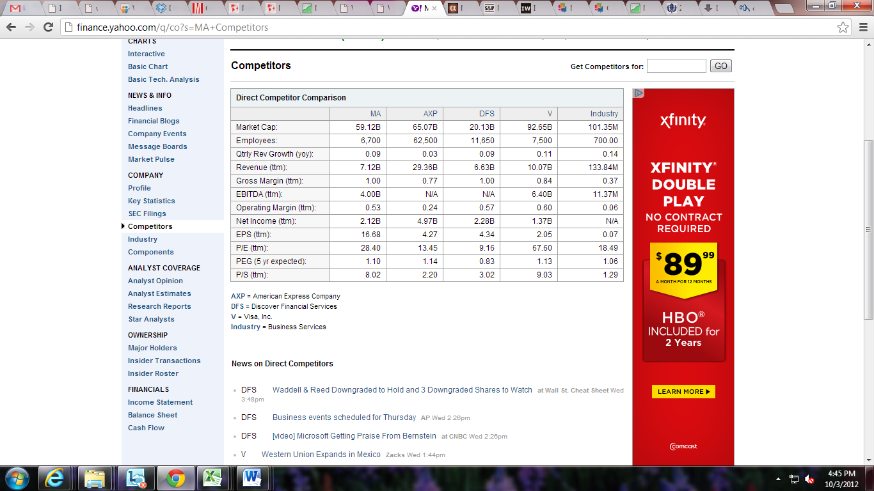

**WACC Calculation: Total Return Calculation:**

 

**Valuation Assumptions:**



**Historical Financial Data:**









**Source:** DIS 10-K, Morningstar, S&P Net Advantage, S&P Capital IQ Equity Research, ValueLine, Thomson One Banker, Yahoo Finance, Google finance

**Notes:**