

Business Summary

Coca-Cola is the world’s largest nonalcoholic beverage company. The company sells a variety of sparkling and still beverages and generates about 70% of its revenue and 80% of its operating profit in international markets. Coke’s core brands are a mixture of CSD (carbonated soft drinks) sports drinks, bottles water, and juices; Coca-Cola, Sprite, Dasani, Powerade, and Minute Maid[1]. Following the asset swap with CCE, Coke now owns about 80% of its distribution in North America. Coca-Cola markets, manufactures, and sell beverages concentrates both in the United States and International markets. With its vast distribution network, Coca-Cola is able to introduce its products to 200 countries.

The Company has been devoted to invest in emerging markets as it announced that it plans to heavily invest in China and India. The company intends to invest approximately $4 billion into China over the next 3 years and $5 billion into India for the next 8 years.

Domestic Industry Analysis

The CSD industry is domestically led by three major players: The Coca-Cola Company, PepsiCo Inc., and Dr. Snapple Group Inc. In addition, this industry is influenced by several key economic drivers: Per capita consumption, demand from food services and drinking places, demand from supermarkets and grocery stores, and price of sugar. As a result, this industry is highly correlated with economic circumstances and consumers’ sentiment.

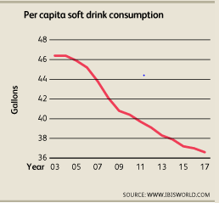As presented by the chart, the domestic consumption, in gallons, is expected to fall in the years leading to 2017. As the consumers become more health oriented, the estimated decline is approximately 36.6 gallons per capita as opposed to 40.2 gallons per capita in 2011. The domestic market is quite saturated and consumers are becoming more oriented towards healthy consumption. As a result, the industry witnessed a loss of 5.9% in revenue, or approximately $16.2 billion in 2012. The change in sentiments has forced the major companies to adapt to the needs of consumers and started to mitigate towards healthier ranges of products; sports and energy drinks, premade tea, bottled water and other beverages. These new segments are growing at a rate that is faster than the CSD’s rate and thus causing cannibalization of sales. As a result of this shift in consumption, the total number of companies in this industry is expected to stagnate over the course of five years until 2017 at an annualized rate of 2.8% per year to 644 companies.[2]

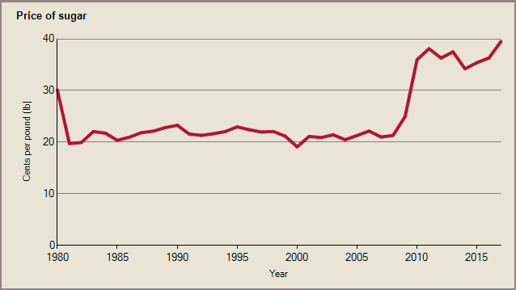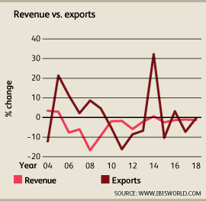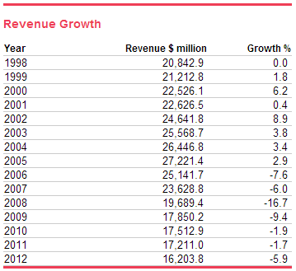From an operational prospective, the industry will face obstacles throughout 2017 as a result of high unemployment rates which will suppress discretionary spending. The lingering effects of the subprime mortgage crisis have also caused household wealth to remain low. Profitability will suffer as well, Sugar prices have increased an annual rate of 13.9% in the past five years and will continue to increase up till 2012. Sugar‘s main sweetener substitute is corn syrup, and corn is also the main crop used in ethanol production in the United States. High oil prices since 2005 have caused increased use of corn-based ethanol as a substitute and additive for gasoline. This trend raised prices for all corn products and shifted demand away from corn syrup and toward sugar, linking sugar’s price to movements in the price of oil[3]. Plastic material prices increased at an annualized rate of 3.9%. Those percentage increases in price has caused manufacturers to increase marketing budgets and even that wasn’t sufficient to retain customers.[4]

All these factors will contribute to declining revenues within the domestic industry at an average rate of 1.3% per year from 2012 to 2017. The surge of generic CSDs provide strong competition for branded products simply because branding and marketing are not prominent factors of consumption (in majority, and not all geographic locations), and thus low price growth is anticipated.

In early 2011, players within the industry sought to implement a dominant business model know as Vertical integration. Companies who sought to implement this model were focused on creating new flavors, producing syrups, and bottling beverages. After TCCC bought its largest bottlers in 2010, the company was able to efficiently manage its portfolio to adapt to different consumer niches. TCCC experienced a robust growth in international markets tot hey years leading to 2012, but the demand curve was balanced out by companies trying to offshore and contracting out bottling agreements to companies who are the closest to the consumers. As a result, the amount of exports decreased at an average annual rate of 3.7% since 2007 and imports declined at an annualized rate of 10.3%.[5]

International Analysis - Opportunities

With all the declines in growth and revenue, the CSD market still accounts for 40% volume share of the global soft drinks industry. For the sake of simplicity, we will focus on two key markets; China and India. The market in developed countries such as the U.S is quite saturated and the concentration needs to be mitigated towards international markets. Sales of carbonated soft drinks (CSD) in China are forecasted to hover around 20.6 billion liters by 2016; this figure represents a growth of 47% against 2011. The per capita consumption in China is currently 10.34 liters, compared to 167 liters in the US. The International and developing market is mainly concerned about artificial ingredients rather than calorie content, as opposed to the U.S. Seven out of ten consumers in developing countries are trying to avoid drinks with artificial ingredients and are looking to buy drinks with natural ingredients, this highlights an unmet need which could be satisfied by manufacturers. We are, however, seeing manufacturers slowly mitigating towards this unmet need; in 2011, 1.8% of new launches of carbonated soft drinks carried a no additives or preservatives claim – only up slightly from the 1.5% launched in 2006. Overall, statistics have shown that China’s carbonated soft drink market has seen low double digit growth (up 10.2% from 2006-10), which is significantly faster than other global markets such as the US and UK (-1.5% and -1% respectively)[6]. Approximately 96% of Chinese consumers drink carbonated soft drinks, but the frequency of consumption remains lower than other beverages because they tend to have more artificial ingredients.

The future of this, international, market is within increasing sales of single-serve packaging. The ‘on-the-go’ consumption occasion is increasingly important due to the rapid growth of urban convenience stores. Smaller packages can also increase appeal amongst the growing office snacking culture. Today, most consumers in China (75%) drink carbonated soft drinks during mid-afternoon, and nearly half (52%) of consumers drink carbonated soft drinks at work.

In India, the per capita consumption is approximately 4 liters. The industry estimates that the beverage market should grow at twice the rate of GDP growth. The Indian market should have, therefore, grown by at least 12%. However, it has been growing at a rate of about 6%. In contrast, the Chinese market grew by 16% a year. Coca-Cola plans to spend an estimated $5 billion in India to increase capacity in its Indian bottling unit and its 13 franchises as well as to expand distribution network. Pepsi started to sell its products in India before Coca-Cola and thus it had an edge in India, but Coca-Cola was able to buy PepsiCo top brand in India Parle Agro which gave Coca-Cola a 60% share of the Indian soft drink markets while PepsiCo only maintains 37%. All the investments made by Coca-Cola in India are aimed to build capacity and improve marketing in an attempt to fulfill double revenue and volume by 2020. In India, the growth is in the rural areas, and that’s where Coca-Cola has an advantage, Coca-Cola sought to expand its distribution infrastructure to effectively serve a disbursed population, its outlets have been growing exponentially since 2001. Penetrating the rural parts of India meant reaching to approximately 600,000 square km. The emphasis on the rural market is, like china, based on single-serve packaging or “on the go” and so Coca-Cola mitigated towards 200ml bottle as opposed to the standard 300ml . Tradition countries, like India, lack the presence of chained convenience stores, that is, most purchases take place in independent small grocers. Increasing coolers in each outlet offers both good product placement and operator loyalty. This is such an important factor, especially in rural India, which approximately 40% of all sales take place. Increasing awareness of hygiene also offers a huge potential in India, with the lack of clean water in certain rural areas, Coca-Cola can reach a large untapped consumer segment. Rural households account for 70% of the country's population, but only 19% of soft drinks off-trade volumes. Improvement of supply will also play a vital role in driving sales, from direct sellers offering low price bottled water (which reaches 18% of off-trade volume sales in India) to grocers seeking expansion to mid-size cities and rural areas.

International Analysis - Threats

Packaged drinks consumption patterns, especially in traditional markets (mainly Asia), remains a matter of serving a specific need – whether it’s better taste, greater safety, or convenient packaging. With low incomes limiting demand for branding or additional added value, competition from unpackaged local beverages is on the rise and traditional retailing, such as independent corner shops and kiosks, remains the primary distribution channel. In China, demand is growing for simple and straightforward products tagged 'organic', 'natural' and 'fresh', and offering added value, with premium exotic and functional ingredients including super-fruits, and vitamins/minerals[7]. Chinese consumers are becoming more health conscious after the increase in childhood obesity, and thus 50% of consumers consider carbonated soft drinks to be a direct threat with 67% of the population are expressing he desire to only purchase diet or low-calorie drinks. The growth prospects of the Mainland China economy can have some effects on the beverages industry; manufacturing exports are expected to decline and thus affecting beverage sales in southern and eastern provinces.

In India, as incomes rise, demand for branding increases with new middle-class consumers looking to the status and prestige of global brands. Basic, affordable products, such as bottled water and concentrates, are joined by highly branded carbonates and energy drinks, as consumers increasingly seek to define themselves as part of a global consumer class.[8] Constant branding efforts need to be placed to ensure stability and future growth. Both companies are heavily invested in both sports and music (cricket and Bollywood) to promote their products.

In most parts of India, the loyalty of brands is depended upon catchment areas, and in order to maximize the rate of attachment the retailers need to effectively apply a shopper-driven supply chain. That means that shoppers have different behavioral patterns; they act differently at different times of the day. Also within a month, there are different shopping patterns on weekdays, weekends and on pay day weekends, the differences are significant. Coca-Cola will need to continuously adapt its proposition to that changing demand of shoppers from one-size-fits-all to a more customized approach.[9] This tells us that, under certain, circumstances, customers just want a cold drink and not necessarily Coca-Cola or PepsiCo; a huge customization effort must be in place in order to gain the consumer’s loyalty.

Competitors

Although Coca-Cola has other competitors, PepsiCo competes on the same level, internationally. There are few things that gives Coca-Cola an edge in China. First, there is a reason why Coca Cola’s logo is identified 98% of time, Coca-Cola’s logo doesn’t only promote a product, but it adapts to the cultural values, norms, etiquette of a particular area. When Pepsi entered the Chinese market, the translation of their slogan “Pepsi Brings you Back to Life” was a little more literal than what was intended. In Chinese, the slogan meant, “Pepsi Brings Your Ancestors Back from the Grave.” And thus they faced hostility from the public. Coca-Colas ability to transition into the Chinese culture has been a huge advantage for them, to the extent that approximately 17% of the Chinese population believes that Coca-Cola is a Chinese brand. Unlike Coca-Cola, PepsiCo established bottling companies and subsidiaries with regional enterprises rather than international conglomerates like Coca-Cola has done with COFCO, Swire Group and Kerry Group. The problem was that PepsiCo’s regional partners were not strong enough to win over regional markets. Moreover, the profit distribution between PepsiCo and its distributors caused it to lose its grip over its bottlers. PepsiCo took more than 85% of the total profit and left its bottlers with meager profits that caused lots of friction and thus affected sales in parts of china[10]. PepsiCo has had many obstacles especially in emerging and developing market where its net revenue declined on an average of 13 %, primarily due to constant beverage refranchising efforts in China and Mexico.

PepsiCo did start earlier in India and was able to establish solid distribution networks and that has caused Coca-Cola some setbacks in terms of distribution capabilities, but not market share. Coca-Cola has 60% of the market share compared to PepsiCo 37%. Despite popular thought, carbonated soft drinks are not the biggest segment of the market, bottled water is. Coca-Colas brand, Kinley, contributes to about 35% of that total water market as opposed to PepsiCo’s, Aquafina which only holds about 12% of the market.

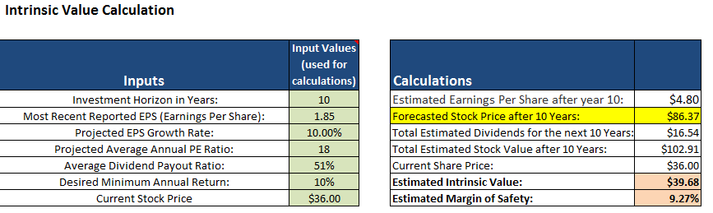

Valuation

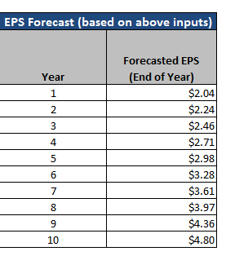

* Based on our assumptions and capability of growth we believe that the stock would be worth $86.37 in 10 years.
* As the company is expanding into international markets and increasing its distribution network, we project an EPS growth of 10% and FCF growth of at least 8% for the next 10 years, and 3%-4% growth to perpetuity
* Our inputs provide us with approximately 10% margin of safety that serves as a cushion if

earnings fall below current trends.

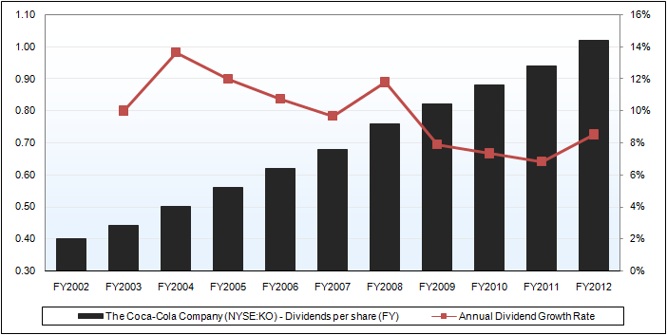KO’s valuation is backed by its healthy financials that are better than the finances of their peers. When we combine its in-line growth, strong global expansion, and leading margin performance, Coca-Cola should warrant a decent premium valuation over its peers. Coca-Colas strengths are backed by its current stock valuations at 12.6x forward EV/EBIDTA, 18x forward P/E, and 1.95 PEG ratio; this peg ratio is lower than PepsiCo’s 2.11x and Nestle’s 2.73. Moreover, KO has a dividend yield of 2.75% which is safely backed by the company’s constant ability to grow its dividend over the past decade. Its dividends have been growing steadily by a 10-year CAGR of approximately 10%. We do recognize that metrics such as ROIC and ROE are somewhat below the industry average, but KO has had higher overall profit margins; based on current trends their EBITDA margin is estimated to expand by 1.4% which is higher than the industry average of 0.6%. They also have a strong free cash flow margin of 13.7% which is well above the peer average of only 6.4%. The question then becomes, Is this sustainable? Coke’s performances have been consistent by looking at their payout ratios. When we look at the free cash flow payout, KO’s annual dividend payment, historically, is equivalent to more than half of the annual free cash flow which indicates that there is room for further dividend increases for the coming periods.

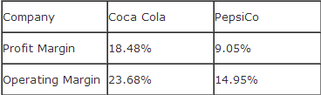 Coca-Cola has also put significant efforts to maximize productivity and minimize cost. The company had announced earlier this year that it intends to establish a reinvestment program from 2012 throughout 2015 to innovate in supply chain, marketing, and IT systems. This constant need for improvement and ability to adapt to surrounding makes Coca-Cola unique, and makes us feel at ease when comparing it against PepsiCo. Coca-Cola’s commitment to those changes is evident in their financials.

We would expect Pepsi to have a much higher profit and operating margin because of YUM’s huge profits over the few years – the connections with fast-food would provide such growth, but the company has recently reported a 3Q2012 net of $1.9 billion, versus $2 billion from a year earlier. On the other hand, Coca-Cola has been able to provide 4% net gain in 3Q2012 versus 3Q2011. Coca-Cola’s high profit margins are somewhat impeded by its asset turnover inefficiencies, 0.6x compared to the peer median of 0.8x, and this only suggests that Coca-Cola has a margin driven operating model compared to other companies in this industry. The company also has a higher gross margin, 62% compared to its peers with only 50%. Moreover, Coca-Cola’s bottom-line operating performance is higher than the industry’s median, a pre-tax margin of 23.2% compared to peer median of 12.9%, this suggests that Coca-Cola has a relatively tight grip on operating costs and pricing power advantages.

What makes us confident about our valuation goes beyond the financials. It is the fact that Coca-Cola is constantly changing and adapting to the needs of the environment. History has shown us companies that came up with brilliant introductions but failed to prosper because there was no drive to improve (i.e., Kodak and Xerox). Coca-Cola has predictable and sustainable patterns that are present in growth, production, and distribution.

1. http://quote.morningstar.com/stock/s.aspx?t=ko
2. http://clients1.ibisworld.com/reports/us/industry/currentperformance.aspx?entid=285
3. http://clients1.ibisworld.com/reports/us/bed/default.aspx?bedid=176
4. http://clients1.ibisworld.com/reports/us/industry/currentperformance.aspx?entid=979
5. http://clients1.ibisworld.com/reports/us/industry/industryoutlook.aspx?entid=285
6. http://chinabevnews.wordpress.com/2012/04/05/carbonated-soft-drinks-chinese-consumers-embrace-no-additives-preservatives-trend-but-manufacturers-slow-to-respond/
7. Haffner, Rick. "Research in Focus - Soft Drinks: How Consumption Patterns Drive Branding and Product Development." just - drinks global newsOct 02 2012. ABI/INFORM Complete. Web. 16 Nov. 2012 .
8. Haffner, R. (2012, Oct 02). Research in focus - soft drinks: How consumption patterns drive branding and product development. Just - Drinks Global News. Retrieved from http://ezproxy.lib.uconn.edu/login?url=http://search.proquest.com/docview/1081617389?accountid=14518
9. http://search.proquest.com.ezproxy.lib.uconn.edu/abiglobal/docview/1035170130/13A6C3D2BCC5742E1A6/6?accountid=14518
10. http://www.bjreview.com.cn/business/txt/2011-11/28/content_408378.htm