Recommendation: BUY
Total Annual Return Est.:
3 year FV | 33.8%
5 year FV | 20.2%
Financial Snapshot:
Price | $37.4
DCF Value | $85.16
Buy Target | $72.38
Sell Target | $97.93
P/E | 17x
Forward P/E | 17.6x
Div Yield | 2.6%
Market Cap | $173.76Billion
52 Wk Range | $32.37-$40.67
EPS Growth | 10.5%
PEG | 0.1831
Credit | A++
Current Ratio | 2.23x

Investment Theme: Looking for companies that have strong competitive positioning in both US and International market. Investing in companies that have strong free cash flow and dividend in a stable industry. Taking advantage of forward-looking management decisions.

Overview: The Coca-Cola Company (KO) is engaged in the manufacture, distribution and marketing of non-alcoholic beverage concentrates and syrups. My buy recommendation of KO is based on the top down analysis of the consumer staples sector.

Beverage companies have slow developed market growth, which makes the industry unfavorable. With sugar and corn prices being more expensive, price hikes or lower margins may occur. Most companies are focusing on gaining share in emerging economies seeing as developed nation growth is on a decreasing trend. This industry is also recognizing the trend in developed countries toward healthier foods and lifestyles.

The Coca-Cola Company creates value by diversified geographical presence, which helps the company mitigate the various risks associated with the over dependence on a particular market. The strategic acquisitions in line with the current business operations could help the company to enhance its market presence and improve top line performance.
The Coca-Cola Company has focused on realizing its 2020 Vision—an aggressive but achievable systemwide plan for growth launched at the outset of 2010. Across the first two years of the 2020 Vision, Coca-Cola met or exceeded its long-term growth targets. In 2011, the company increased sparkling volume 4 percent and still volume 8 percent. All told, it sold 26.7 billion unit cases, earning $46.5 billion in revenues. Coca-Cola delivered nearly 1 billion unit cases of incremental organic volume growth—the equivalent of adding another market the size of Japan to its business—and increased operating income by $1.7 billion to $10.2 billion. It became a better competitor, gaining market share across the world in almost every nonalcoholic beverage category and increasing its total market share. Early in 2012, the Coca-Cola Company announced its 50th consecutive annual dividend increase, raising its dividend 8.5 percent.
KO, trading at $37.4, results in a P/E ratio of approximately 17x based on current-year EPS estimates of approximately $2.2. The provided discounted cash flow valuation that assumes a 7.6% five year compounded annual growth rate and a WACC of 4.77%, resulting in an intrinsic value of $85.16.

The primary risk to the performance of Coca-Cola is its reported declined liquidity (with increasing debt due to acquisitions) in the fiscal year ended 2011, which could impact its growth and expansion plans. However, I remain cautiously optimistic regarding the strong cash flow over the last five years and the new share repurchase program of 500 million additional shares of the Company’s common stock. With the strong brand equity, I believe Coca-Cola will act constantly stable in an upward trend in the current economy.

2012 Q3 and Year-to-Date Results: Strong global volume growth of 4% in the quarter and 5% year-to-date, with volume growth across every geographic operating group in the quarter. North America volume grew 2% in the quarter and year-to-date, and international volume grew 5% in the quarter and year-to-date. Third quarter reported net revenues grew 1% and comparable currency neutral net revenues grew 6%. Year-to-date reported net revenues grew 3% and comparable currency neutral net revenues grew 6%. Third quarter reported operating income and comparable currency neutral operating income both grew 1%, in line with our expectations. Year-to-date reported operating income grew 5% and comparable currency neutral operating income grew 4%. Currency represented a 5% headwind on comparable net revenues and a 7% headwind on comparable operating income in the quarter. Third quarter reported EPS was $0.50, up 4%, and comparable EPS was $0.51, down 2%. Year-to-date reported and comparable EPS were both $1.56, up 5% and 2%, respectively. Year-to-date cash from operations was up a strong 15%.

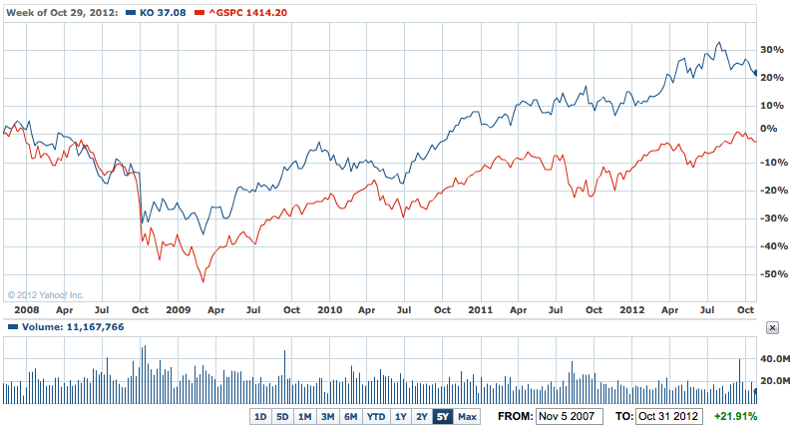

Investment Thesis: The Coca-Cola Company has the high potential to be benefited from the growing demand in the non-alcoholic beverage market. Coca-Cola shares have been a rewarding holding so far this year, rising roughly 10%, versus single-digit gains for the broader U.S. benchmarks. The company had constantly strong volume and value share growth in North America as well as in International market. Coca-Cola gives investors a very high ROE, which is over 19% higher than other beverage or similar companies return. The company has also increased their stock dividend every year for almost 50 years straight.

Pros:
- Coca-Cola was providing new share repurchase program of 500 million additional shares of the Company’s common stock, which will not impact the Coca-Cola's previously announced targeted range of $2.5 to $3 billion in net share repurchases this year. (10/18/12)
- The company announced that it has completed the transaction to acquire approximately half of the equity in Aujan Industries’ beverage business, one of the largest independent beverage companies in the Middle East. With the completion of the transaction, The Coca-Cola Company has acquired 50% of the Aujan entity that holds the rights to Aujan-owned brands, and 49% of Aujan’s bottling and distribution operations. (09/24/12)
- Other acquisitions such as Great Plains Coca-Cola Bottling Company (12/30/11) and an additional minority interest in Coca-Cola Central Japan Company (Dec. 2011) also provide Coca-Cola strong competencies.
- Coca-Cola generated strong cash flows from operations over the last five years. The company has managed to fund its capital expenditure plans and dividend payout through internally generated cash flows. Operational cash flows generated through 2007-2011 were $7,150m (2007); $7,571m (2008); $8,186m (2009), $9,532m (2010), and $9,474m (2011); which was sufficient to meet the capex requirements over these years of $1,648m (2007); $1,968m (2008); $1,993m (2009), $2,215m (2010), and $2,920m (2011). Such strong financial position of the company has helped it in funding its capex and development plans from the internally generated funds.
- Coca-Cola enjoys a strong brand equity, which provides it with an edge over its competitors while attracting new customers and retaining a loyal customer base.

Industry Trends: Improved trends for non-carbonated beverages as consumers return to healthier products after briefly trading down to cheaper alternatives during the recession. Challenging trends for carbonated beverages over the longer term, with the exception of flavored carbonated beverages, which have shown appeal to young and faster-growing ethnic groups. Overall, the domestic non-alcoholic unit sales volume growth will improve on increasing advertising and promotional spending and new product launches. For the long term, the volume trends will benefit from increased penetration into non-traditional distribution channels and growing consumer demand for non-alcoholic product, which should continue to raise non-alcoholic beverage per-capita consumption levels. There are significant opportunities for consumption growth in developing and emerging regions. Through October 19, the S&P Soft Drinks Index rose 7.1%, versus a 13.7% gain for the S&P 1500 Index. The sub-industry index rose 5.6% in 2011, versus a 0.3% decline for the S&P 1500.

Business Summary: The Coca-Cola Company is the world's largest producer of soft drink concentrates and syrups, as well as the world's biggest producer of juice and juice-related products. Finished soft drink products bearing the company's trademarks have been sold in the U.S. since 1886, and are now sold in more than 200 countries. Company owns or licenses and markets more than 500 nonalcoholic beverage brands, primarily sparkling beverages but also a variety of still beverages, such as waters, enhanced waters, juices and juice drinks, ready-to-drink teas and coffees, and energy and sports drinks. It owns and markets a range of nonalcoholic sparkling beverage brands, which includes Coca-Cola, Diet Coke, Fanta and Sprite. The Company’s segments include Eurasia and Africa, Europe, Latin America, North America, Pacific, Bottling Investments and Corporate. On December 30, 2011, the Company acquired Great Plains Coca-Cola Bottling Company (Great Plains) in the United States. In December 2011, the Company acquired an additional minority interest in Coca-Cola Central Japan Company (Central Japan). In September 2012, it acquired approximately 50% equity in Aujan Industries’ beverage business. Sales by operating segment in 2011 were derived as follows: North America (44.2% of revenues); Bottling Investments (18.3%); Europe (10.3%); Pacific (11.7%); Latin America (9.5%); Eurasia and Africa (5.8%); and Corporate (0.3%). In 2011, trademark Cola-Cola beverages accounted for approximately 49% of worldwide case volume with sparkling beverages representing about 75% of volumes. Trademark Coca-Cola beverages accounted for 49% of U.S. unit case volume while sparkling beverages represented 70% of total U.S. case volume.

Management Review: Muhtar Kent is Chairman of the Board and Chief Executive Officer of The Coca-Cola Company, a position he has held since April 2009. Previously he was President and Chief Executive Officer and earlier, President and Chief Operating Officer. In four years as CEO of the Coca-Cola Co., he has cranked up profits and trumped Pepsi in the beverage wars. Now Kent is shaking up Coke's culture and remaking the company in his own image.

Financial Trend Analysis: After the down-turn caused by the great recession in 2008, financial trends over the trailing five years have largely been positive and exceeded the performance of S&P 500 as we can see from the previous chart. Specific trend figures are illustrated in the appendix of this report. Revenue has grown at a upward trend and jumped to 32.9% in 2011, while earnings have grown at a rate of 10% from 2007 to 2011. Sales and operating profit have increased steadily over the past five years. After the 3rd Quarter Earnings announced with management’s decision of share repurchase and global investing program, I believe that Coca-Cola will continue to perform constantly with growth around 8%-10% during the next five years.

Financial Health: The Coca-Cola Company maintains a strong balance sheet with a lot of cash available to fund investments in research and development as well as acquiring perspective companies to help enhance their portfolio in certain areas, for example bottling and other soft drink brands. Though Coca-Cola’s debt grew significantly in 2010 and 2011 due to acquisitions, with strong volume and value share growth in both US and International market, Coca-Cola will quickly have it recovered. Coca-Cola’s new share repurchase program of 500 million additional shares of the Company’s common stock, which will not impact the Coca-Cola's previously announced targeted range of $2.5 to $3 billion in net share repurchases this year, will increasing EPS under the same profit for the shareholders.

Competitive Analysis: The major three competitors are Pepsico, Inc. (PEP), Nestle (NSRGY), and Dr Pepper Snapple Group, Inc. (DPS). Coca-Cola has the highest growth margin and operating margin among the three. It is the world's largest producer of soft drink concentrates and syrups, as well as the world's biggest producer of juice and juice-related products. It enjoys a strong brand equity, which provides it with an edge over its competitors while attracting and retaining a loyal customer base.

Risk Factors:
- The Coca-Cola Company reported declined liquidity in the fiscal year ended 2011, which could impact its growth and expansion plans.
- Coca-Cola has been involved in some product recalls, which reflect the lax quality control of the company. i.e. In November, 2011, the company recalled 88,000 themed drinking glasses for quality reasons.
- The Company’s operations are subject to a number of laws and regulations by federal, state and local Governmental entities and agencies in the US and other foreign countries, which may have a material adverse effect on Coca-Cola’s business, financial condition or results of operations.
- Coca-Cola reported increased operating costs in the fiscal year ended 2011, which affected its margins.
- Increase of raw material cost may have a major impact on the operational performance of the company.

DCF Valuation Model:

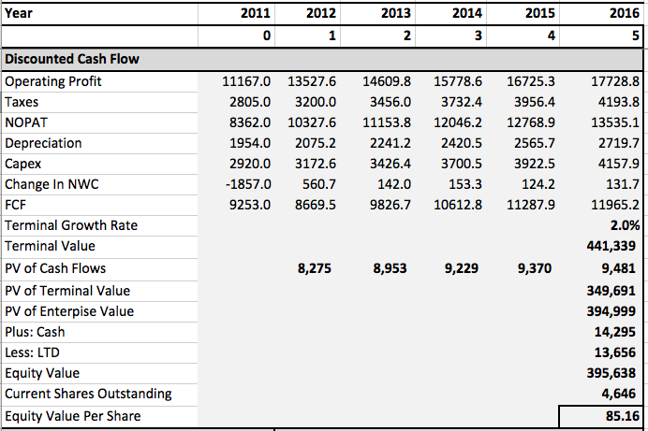
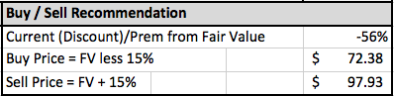

Total Return Calculation:
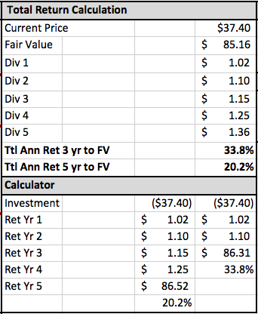
Comparative Valuation Analysis:
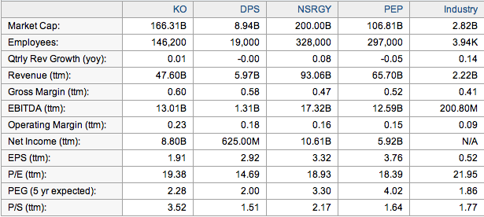

WACC Calculation:
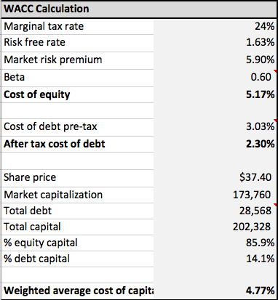

Valuation Assumptions:

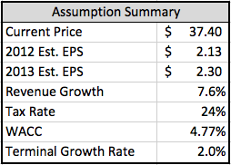
Income Statement Projection:
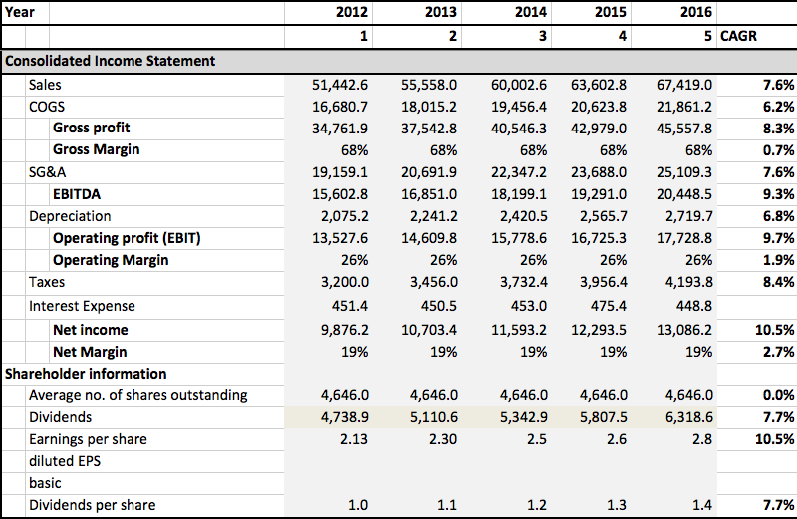
Historical Financial Data:

Income Statement
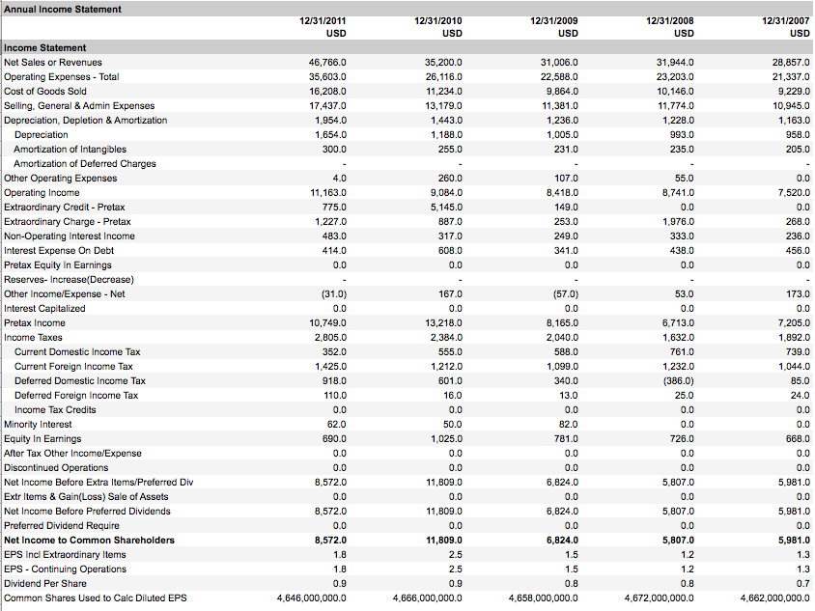

Cash Flow Statement
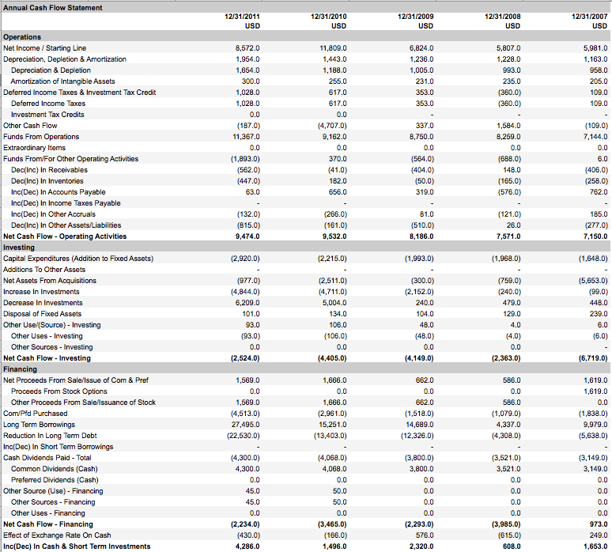
Balance Sheet
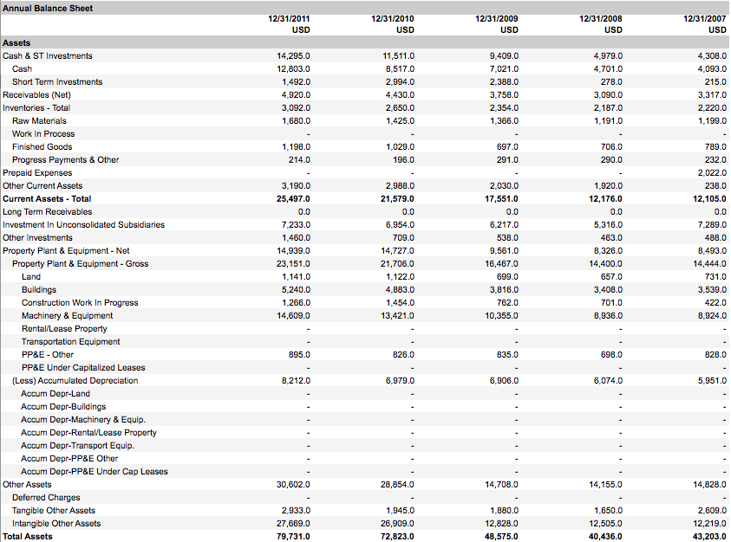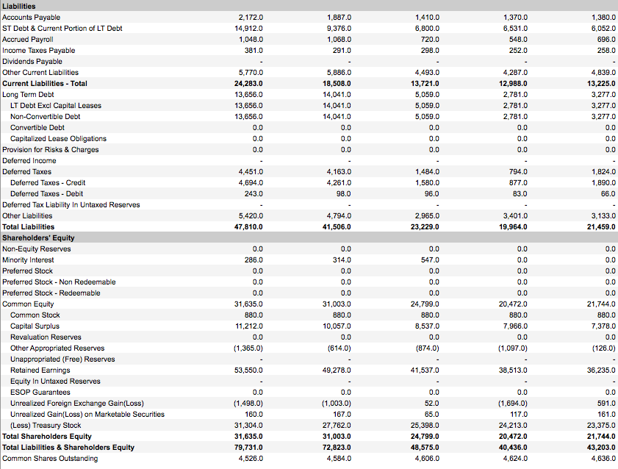

Key Ratios
