**Recommendation: BUY**

**Total Annual Return Est.:**

|  |  |
| --- | --- |
| 3 year FV | 10.3% |
| 5 year FV | **6.9%** |

**Financial Snapshot:**

|  |  |
| --- | --- |
| Price | **$52.28** |
| DCF Value | **$67** |
| Buy Target | **$56.97** |
| Sell Target | **$77.08** |
| TTM P/E | **17.3x** |
| Forward P/E | **18.1x** |
| Div Yield | **1.6%** |
| Market Cap | **$95 Billion** |
| 52 Wk Range | **$28.19 - $53.40** |
| EPS Growth | **10.7%** |
| PEG | **1.62** |
| Credit | **BBB+** |
| Current Ratio | **4.83x** |

**Overview:** Disney benefits from its strength in diversified business operations, strong brand identify strong marketing activity and global market presentence. Disney, ESPN, ABC, Pixar, and Marvel are an amazing collection of brands that grow stronger every day as new platforms and new markets provide enormous new opportunities for high quality content and experiences. Disney owns a collection of valuable assets, but its media networks, which generate more than half of the company's operating profit, are the backbone of this conglomerate. As a content-oriented company, DIS's top strategic priorities include creativity and innovation, international expansion, and leveraging new technology applications. We believe Disney is well positioned to meet the challenges of the fast-changing media and entertainment. The company could expect a boost in its revenue from the positive trends in advertising markets in the US and Europe. The company’s new expansion plans could ensure its progress for the near future catering to the needs of its customers.

Revenue is expected to grow between 3% and 5% annually over the next five years with margins expanding slightly due to more and more projects progressing toward or reaching steady-state operations.

DIS, trading at $52.28, results in a P/E ratio of approximately 18.1x based on current-year EPS estimates of approximately $2.9. The provided discounted cash flow valuation that assumes a 4.2% five year compounded annual growth rate and a WACC of 7.82%, resulting in an intrinsic value of $67. When performing a sensitivity analysis on the WACC between 7%-8.5% we receive a fair value range of $81.48-$58.29.

The primary risk to the performance of Disney is global economic growth, should major markets in which Disney operates see a major and prolonged economic downturn revenue growth will be significantly less than expected. Our group remains cautiously optimistic regarding the global economy and do not foresee significant negative impacts to Disney, but it will be closely monitored with respect to Disney.

**2012 Q3 Results:** Disney reported $1.8 billion in net income and earnings of $1.01 a share for the quarter ended in June, up 31% versus a year prior and ahead of the 93-cent consensus estimate from analysts surveyed by Thomson Reuters. The company missed slightly on sales, however, reporting $11.1 billion in revenue against a consensus estimate of $11.3 billion.

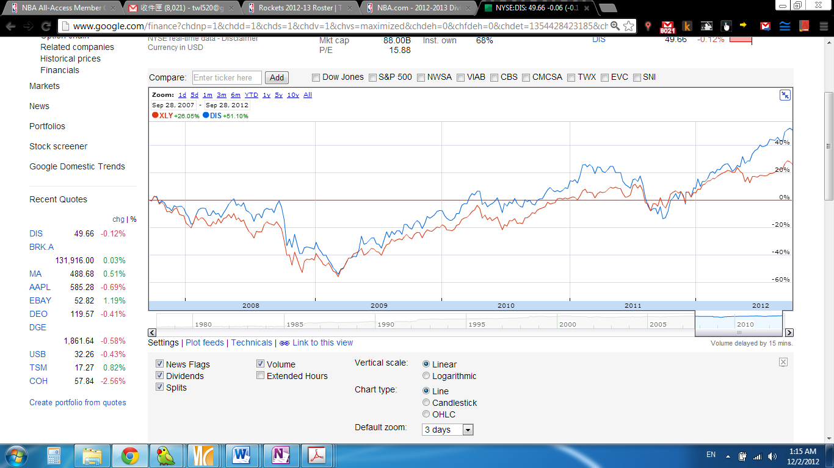

Investment Thesis: Solid box office performance of "The Avengers" should significantly lift the studio and consumer products business division into FY 13. With affiliate renewals covering ~75% of subscribers due by the end of CY2014, we believe that given the strength of its cable networks and recent deals that have set the market, Disney’s affiliate revenue growth can modestly accelerate over the next few years to ~8%. At Parks, key investment projects, which operated at breakeven in FY11 and FY12, should begin to generate incremental profit in FY13. In turn, this should drive margin expansion back toward pre-recession levels and boost earnings growth.

Pros:

* New projects in the Parks segment are likely to generate 10~15% IRR.
* The US online retailing is predicted to reach USD 201.4 billion by 2013. DIS through its Interactive Media segment derives revenue from e- commerce activity.
* DIS has invested $350 million to develop its own in-house video game development capabilities, which will strengthen the company’s digital gaming portfolio.
* DIS purchased comic book company Marvel, which gives DIS the rights to 5000 Marvel characters and their associated royalty and licensing revenues from games, movies, clothing, toys, and theme park ride.
* DIS is growing significantly faster than its global peers
* $3B in share repurchases for F2012E
* Parks and Resorts continue to perform well through September. Attendance, occupancy, and spending on a per room basis continue to trend higher. Attendance is strong at California Adventure, with people spending more time at the park (67 hours v. 45hours previously). Furthermore, the cruise ships have had a ''spectacular'' response, with the CFO reiterating 94% occupancy.

Industry Trends: While traditional formats (DVDs, CDs) and channels have likely reached saturation, we see continued evolution of newer distribution windows that creating both opportunities and challenges for entertainment content providers. Changing consumer habits should spur a convergence of content, technology and services. With the likes of Hulu, Netflix and Vevo/YouTube becoming popular streaming destinations, and new business models for web-TV authentication under experimentation, we believe online video could provide a compelling longer-term opportunity for content providers, which are increasingly embracing social media (e.g., Facebook, YouTube and Twitter) as important outlets.

Business Summary: The Walt Disney Company, together with its subsidiaries, is a diversified international family entertainment and media enterprise company. The Company operates in five segments: Media Networks, Parks and Resorts, Studio Entertainment, Consumer Products and Interactive Media. The company through its Media Networks encompasses an array of broadcast, cable, radio, and publishing businesses. It produces and acquires live-action and animated motion pictures, musical recordings and live stage plays. It also carries out operations in licensing the Disney brand for a variety of merchandise. 75% of total revenues come from North America.

In recent years, the company embarked on its latest round of capital spending related to its theme parks and resorts businesses, including: a new mixed-use resort in Hawaii (opened summer 2011); significant expansion of Disney World's Fantasyland (2011); three new themed areas -- including Toy Story Land – at Hong Kong Disneyland (2011); two new cruise ships named Disney Dream and Disney Fantasy (2011); and a new Cars Land at Disneyland's California Adventure (June 2012); Also, construction recently began at the company's first theme park in mainland China (Shanghai), for opening by 2016.

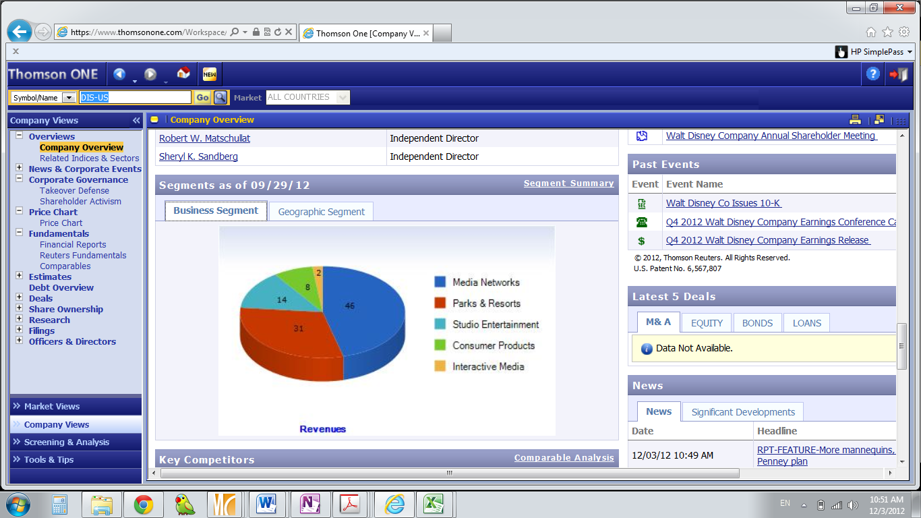 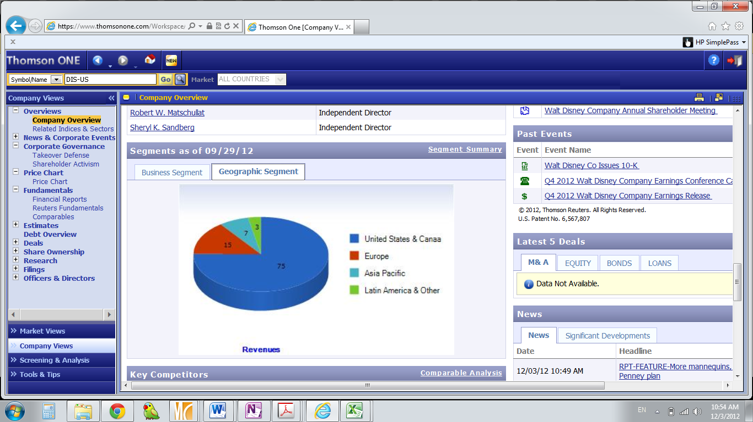

Management Review: Bob Iger has served as CEO since October 2005 and he recently announced that he plans to remain at the helm through 2016.Tom Staggs, former CFO and now head of the parks business, and Jay Rasulo, current CFO and former head of the parks business, are currently viewed as top candidates to replace Iger. However, we believe succession plans could change multiple times before 2016 arrives. Iger has shown a willingness to embrace new technology while reinforcing Disney's commitment to high-quality content. For example, he knew the importance of animation to its studio entertainment business, so he quickly patched up the relationship with the late Steve Jobs, then the CEO of Pixar, and acquired the computer animation firm in 2006. The board consists of 13 directors, 10 of whom are considered independent. We think the board benefits from having members with various backgrounds and areas of expertise. For instance, Sheryl Sandberg, COO of Facebook, can offer an important technology perspective to Disney.

Financial Trend Analysis: Financial trends over the trailing five years have largely been positive. Specific trend figures are illustrated in the appendix of this report. Revenue has grown at a 3.5% CAGR over the last five years, except in FY2009. Parks margins could hit prerecession levels over time. DIS has nearly completed all major capital projects, but there are still preopening expenses that can modestly weigh on margins in the near term, such as hiring, training, and marketing to ensure a strong start for the unveiling. Thus, margins could expand slightly as more and more projects progress toward or reach steady-state operations. Returns on equity and total capital are following similar trends.

Financial Health: Disney's financial health is solid. Debt is a low percentage of total capitalization. The company's debt/capital ratio hovers around 25%, which we think is reasonable. We expect EBITDA to cover interest expense more than 30 times on average during the next five years.

Competitive Analysis:DIS competes with several large players such as Time Warner Inc., CBS Corporation, Viacom Inc., and News Corporation in different areas. (Please see the diagram in the next page) Compared to its peers, DIS is more diversified. The company’s wide geographic presence increases its customer base providing an opportunity to generate high revenues.

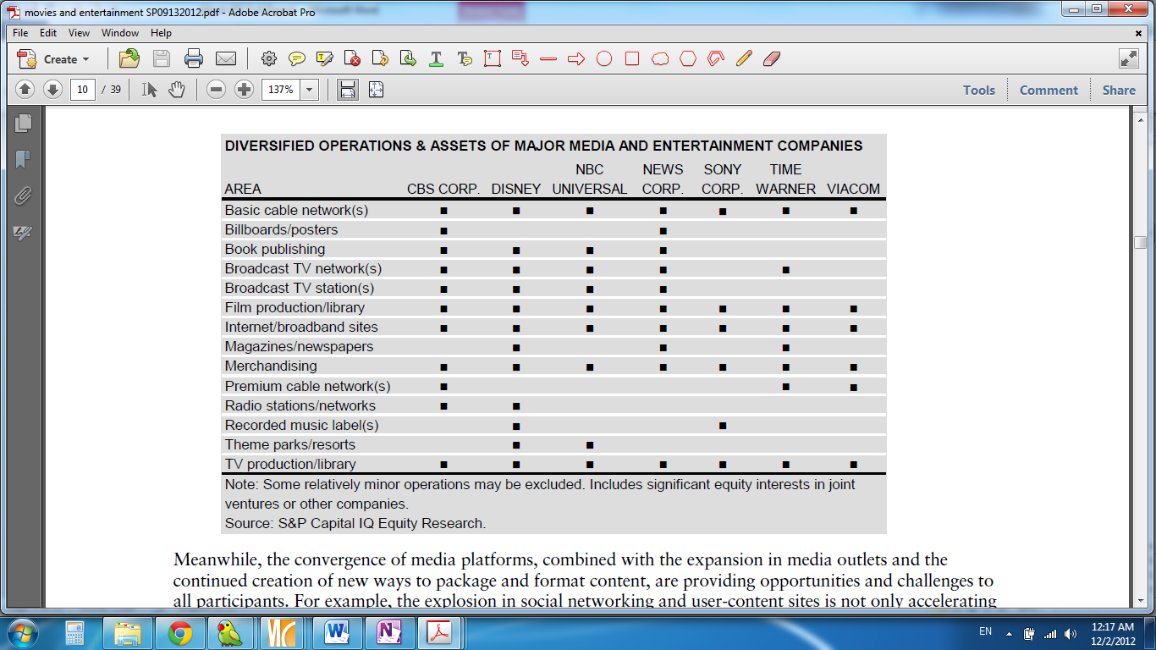

Risk Factors:

* Relatively high vulnerability of the company's core businesses to a slowdown in consumer discretionary spending, as well as its relatively high exposure to capital-intensive theme parks businesses.
* Several regulations by governmental authorities in the US and worldwide influence the company’s business operations and may impede its expansion activities.
* Fluctuating Macro Environment may have material impact on the company’s business and earnings. It may also have impact of economic and market conditions on third parties, such as suppliers, film co-financing partners, retailers, insurers, lenders, and other sources of financing.

**DCF Valuation Model:**



**Target Prices:** **Sensitivity Analysis:**



**Comparative Valuation Analysis: WACC Calculation:**



**Total Return Calculation: Valuation Assumptions:**

 

**Income Statement Projection:**



**Historical Financial Data:**









**Source:** DIS 10-K, Morningstar, S&P Net Advantage, S&P Capital IQ Equity Research, ValueLine, Thomson One Banker, Yahoo Finance, Google finance

**Notes:**