Analyst Report | Ticker: COH | 11/16/2012 | UG Student Managed Fund 2012

Coach Incorporated
Key Financial Metrics
52 Week Range: 48.24 – 79.70  Price/Earnings: 15.2x  Intrinsic Value: $86.89  Dividend Yield:1.93%  Market Cap: $16 bil | ROE: 57.63%  ROIC: 56.88%  ROA: 36.2%  Debt/Equity: .55  Price/Book: 8 | Gross Margin: 72.9%  Profit Margin: 21.81%  FCF Yield: 6.5%  EPS: $3.53  # of Shares: 292 mil

Stock Price vs. TIF & S&P 500 | Rationale
 | We issue a buy price for COH with a forward price of $86.89. We believe COH’s strong same store growth, successful expansion into international markets, and cheap stock price provide an excellent opportunity to invest some of the fund’s capital.

Highlights | Company Risks
- The company continues to post strong financials with increasing revenue and profits. The recession of 2008 was barely a hiccup for them, and they were right back to where they left off the next year. Coach has also been continually buying back shares, and has begun issuing a dividend.  - Has a brand value of $13.4 billion according to a branding study done by Interbrand. This figure demonstrates the strength of Coach’s brand, the loyalty of their customers, and their continuous ability to keep up with fashion trends.  - During the recession in 2008, Coach refused to lower its profit margins and prices, in order to maintain its luxury brand image. | - Coach has exposure to many foreign markets, and foreign interest rates.  - A poor economy could greatly reduce consumer spending, thus hurting Coach’s revenues.  - Increasing competition in the industry and constantly changing fashion trends will make it difficult for Coach to stay innovative.  - Coach’s outsourcing of their product exposes them to the risk of losing each individual vendor, including one that accounts for 16% of Coach’s total units.  - The increasing production of counterfeit products will continue to hurt Coach’s brand image and their revenues.

Current Events
- Coach continues to expand internationally to increase revenues, and has shown this by increasing the number of international stores by 18% in fiscal 2012.
- Coach’s recent announcement of having an ‘investment year’ not only lowered their market price, but also shows their determination to provide long-term shareholder value.
- Coach continues to buy out its distributors in foreign countries in order to remove itself from third-party risk.
- The company has announced it will buy back as much as $1.5 billion in shares outstanding by June 2015.

Coach Incorporated Analyst Report UG Student Managed Fund
Business Summary
Coach has grown from a family-run small leather goods business to the largest company in the accessory market. The company's core products are handbags, which represent 65.0% of revenue. The remainder comes from accessories (about 28%) and a small portion (about 7%) comes from other products, such as eyewear, footwear and fragrance. The company typically has three to four collections per quarter and four to seven styles per collection. The company also has a strong international presence, receiving 18% of revenues from Japan, and 6% of revenues from its new initiative in China. Coach has continued to buy out its distributors internationally in order to control the flow of products being sold, and to remove itself from third-party risk. They now own their distributors in Japan, China, Hong Kong, Macaw, Singapore, Taiwan, Malaysia, and Korea, with joint ventures in Spain, Portugal, Great Britain, France, and Ireland.

The lower-priced Poppy bags, which feature more vibrant colors, help add a youthful design to Coach's product offerings. The company has invested heavily in designing a marketing strategy around the Poppy brand. Most recently, the company opened two temporary, stand-alone Poppy locations in key department stores and expects to open more of these pop-up locations in the future. Coach has also recently created a new brand initiative under the name “Reed Krakoff”, and has begun opening specialty stores across the world.

Coach's factory outlet strategy has also helped the company broaden its demographic reach without diluting the strength of its core, full-priced offering. Coach has more than 100 factory stores in the United States, which offer the Coach merchandise at discounted prices and target a more value-oriented consumer who would not typically purchase a Coach bag. During the past five years, the company has experienced growth in its factory store segment. Its existing factory store consumers are buying more than they did in the past and customers who are new to Coach are also increasing their sales.

Valuation
I valued Coach by growing out the company’s earnings per share at its expected growth rate. First, I calculated how much cash per share the company had. I then established two different earnings yields based on the stock price with cash included, and without cash included. This resulted in yields of 6.47%, and 6.82%, respectively. Using the company’s 2013 expected earnings per share, I then calculated the expected earnings yield with cash, and without cash included. This resulted in yields of 7.06%, and 7.44%, respectively. Looking at the difference between the earnings yields over time, I concluded Coach is expected to grow at 9% per year. I used this growth rate to grow the non-cash earnings yield out at 9% for five years, resulting in a yield of 10.49%. Since Coach generally trades at about 16 to 18 times earnings, I multiplied those numbers by my expected yield, which resulted in a five year trading range of $86.89 - $97.75. To earn a 10% annual profit over five years, the price would need to be $53.95. See the calculations in the Appendix.
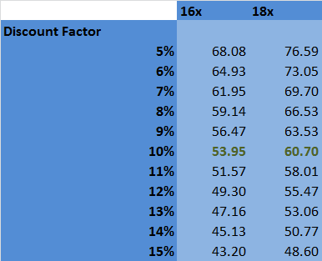

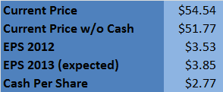

Coach Incorporated Analyst Report UG Student Managed Fund
Industry Overview
The Handbag, Luggage, and Accessories Stores industry includes specialty retailers that primarily sell handbags, luggage or clothing accessories, or any combination of these products. The industry is dominated by major players such as Coach Inc, Louis Vuitton Moet Hennessey, and Claire’s Stores. This industry is also primarily driven by per capita disposal income. If the economy continues to rebound during the next five years, industry revenue is forecast to grow at an even faster annualized rate of 4.5% to reach $11.9 billion by the end of 2017. Furthermore, consolidation will help maintain profit margins, which will hover at about 12.0% of revenue during the next five years.
- The market is maturing as companies move into new categories and increasingly fight against counterfeit goods.
- As new geographic locations are limited, the men's goods category is expected to continue to grow, stimulating new sales within existing markets.
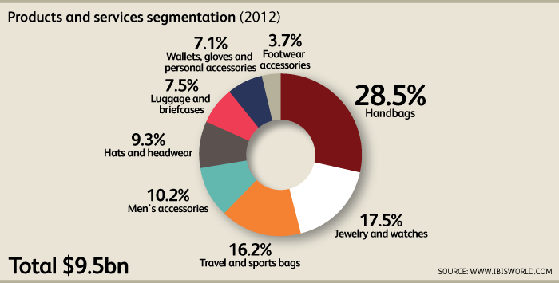
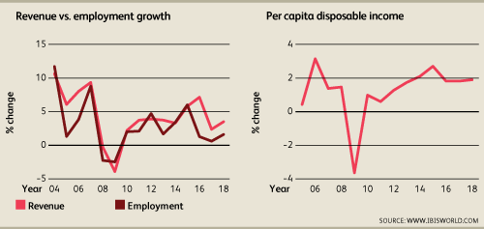
- With new sales opportunities under pressure, retailers are going on the offensive against stores that sell counterfeit accessories.
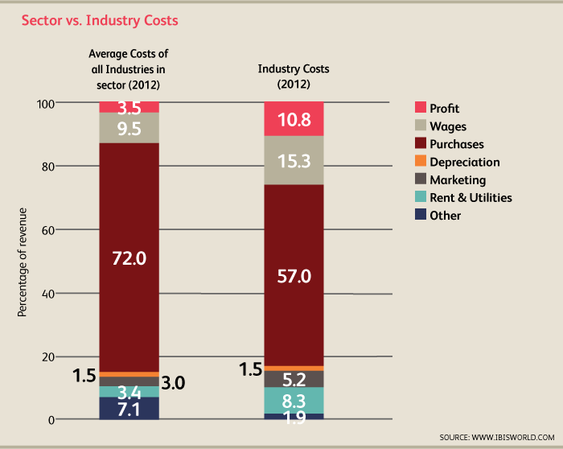
The recession did little to slow down the Handbag, Luggage and Accessory Stores industry in the past five years. This is a positive sign in an economy with a potential recession looming over its head. As the industry becomes overly saturated with participants, consolidation will begin, merging smaller, less profitable players with larger corporations.

Rising incomes will allow consumers to purchase more higher-priced accessories, handbags and luggage. Moreover, Americans will be able to take more trips, necessitating new suitcase and travel bag purchases. In fact, over the next five years, the number of domestic trips taken by Americans is forecast to rise by 3.0% per year on average, while outbound trips are anticipated to grow by 3.1% per year on average. Combined, these trends will drive industry growth over the next five years.
Coach Incorporated Analyst Report UG Student Managed Fund
Competitors
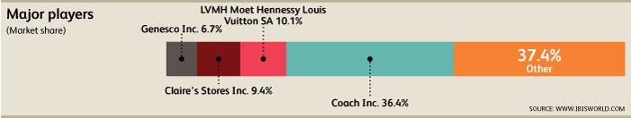

Louis Vuitton Moet Hennessey
Headquartered in Paris, France, LVMH Moet Hennessy Louis Vuitton is an international group of companies that is principally engaged in the manufacturing and sale of luxury products. Of the company's five business divisions, LVMH participates in the Handbag, Luggage and Accessory Stores industry through its fashion and leather goods segment, which accounts for about 30.0% of total company revenue. LVMH's other divisions include selective retailing, wines and spirits, perfumes and cosmetics and watches and jewelry. The group's fashion and leather goods participants produce and market premium leather goods, bags and accessories through various brands, including Louis Vuitton, Loewe, Celine, Berluti and Marc Jacobs.

LVMH has proactively advertised through celebrity endorsements, which are expected to facilitate a larger customer base through wider reach and higher efficiency of celebrity advertisements. According to the company, this promotional strategy has supported industry growth. Unaided brand awareness increased by 180.0% and message association rose by 56.0%. Furthermore, brand favorability increased by 39.0% and purchase intent also increased by 27.0% for advertisements that feature popular athletes.

Claire’ Stores
Claire's is a retailer of costume jewelry and accessories. The company's stores operate under the trade names Claire's and Icing. Claire's operates in the United States, Puerto Rico, Canada, the US Virgin Islands, England, Ireland, France, Spain, Portugal, Belgium, Switzerland, Austria, the Netherlands and Germany. In 2007, an affiliate of the private equity fund Apollo Management acquired Claire's Stores for $3.1 billion.

Claire's caters to teens from 13 to 17 years old and tweens from 7 to 12 years old, with products that range in price from $2 to $20. Claire's customers also include younger children in the age range of three to five years old, through the "Claire's Club" brand. The company's second store concept in North America is Icing, which caters to teens and young women in the 18- to 27-year-old age range. Customer-centric store design is aimed toward increasing customer satisfaction and loyalty through appropriate merchandising and pricing. Also, the increasing teen market in the United States presents a strong opportunity for sales growth with the company.

Claire's sales are divided into two principal product categories. The jewelry segment, which accounts for about 53.0% of revenue, includes costume jewelry and ear piercing services. The company's second major segment is accessories, which makes up the remaining 47.0% of revenue. This category offers other fashion accessories, hair ornaments, handbags, small leather goods and cosmetics.

Summary: Coach continues to grow and maintain its dominate market share. The company fuels this growth by expanding internationally and maintaining its market share in North America by posting a 6.6% comparable stores growth this year. Its development of the Poppy brand has allowed it to expand into lower priced markets without tarnishing its strong luxury brand.

Coach Incorporated Analyst Report UG Student Managed Fund
Appendix
