Recommendation: BUY
Total Annual Return Est.:
3 year FV | 10.1%
5 year FV | 6.7%
Financial Snapshot:
Price | $56.8
DCF Value | $71.74
Buy Target | $60.98
Sell Target | $82.5
P/E | 16.06x
Forward P/E | 14.1x
Div Yield | 2.1%
Market Cap | $16.195Billion
52 Wk Range | $48.24-$79.70
EPS Growth | 9.9%
PEG | 0.8964
Credit | A
Current Ratio | 1.68x

Investment Theme: Investing in companies that have strong and stable growth in the US market, and also provide continuing growth potential in the international market. Looking for companies that have double-digit revenue and sales growth, and still doing distribution expansions. Taking advantage of forward-looking management decisions and upcoming holiday season.

Overview: In an unstable after-recession economic environment with the election cycle, Coach is one of few companies that have positioned itself well to handle the uncertainty and hedge its exposure in the volatile markets in the Luxury Goods industry.

Coach fills a void between designer labels and moderate brands with its high quality, smartly priced goods. It positioned its products as affordable luxuries that fit very well in the current economy. Consumers are saving money from buying less high-end products, but at the same time, they are looking for luxuries that can provide good quality, well known brand, but lower price. My buy recommendation of COH is based on the top down analysis of the Consumer Discretionary sector.

Coach is pursuing four key strategies to strengthen its leadership position and improve productivity: (1) build share of North American women's accessories market via continuous product innovation and improvement and retail expansion, ultimately bringing the total to over 500 locations including 30 in Canada; (2) grow the men's business in North America and Asia; (3) raise brand awareness and build market share of emerging markets, notably China; and (4) raise brand awareness and maximize online sales through its global e-commerce sites and programs, third-party flash sites, marketing sites and social networking.
Coach is expanding its addressable market through a renewed focus on its men's business. The company reported that sales of its men's bags and accessories doubled in North America during FY 12, driving the overall men's premium category, which grew 25%, to $800 million. Globally, Coach men's sales doubled in FY 12, to over $400 million, supported by new dual-gender and stand-alone men's stores, and an expanded men's assortment in about half of COH's directly operated retail locations. The company had 30 men's stand-alone factory stores, five stand-alone men's retail stores, and over 85 men's retail shop-in-shops in North America at the end of FY 12.
COH, trading at $56.8, results in a P/E ratio of approximately 16x based on current-year EPS estimates of approximately $3.53. The provided discounted cash flow valuation that assumes a 10.6% five year compounded annual growth rate and a WACC of 9%, resulting in an intrinsic value of $71.74.
Although Coach has the risk of increasing sourcing cost and heavily rely on the Chinese and Japanese market, I remain cautiously optimistic regarding the strong cash flow over the last five years and the new $1.5 billion of shares repurchase approved. With the strong brand equity, I believe Coach will act constantly stable and grow in an upward trend in the current economy.

2012 Q4 Results: From the Q4 earnings release, we can tell that Coach, with its strongest sales and EPS, beats the market in over two years, the best showing dating back to 4Q08. Coach’s revenue beat of 14.5% and EPS beat of 7.5%. It is a high quality quarter that has growth in all distribution channels. Coach created the best operating margin since first fiscal quarter of calendar 2007. The company’s inventory growth (+35% YOY) suggests the North American holiday season will be better than the last, but also that management is not being too aggressive (inventory declined 16% YOY in 1Q10).

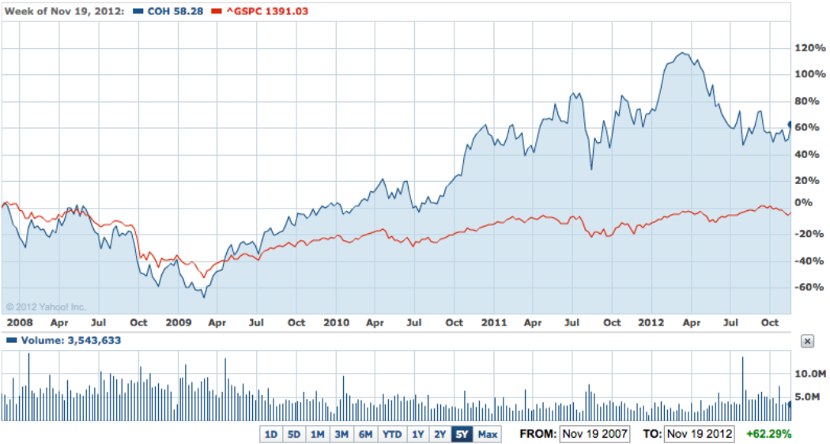

Investment Thesis: Coach consistently generates operating margins now over 32%, the highest in our luxury goods coverage universe. Coach's profitability stems from a narrow economic moat founded on a brand that commands premium pricing (particularly in emerging markets), sourcing and distribution advantages, and management's focus on capital efficiency. We believe these competitive advantages are sustainable over our explicit forecast period through, resulting in excess economic profits. Also, the new 1.5 billion of shares repurchase approved gave us another reason of investing in COH.

Pros:
- 2013Q1 earnings call above expectations.
- A new $1.5 billion of shares repurchase approved.
- E-commerce will go live in China on Nov 2012.
- Double-digit top line growth with strong comparable store sales most notably in North America and China.
- China sales rose nearly 40% from prior year.
- Men’s business growth strategy (over 100 stores with a significant Men's presence) got excellent response both in retail and factory stores and was a significant driver of its overall sales growth in 2013Q1.
- Products sell at high margins, gross margins on sales average 70% at least.
- Historically strong financial metrics. Revenue and earnings growth has been exceptional over the past five years growing at 12.7% and 10.3% CAGR respectively.
- The new line, Legacy collection, has done very well.
- Coach holds a #2 place within the Japanese imported accessories market with a 17% yen share. Its position reflects the strength and relevance of the Coach brand with the Japanese consumer who has become increasingly value oriented.

Industry Trends: According to an October 2012 report by international management consulting firm Bain & Co., global sales of personal luxury goods will increase 10% in 2012, to 212 billion euros. Growth is projected across all regions, led by the Asia-Pacific at 18% (including China at 19%), followed by the Americas at 13%, Japan at 8%, and Europe at 5%. Through October 12, the S&P Apparel, Accessories & Luxury Goods Index advanced 12.0%, versus a 13.3% gain by the S&P 1500 Composite Index. In 2011, the sub-industry index rose 17.2%, versus a 0.3% decline for the S&P 1500.

Business Summary: Coach, Inc. (Coach), is a marketer of fine accessories and gifts for women and men. Coach’s product offerings include women’s and men’s bag, accessories, business cases, footwear, wearables, jewelry, sunwear, travel bags, watches and fragrance. The Company operates in two segments: Direct-to-Consumer and Indirect. Accessories include women’s and men’s small leather goods, novelty accessories and women’s and men’s belts. Women’s small leather goods, which coordinate with its handbags, include money pieces, wristlets, and cosmetic cases. Men’s small leather goods consist primarily of wallets and card cases. Novelty accessories include time management and electronic accessories. Key rings and charms are also included in this category. Men’s handbag collections include business cases, computer bags, messenger-style bags and totes. Footwear is distributed through select Coach retail stores, coach.com and about 1,000 United States department stores. Coach’s products offer the quality of higher luxury brands but at more attractive price points. Although about 2/3 of sales come from its more than 345 North American retail stores and more than 120 outlet stores, Coach also sells its products through department stores, international shops, the Internet, its catalog, and Coach stores in Japan and China. Coach recently opened European distribution through department stores. The Company operates in two segments: Direct-to-Consumer (89%) and Indirect (11%). Japan market represents 18% of total sales.

Management Review: Mr. Lew Frankfort is Chairman of the Board, Chief Executive Officer of Coach Inc. When Lew Frankfort joined Coach, Inc. in 1979 as Vice President of New Business Development, the company’s sales were just $6 million. Over the last 33 years, Mr. Frankfort, now Chairman and Chief Executive Officer, has literally transformed Coach from a cottage-industry manufacturer of leather goods into the premier American accessories brand with an increasing global presence. As of June 2012, under Mr. Frankfort’s stewardship, Coach’s annual sales were $4.8 billion. In his more than three decades at the company, Mr. Frankfort has continued to build upon Coach’s strong customer franchise by broadening product offerings, modernizing stores, accelerating retail expansion, improving operational efficiency and growing the brand’s international distribution. At the beginning of his career at Coach, Mr. Frankfort spearheaded the development of Coach Stores and its introduction into international markets. In 1985, Coach was acquired by Sara Lee Corporation and he was appointed President of Coach. In 1995, Mr. Frankfort was named Chairman and CEO. During 2000, he oversaw Coach’s transition to a publicly traded company listed on the New York Stock Exchange.

Financial Trend Analysis: In the five years through FY 12, Coach posted a revenue compound annual growth rate (CAGR) of 13%, a gross profit CAGR of 11%, an EBIT CAGR of 9%, and an income from continuing operations CAGR of 10%. Capital expenditures were $184 million in FY 12, up from $148 million in FY 11, and for FY 13 the company estimates a $250 million capital budget, supporting global store expansion and investments in technology. For FY 11, return on assets was 33%, return on capital was 52%, and return on equity was 58%, all at the top of the peer group. We expect COH to maintain industry leading financial and operational metrics, and we regard the company's management team as excellent brand stewards that uphold strong operating disciplines, and we forecast incremental improvements in gross margin along with SG&A leverage on increasing scale over the long term.

Financial Health: Even the cost of sales is increasing faster than sales due to increasing commodity and production costs. Coach still maintains a very strong balance sheet with little debt and shows the ability to turn its sales into free cash flow. The company’s sales are increasing while shares outstanding are decreasing. Coach is bullish in ROE, free cash flow, and long-term debt to equity. The new 1.5 billion of shares repurchase approved will increasing COH’s EPS under the same profit for the shareholders.

Competitive Analysis: Coach competes with European luxury brands as well as private label retailers, including some of Coach’s wholesale customers. The direct competitors of Coach are Dooney & Burke, kate spade, and Michael Kors, first two are privately held. Among public competitors such as Ralph Lauren and Guess Inc., COH holds the highest sales growth and relatively low P/E.

Risk Factors:
- Global economic conditions can adversely affect the company.
- Fashion (consumer taste and preference) risks.
- Sourcing cost increase in current market.
- Coach's growth strategy relies heavily on strong international markets, particularly Japan and China.
- Duplicate (fake) products in China and other countries.

DCF Valuation Model:
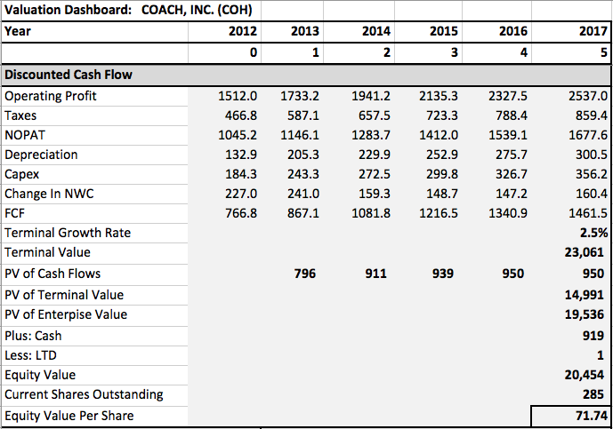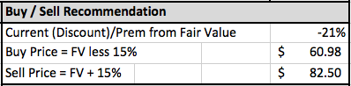

Total Return Calculation:
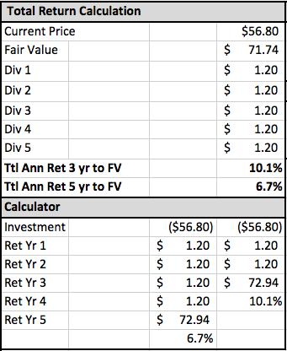
Comparative Valuation Analysis:
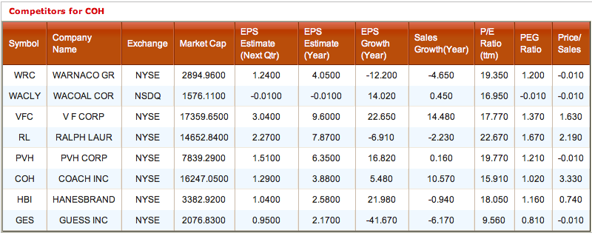

WACC Calculation:
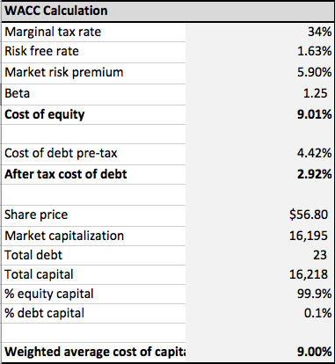

Valuation Assumptions:
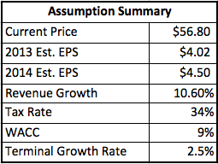
Income Statement Projection: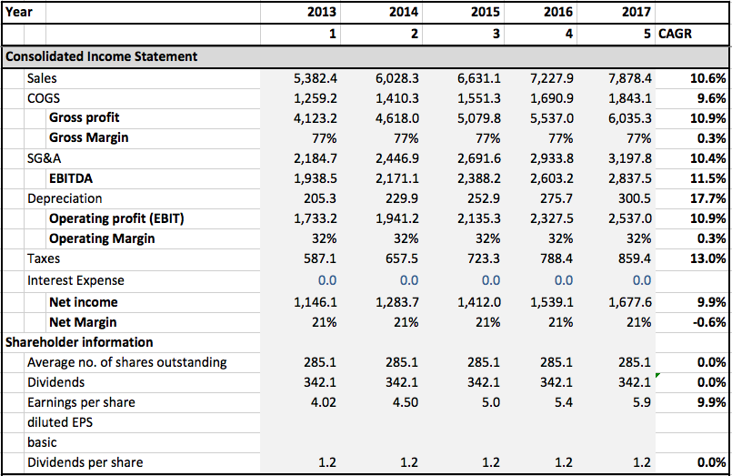
Historical Financial Data:

Income Statement
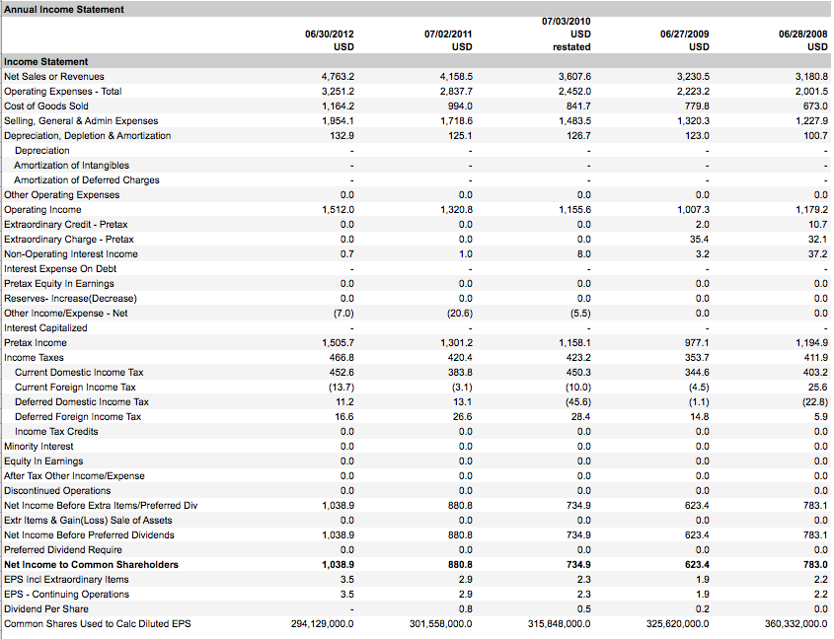

Cash Flow Statement
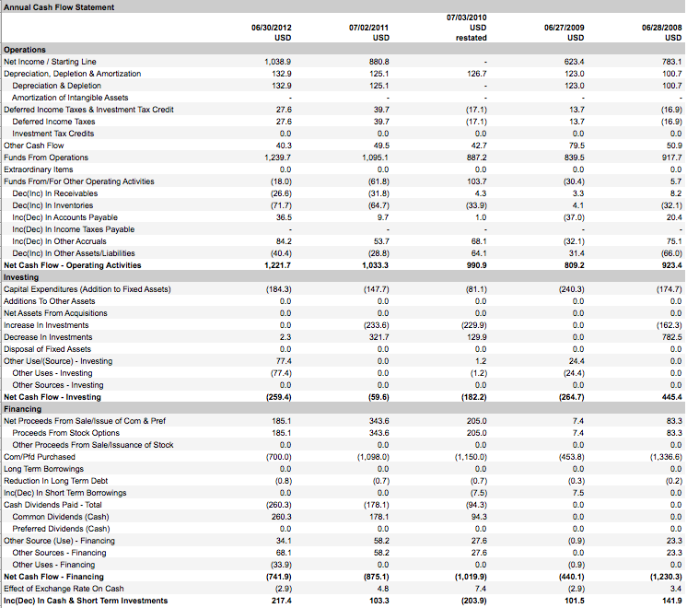

Balance Sheet
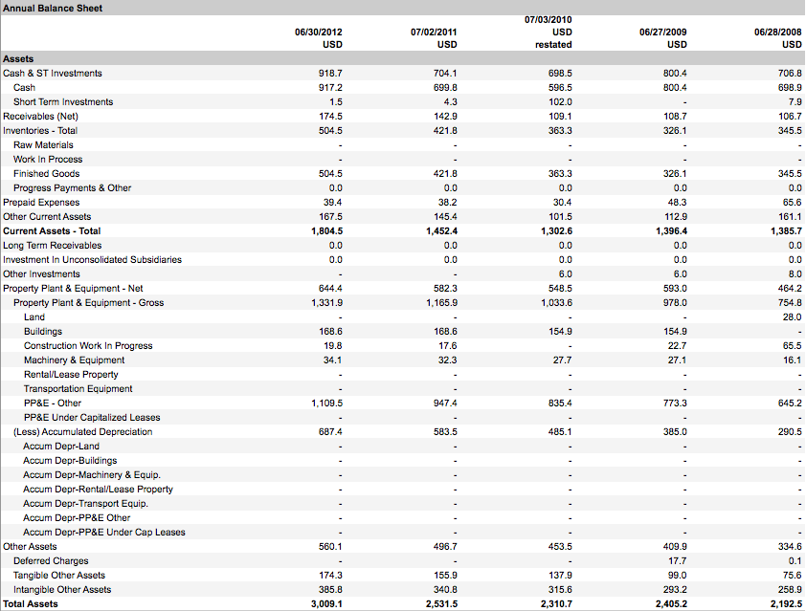
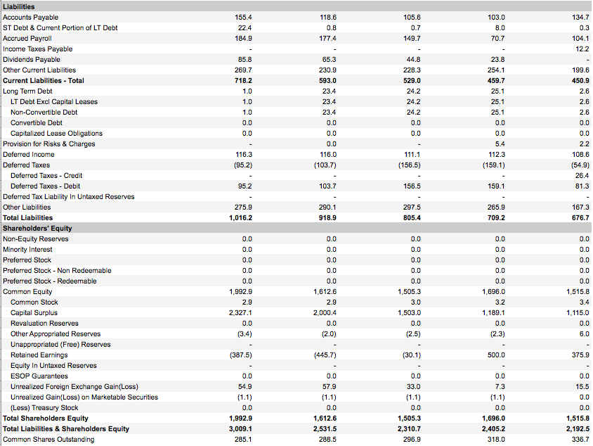

Key Ratios
